A Christmas Hack@Speed



Author: Chris Huntingford

Email: Chris.Huntingford@Microsoft.com

Contents

Prerequisites 3

Introduction 4

How to Hack? 5

All or Nothing 5

Go Rogue 5

Double or Nothing 5

Dream Team 5

Business Case 5

The Solution 6

Core Solution Components 6

Lab 1: Data & Common Data Service (CDS) - Mandatory 7

Solution Components 7

Let’s Begin 8

Lab 2: Configuring Forms, Views & Charts in the CDS* 18

Solution Components 18

Let’s Begin 19

Form Configuration 20

View Configuration 22

Charts Configuration 26

Lab 3: Configuring your Business Process Flow and Model Driven App experience 31

Solution Components 31

Let’s Begin 32

Business Process Flow 32

Model Driven Application 40

Dashboards 46

Lab 4: Configuring your Microsoft Flow Notifications* 57

Solution Components 57

Let’s Begin 58

Microsoft Flow 58

Lab 5: Configuring a Basic Power BI Dashboard* (Optional) 62

Solution Components 62

Let’s Begin 62

Power BI Desktop 62

Lab 6: Configuring the Sales Canvas App* 77

Solution Components 77

Let’s Begin 78

PowerApps Canvas App 78

Lab 7: Testing* 97

Solution Components 98

Let’s Begin 98

PowerApps Canvas App 98

PowerApps Model-driven App 98

Microsoft Flow 98

Power BI 98

Final Learnings 99

# Prerequisites

To complete this workshop, you will need to do the following:

1. Have an active PowerApps trial with the ability to create new Common Data Service environments. To do this, start the process as follows:
   1. “Trials.Dynamics.com” in an IN PRIVATE / INCOGNETO browser window with NO other browser windows open.
   2. Scroll down and click “Sign up here”

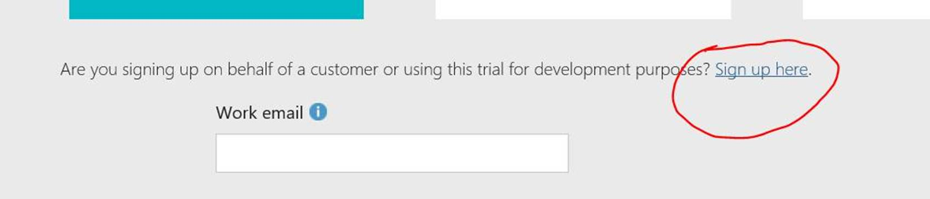

* 1. Then click “No, Continue Signing up”

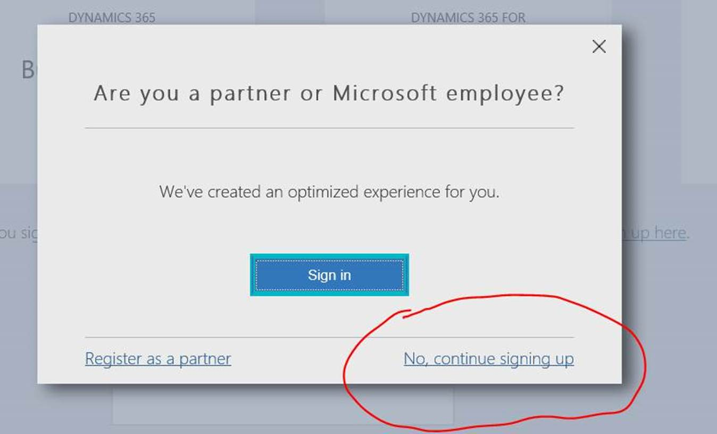

* 1. Follow the instructions…

1. To create a new  CDS Trial environment click [HERE](https://nam06.safelinks.protection.outlook.com/?url=https%3A%2F%2Fdocs.microsoft.com%2Fen-us%2Fpower-platform%2Fadmin%2Ftrial-environments&data=02%7C01%7CChris.Huntingford%40microsoft.com%7C93d6218bde1a4e748b4708d7377396b3%7C72f988bf86f141af91ab2d7cd011db47%7C1%7C0%7C637038841922812228&sdata=u2T6II2VUpu%2FCz46WHhFa32wIC%2BbsETSa6%2BuUyoopx8%3D&reserved=0). This can be done from ANY existing tenant (Preferably from the one generated above)
2. Download Power BI Desktop to your local machine. This can be done by simply going to the Microsoft Store and searching for Power BI Desktop.

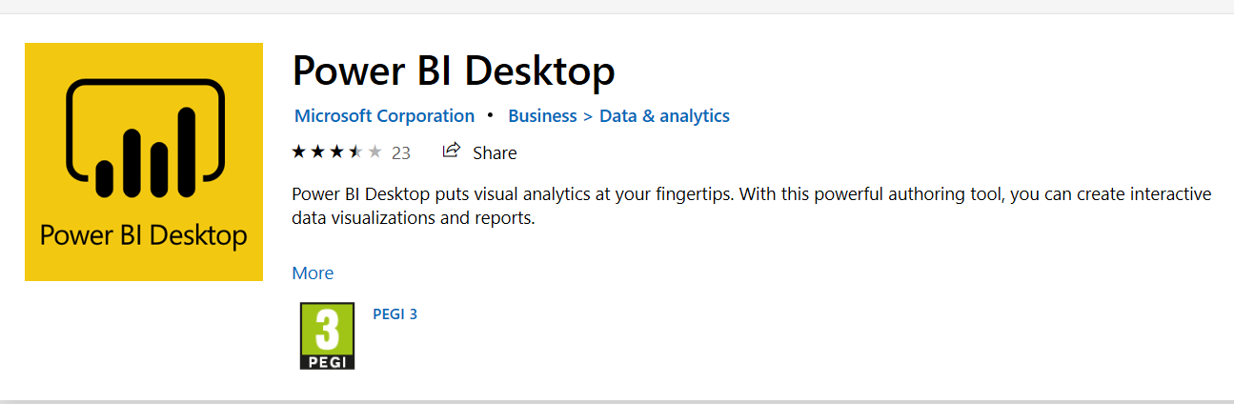

1. Download the “Prospects” Excel File from the following Location [HERE](https://microsoft-my.sharepoint.com/:x:/p/chhuntin/EfRbkrn6fb5MsAEKKH4U58kBbxWyZoT3lgOtQl4LKIX9vQ?e=1tdfYM).

# Introduction

Welcome to “A Tiny PowerPlatform Hackathon” This walk through is designed to take you through various core areas of the Power Platform in order to help you understand how it all fits together in a very short amount of time. The document may appear long, however there are Multiple Screen shots that will help you run through the material.

## How to Hack?

The key part of this Hack is the data supplied in the excel sheet. The ability to get the data into the CDS is of vital importance, Therefore Lab number 1 is Mandatory. After that you are able to select the Labs you would like to do as there is not always an interdependancy between labs, OR you may build what ever you would like on top of the data, as long as it solves the business problem. Any lab that has a title with a * means that it can be done independantly of the others (based on the completion of Lab 1). The below table will help you understand the dependancies.

|  |  |  |
| --- | --- | --- |
| **Lab Title** | **Technology** | **Dependencies** |
| **Lab 1:** CDS | Common Data Service | Lab 1 |
| **Lab 2:** Forms, Views Charts | Common Data Service | Lab 1 |
| **Lab 3:** Business Process Flow, Model Apps & Dashboards | Flow & PowerApps | Lab 1 & Charts from Lab 2 |
| **Lab 4:** Microsoft Flow | Flow | Lab 1 |
| **Lab 5:** Basic Power BI | Power BI | Lab 1 |
| **Lab 6:** Canvas Apps | PowerApps | Lab 1 & Power BI Dashboard from Lab 5 |
| **Lab 7:** AI Builder | CDS, Power Apps (Model Driven & Canvas), Power Automate & AI Builder | Lab 1, Lab 3, Lab 6 |

There are a number of ways that you could approach this hack. These are as follows:

### All or Nothing

Go right ahead and try and knock out this entire hack in the time alocated. This whole build can be achieved in less than 45 min by an experienced Maker.

### Go Rogue

Get the data int the Common Data Service in Lab 1 and then build something completely unique on top of it. Do what works for you…

### Double or Nothing

Couple up and split the work. Get someone to do the CDS & Model driven related configuration and the someone else to do the Power BI, Flow and Canvas App build. This has proven to work very well as both areas do not conflict.

### Dream Team

Get a team together, knock out the first lab and then allocate each lab to a different person. This is also totally doable as various areas do not intersect but work well together.

# Business Case

We are an organisation focused on collecting information about Santa Sleigh sighting and reporting on this information as effectively as possible. We have a number of user stories that we really need to try and fulfil in order to make sure that we are effective, collaborative and decisive with the information we collect.

* We want to store our data in a SINGLE, RELIABLE, SECURE source that is accessible through multiple applications.
* I want to be able to import data from my Excel data sources to the CDS.
* We want to have a great internal mid office application that will enable us to view all of the data clearly as well as interact with the relevant records from a collaborative perspective.
* We want to be able to manage the sighting through a “Management Process” to make sure that each record is logged correctly and accurately.
* We want to Automatically send an email to a specific user to alert them of when a new record has been captured in your data store.
* We want an interactive visual report of the information stored in the data store which will allow us the ability to better understand the types of records that have been captured and the aggregation of information relevant to the types of data captured.
* We want to have the ability to leverage a mobile app to visit people and capture any data or images and store this in a central location, ready for processing by the internal mid office team.
* We want to be able to use AI creatively within the solution to enable users the ability to clearly manage data and interact with information in a more manageable manner.

# The Solution

To help said organisation solve this problem and provide a great amount of value within a simple, single implementation, the following design has been decided on:

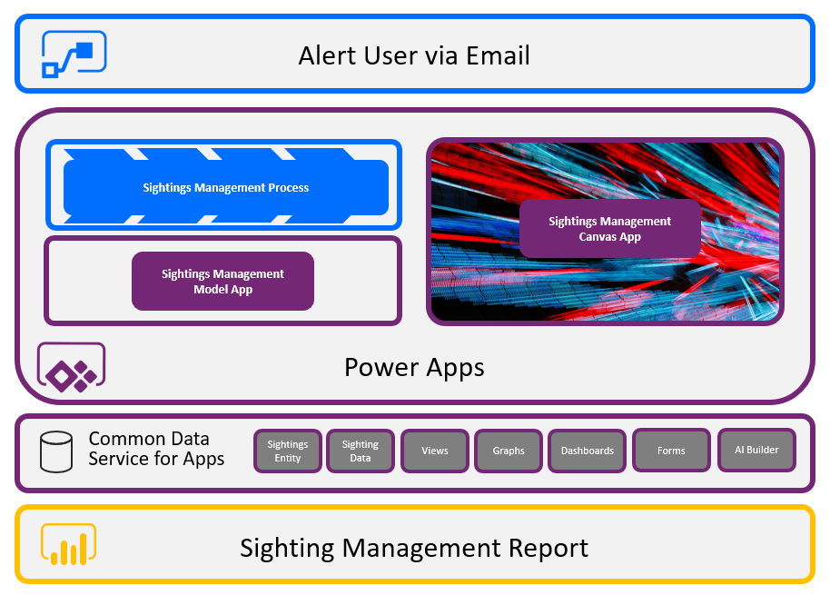

# Core Solution Components

The core focus areas of this course will be as follows:

1. **Power Query:** Used to import data from the core Excel list sent to the regional office as a starting point.
2. **The Common Data Service:** Will act as the core Data Storage mechanism to hold and manage the prospect data.
3. **Power Apps (Model Driven Apps):** The mid office will leverage a model driven app to interact with the prospect and help control the process.
4. **Power Apps (Canvas Apps):** The Sales operatives in the field will leverage a simple canvas app to help capture the prospect data as well as well as expose simple analytics.
5. **Microsoft Flow:** Notifications will be sent to the relevant users by leveraging Microsoft Flow to automate simple interactions.
6. **Business Process Flows:** The mid office user will need to manage the prospect through to completion by running through the visible business process flow on the model driven application form.
7. **Power BI:** To gain full insights and analytics on the relevant prospect data, Power BI will be leveraged as the reporting mechanism to expose the prospect information.
8. **AI Builder:** To leverage the data you have captured in the CDS to further automate your understanding of additional data and enhance the interaction the user has with the information.

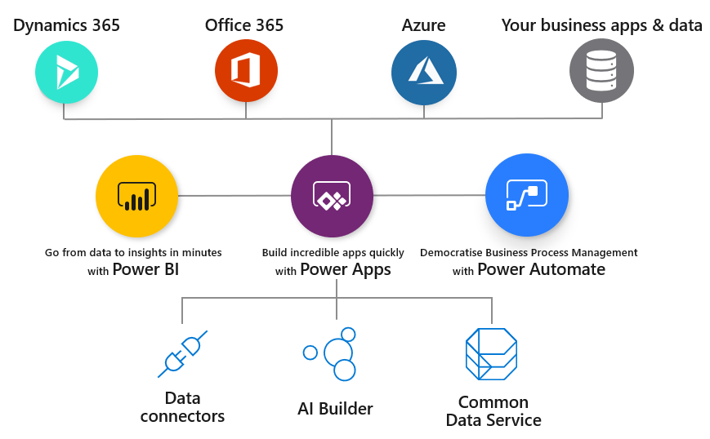

# Lab 1: Data & Common Data Service (CDS) - Mandatory

We will start off by bringing in the Excel data structure into the Common Data service (CDS) by leveraging Data Flows within the CDS and Power Query.

***Please Note:***

***This Part of the Hackathon is mandatory as all other elements of the solution rely on the data being in the Common Data Service (CDS)***

## Solution Components

Microsoft Power Query

The Common Data Service (CDS)

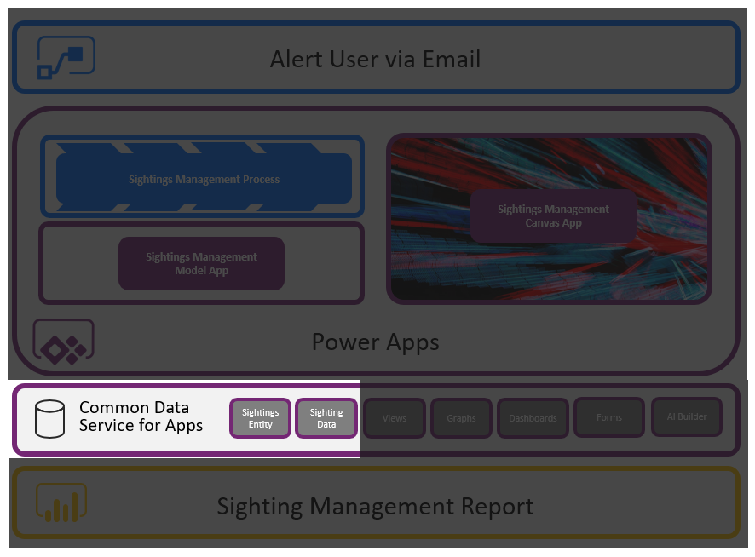

## Let’s Begin

Navigate to make.PowerApps.Com and make sure you are in the environment that you created in the Prerequisites. You MUST NOT be in the “Default Environment”, you must be in the environment that you added.

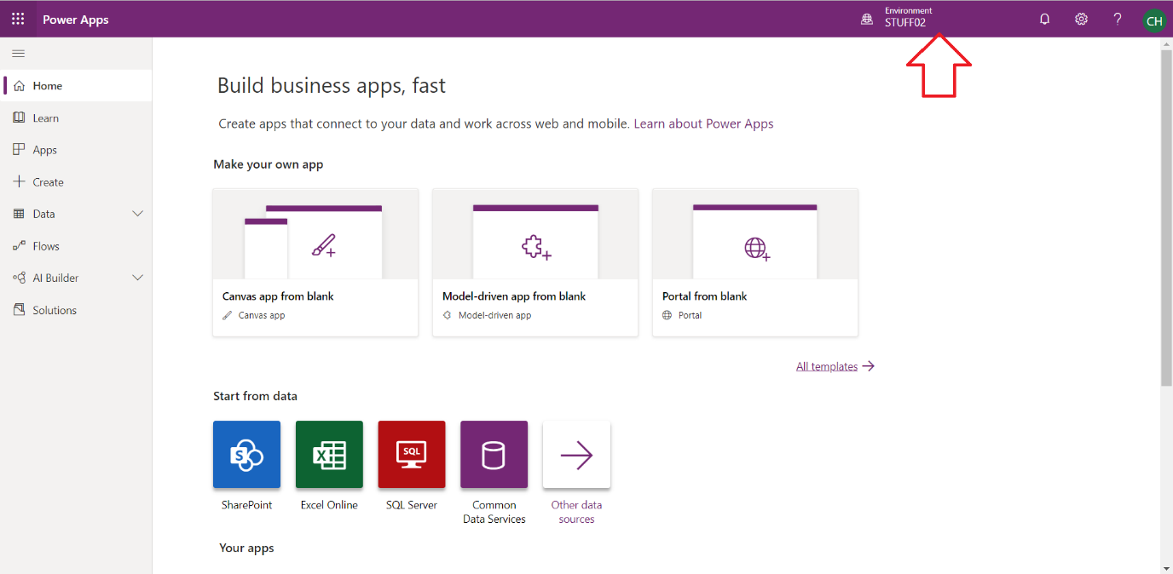

Select DataFlows (May say Data Integrations)

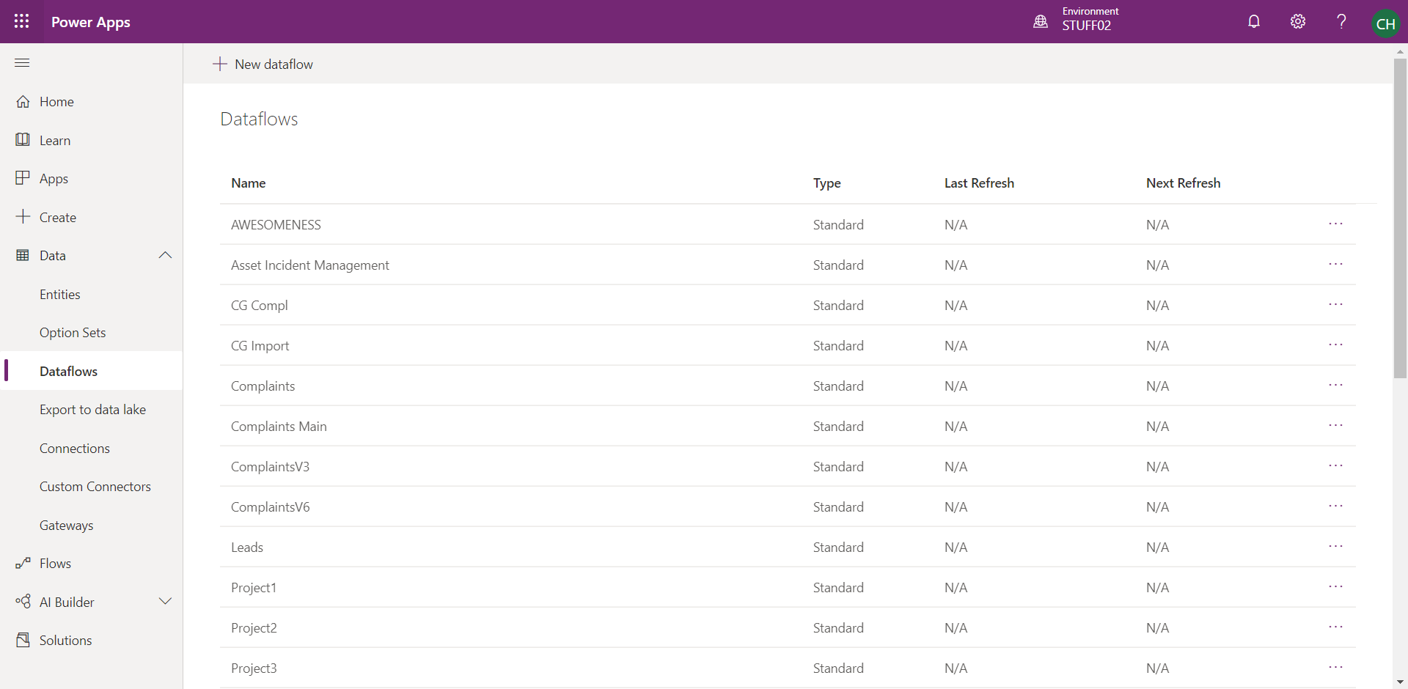

Create a New Dataflow and call it “Sleigh Sightings”.

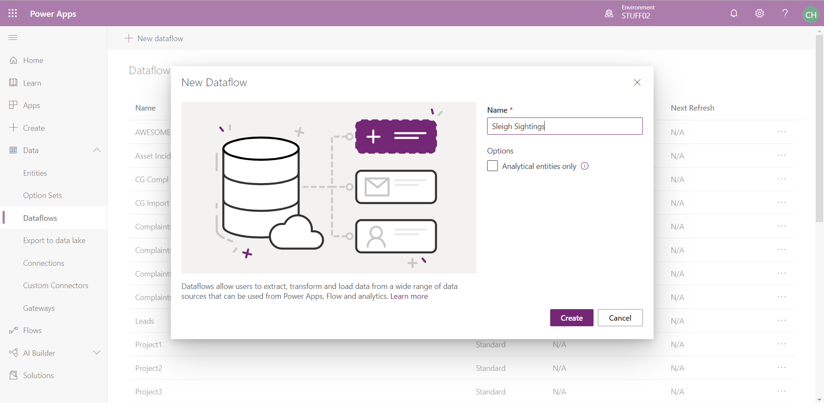

There are a load of options / Data Sources you could select from. Pick “Excel” in this scenario.

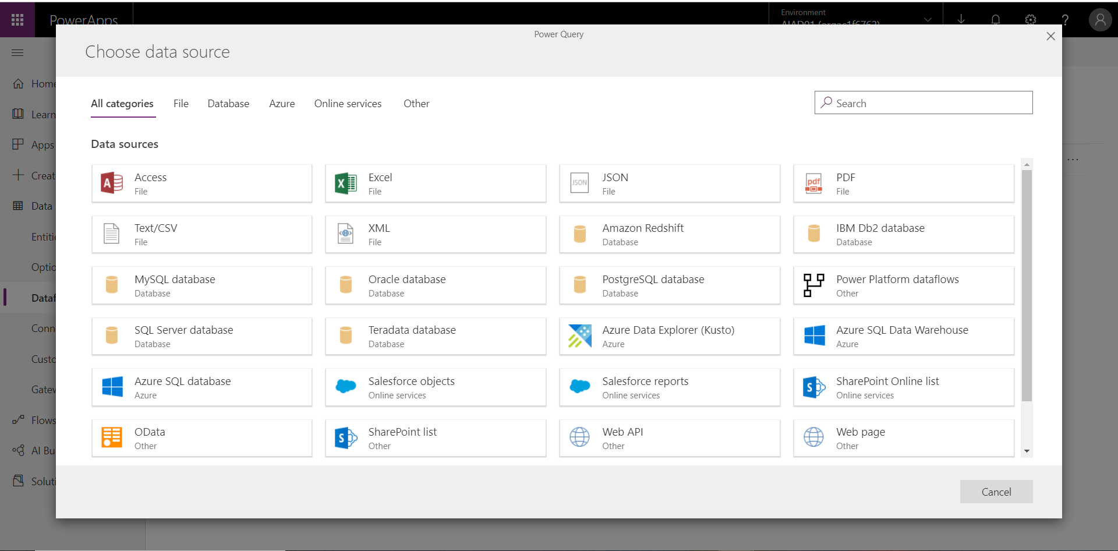

You will now be taken to a page where you need to specify the location of the Excel Document.

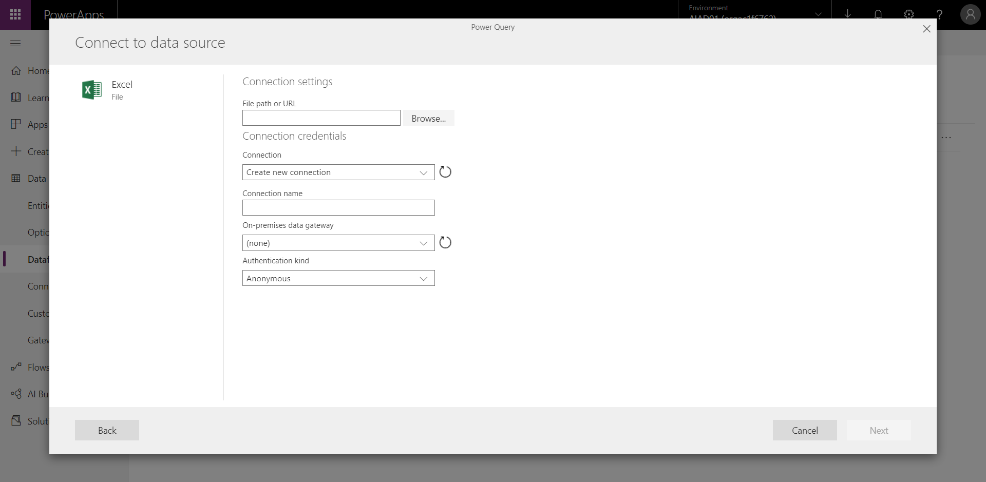

Click “browse” and another OneDrive window will open. Assuming you have not done this exercise before, you will see no files in the OneDrive repository.

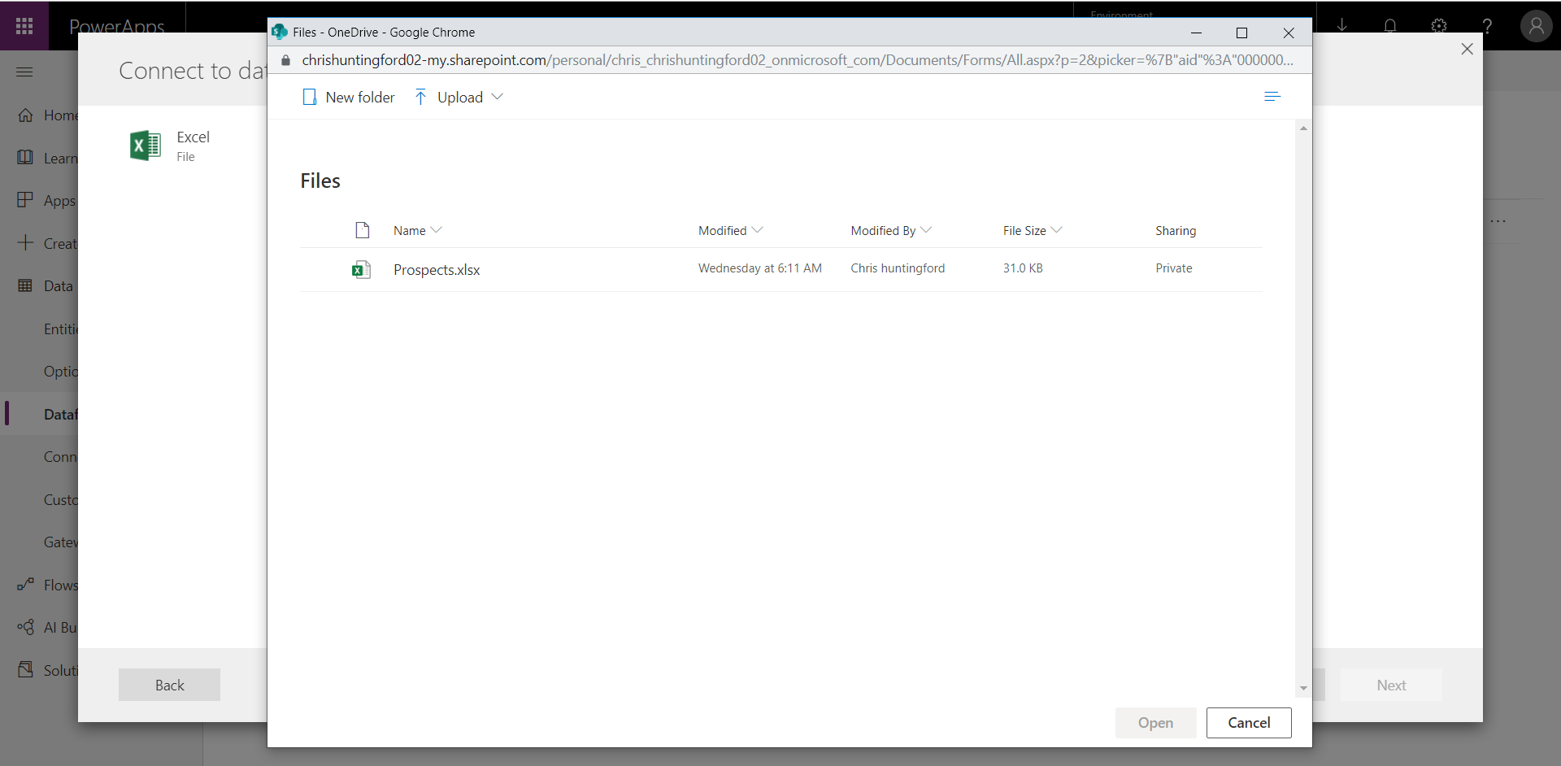

Click “Upload” and navigate to the location where you saved the “Sleigh Sighting” Excel file, Select the file and select Open.

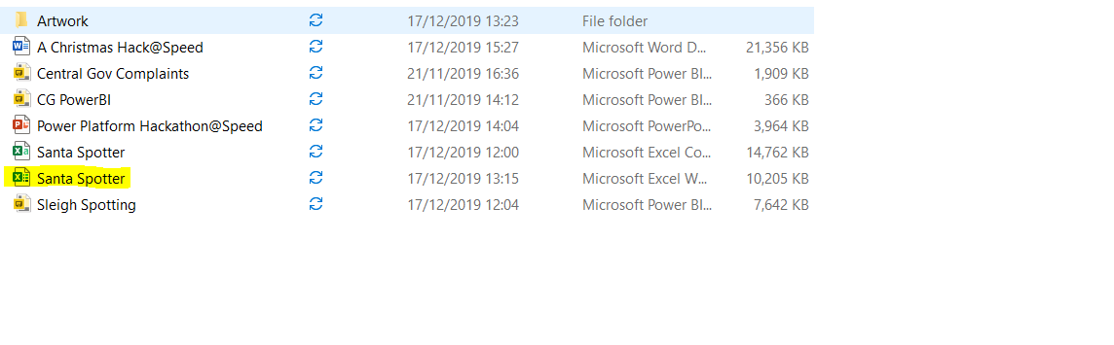

Once the file has been uploaded you will see it in the OneDrive repository.

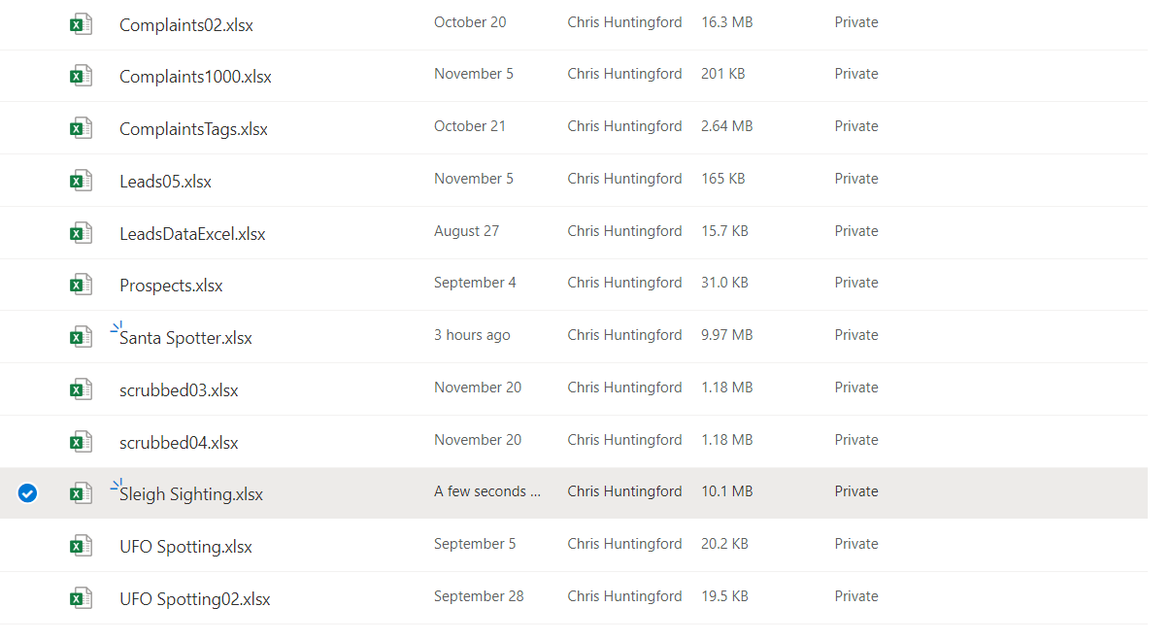

Select the file and click “open”. This will load the file path into the Power Query Data Source connection settings.

Check the file location and click “Next” to progress to the next step.

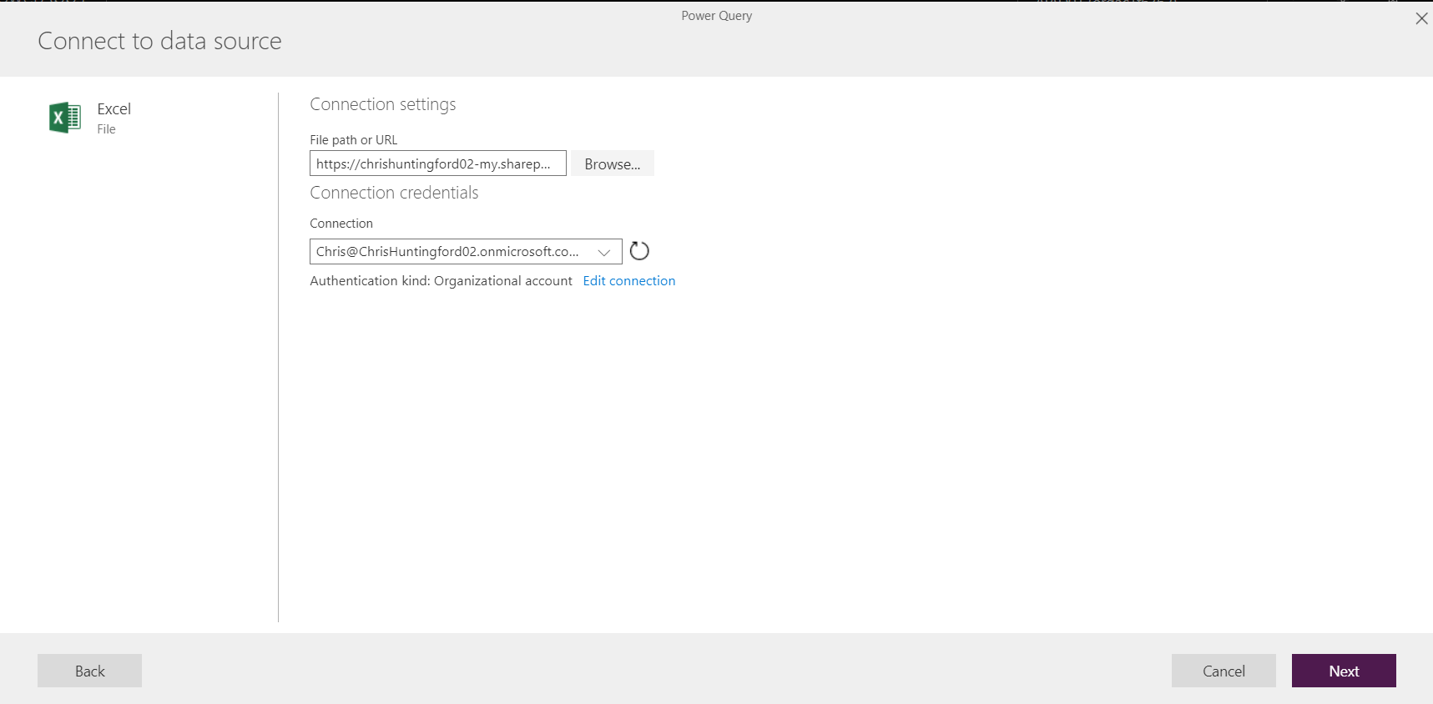

View the Excel dataset in Power query and select “Transform Data” to continue.

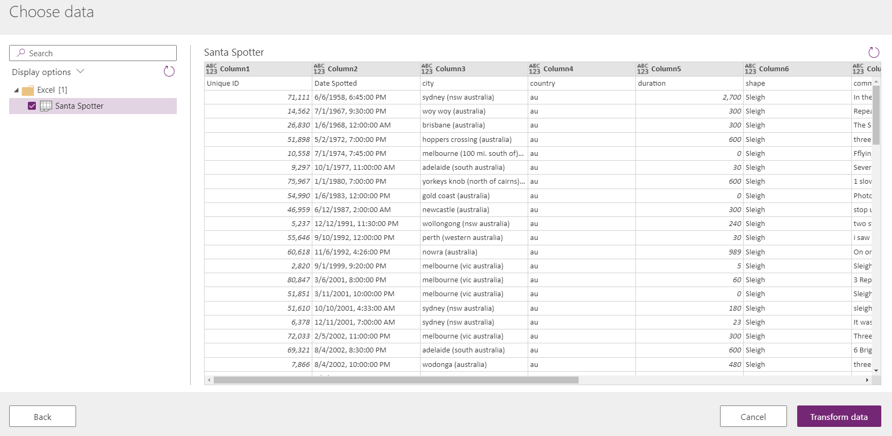

Select “use first Rows as Headers” from the “Transform Table”.

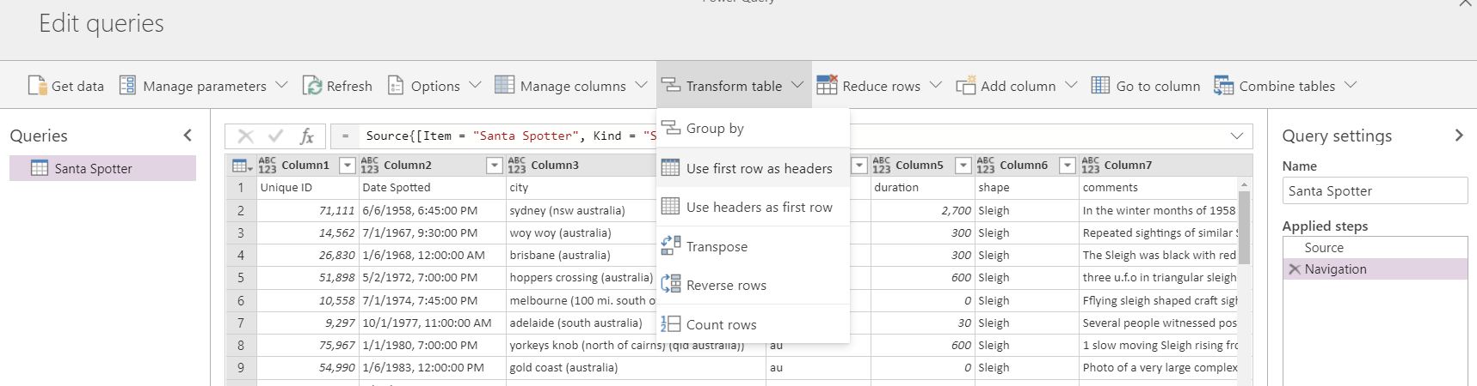

You will see that the new header names are now visible in the table.

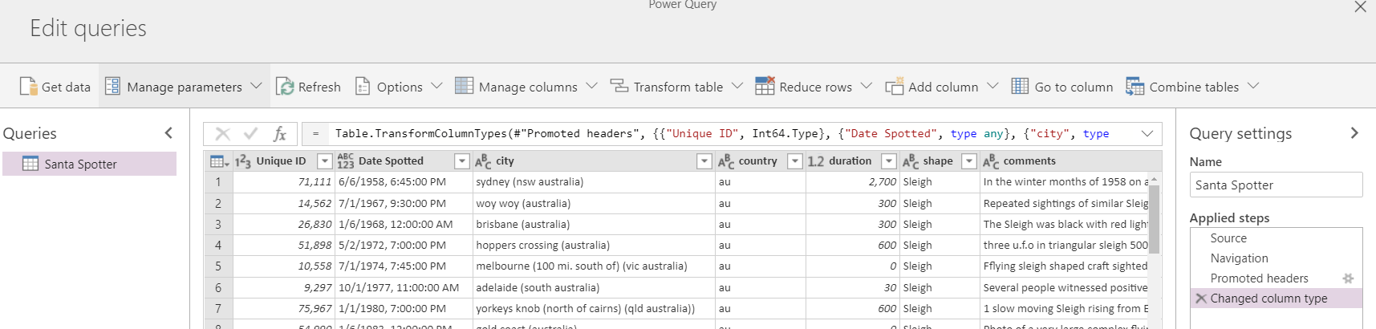

Change “Unique ID” to a text value

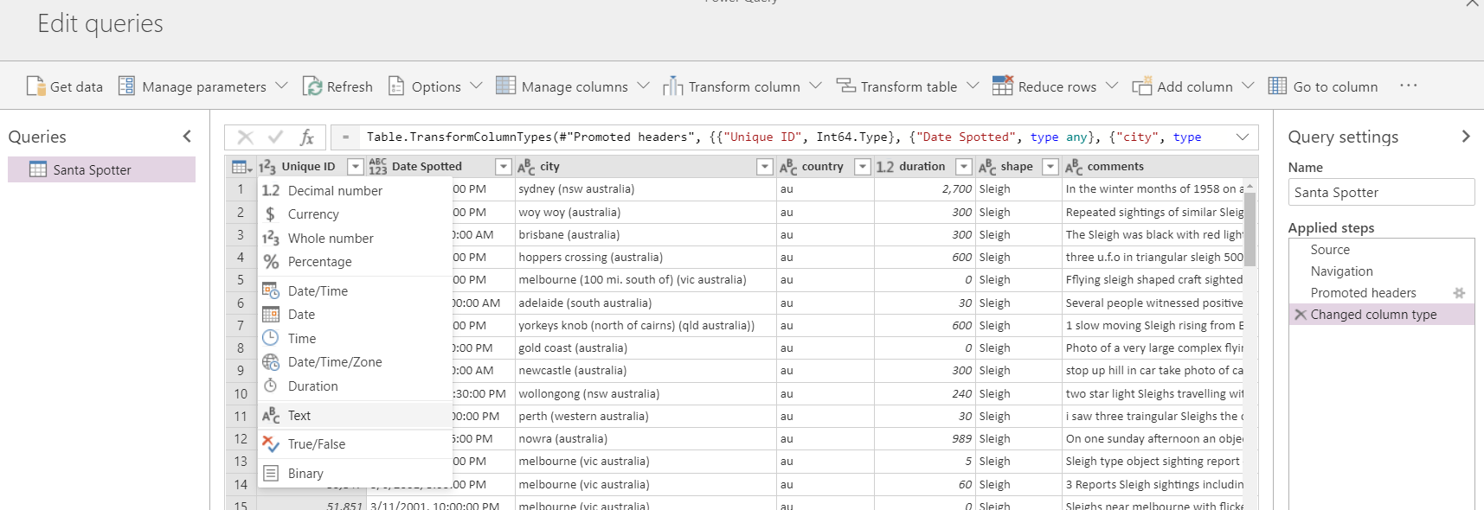

Select “Replace Current” when changing the data types.

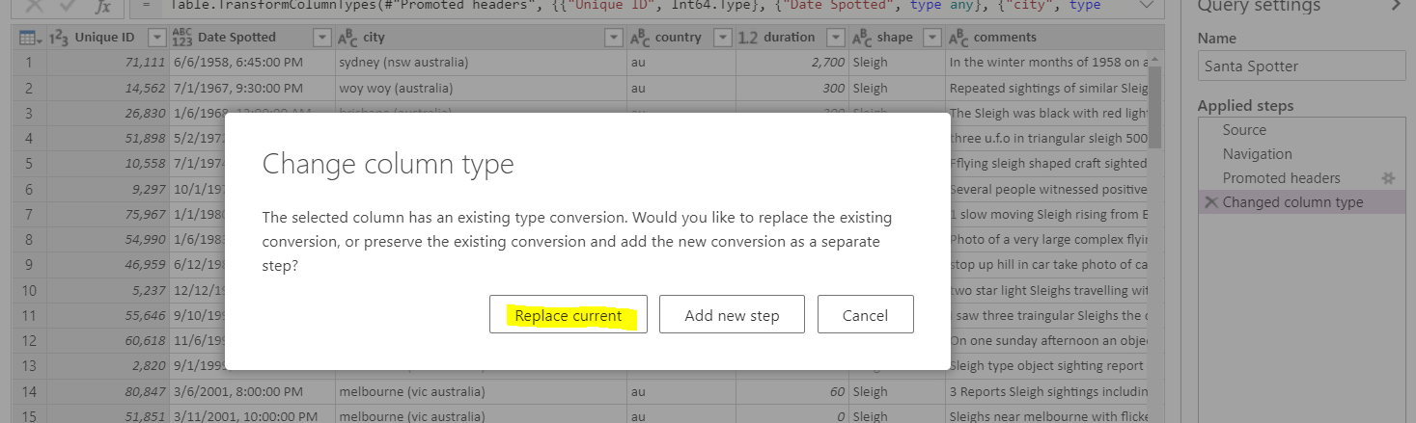

Change the Latitude and longitude data types from Numeric to Text.

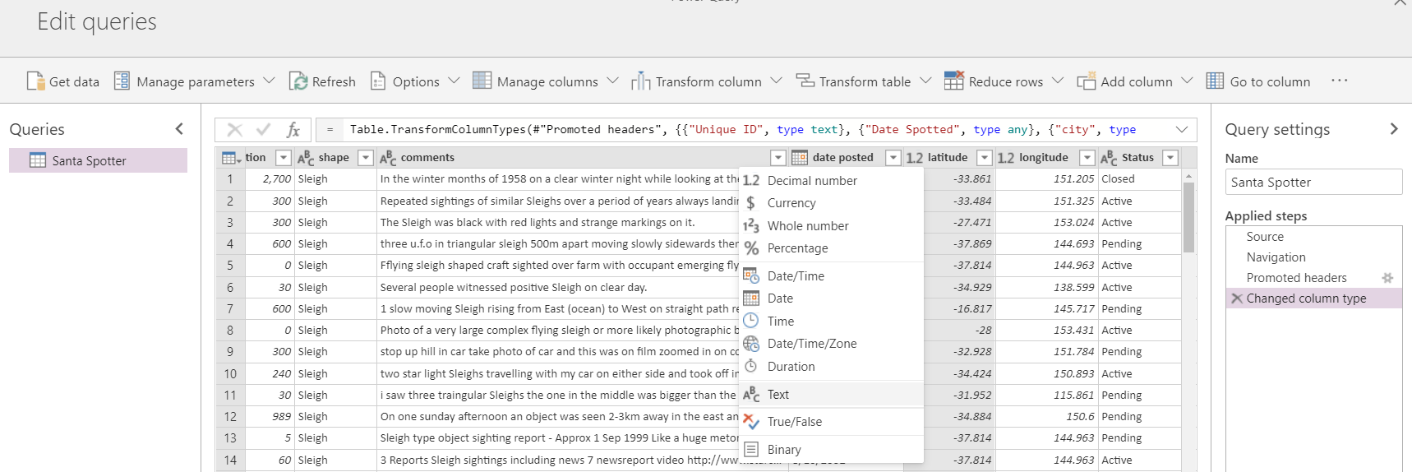

Select “Replace Current” when changing the data types.



Do the same for longitude.

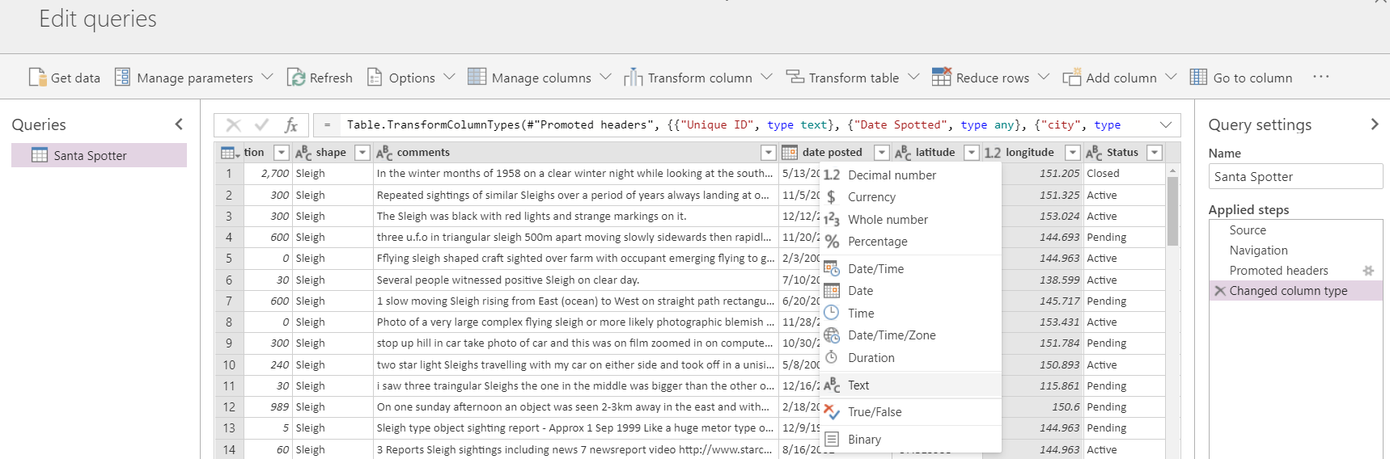

Select “Replace Current” when changing the data types.



Select “Next” to move onto the Power Query load screen.

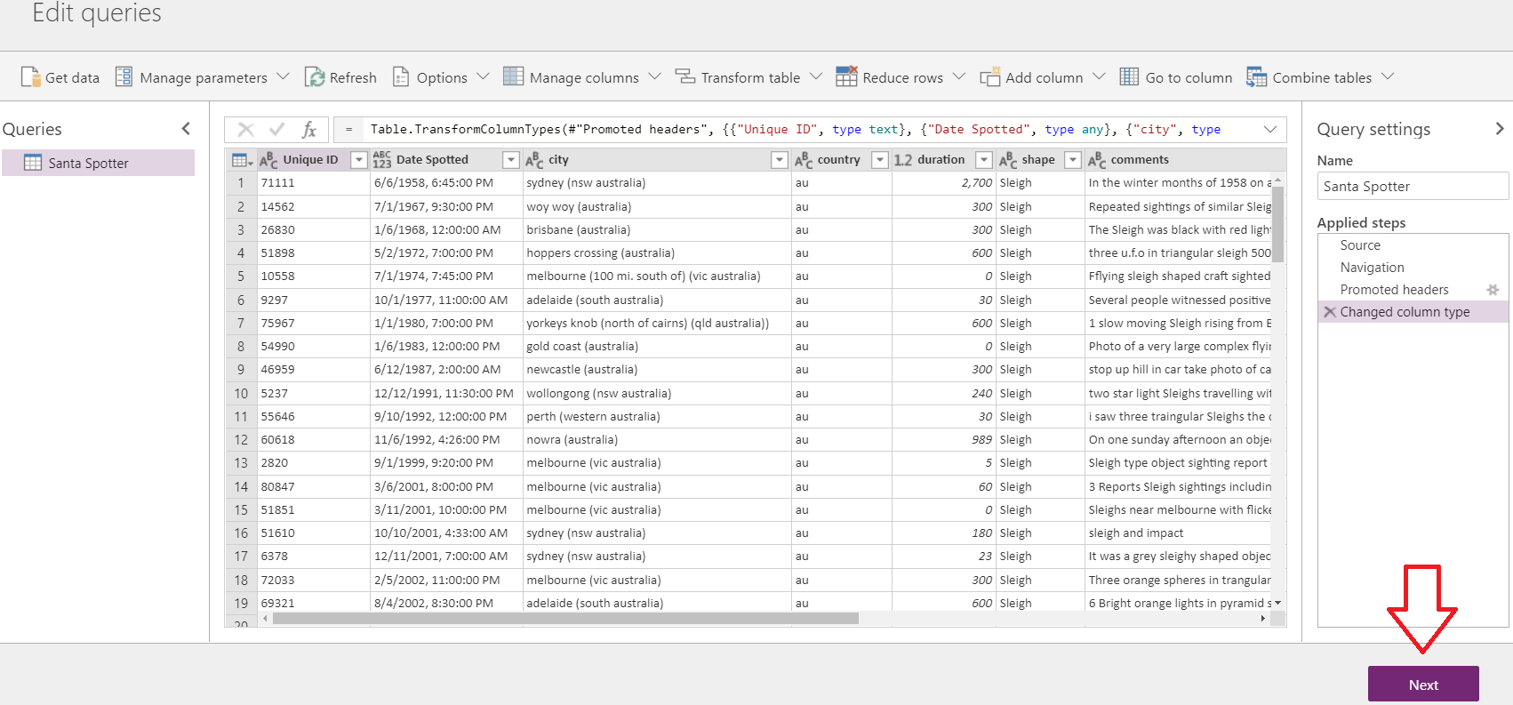

On the Mapping Entities screen select “Load to a New Entity”. This will create a brand-new entity when importing the data and will save you the time of having to create the entity and attributes from scratch.

Enter the Entity name as “Sleigh Sighting” and the Display name as “Sleigh Sighting”.

Select “Delete rows that no longer exist in the query output”.

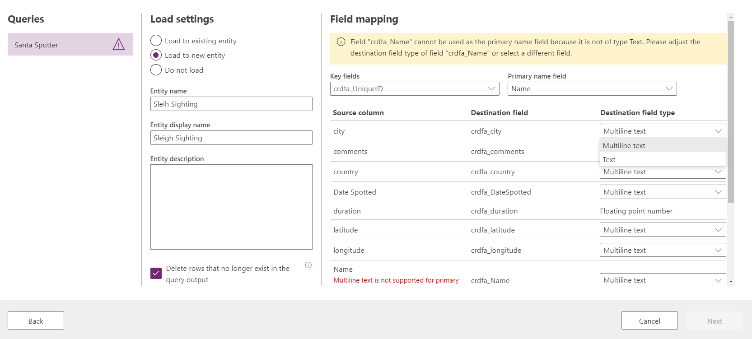

Set all the field types, **EXCEPT FOR “COMMENTS”**, that can be changed, to “Text”.

Set the Key field to “Prospect ID” and the Primary field name to “Unique ID” as well.

Set the Primary name field to “Name”

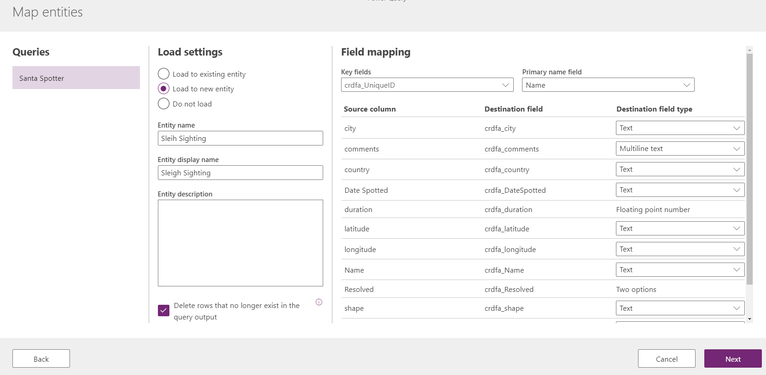

Hit “next” to continue.

Select “Refresh manually” and then click “Create”.

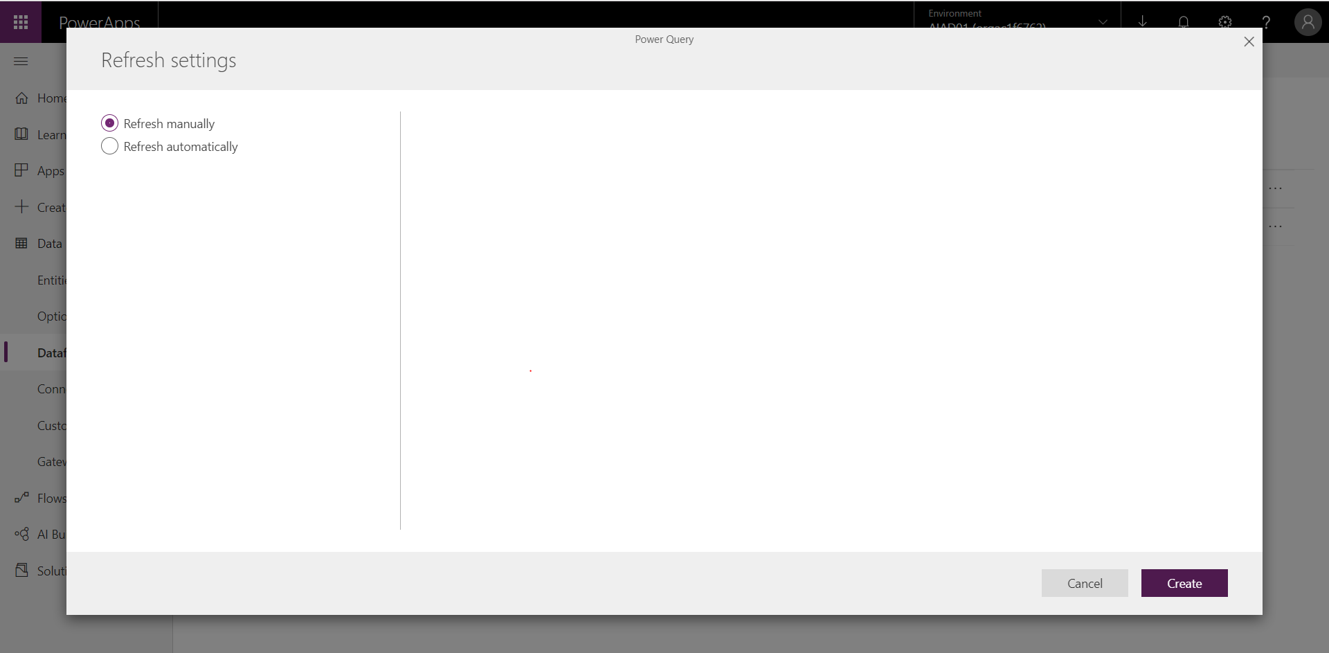

You will be able to see the indicator of the entity being created in the background, in the form of 3 resizing dots. This may take some time so use the time to plan your next steps….

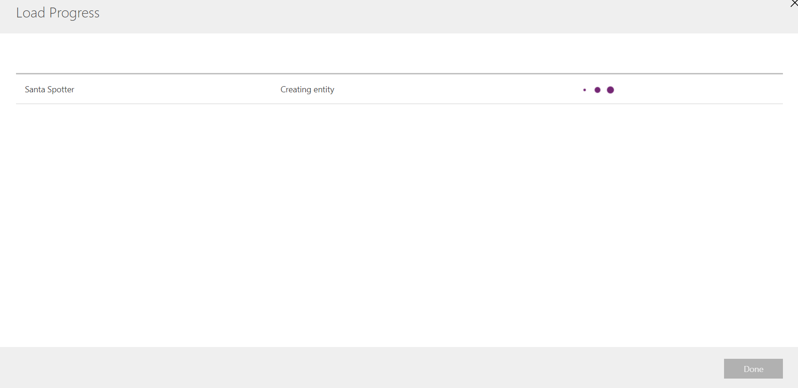

Once the process is complete you will be notified. Click the “Done” button to proceed.

You will see your Data flow has now been added to the list and your entity added to the Common Data Service

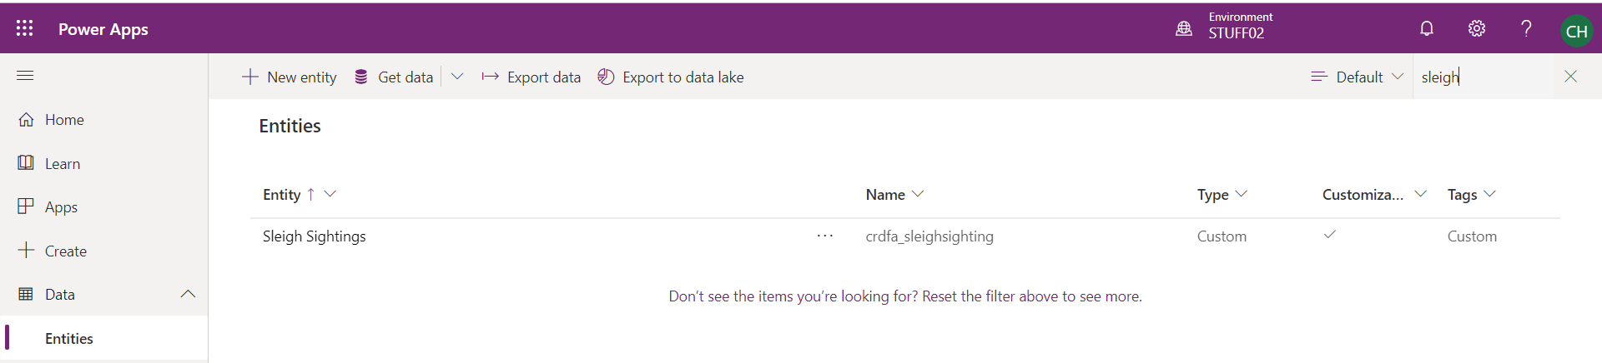

This concludes Lab number 1 and the focus around the bringing in data from a data source into the Common Data Service.

# Lab 2: Configuring Forms, Views & Charts in the CDS*

We will start off by leveraging the data structure you just brought into the Common Data Service (CDS) via Data Flows from Excel. This will give the users of the solution a much more efficient mechanism to interact with the data.

***Please Note:***

***This lab can be completed independently, with only Lab 1 being and no support of the other labs.***

## Solution Components

The Common Data Service (CDS): Forms, Views & Graphs

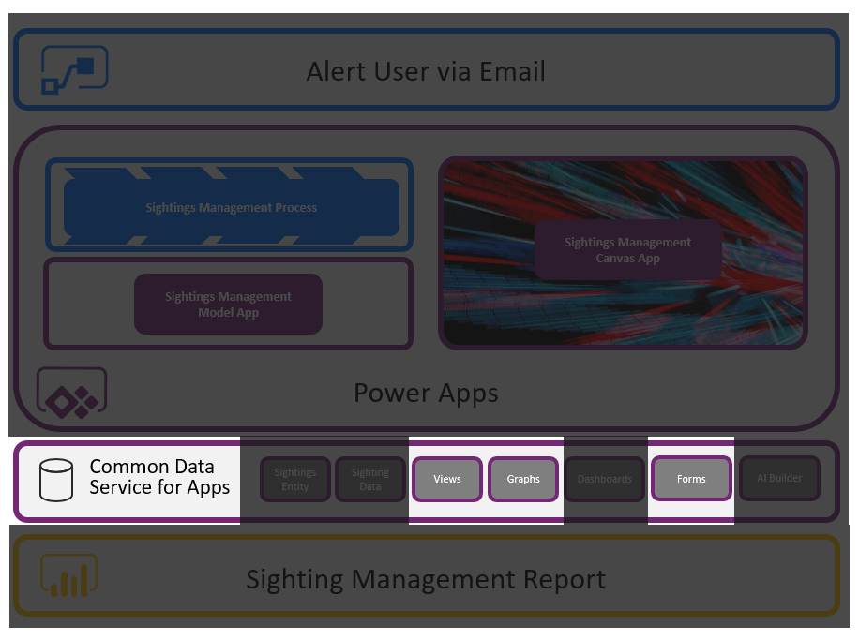

## Let’s Begin

Navigate to make.PowerApps.Com and select “Data” from the menu n the left. Then navigate to “[Entities](https://docs.microsoft.com/en-us/powerapps/developer/common-data-service/entities)”. This will display a list of the standard data entities within the Common Data Service. If you have added any other custom entities or solutions, the relevant set of entities will be visible here.

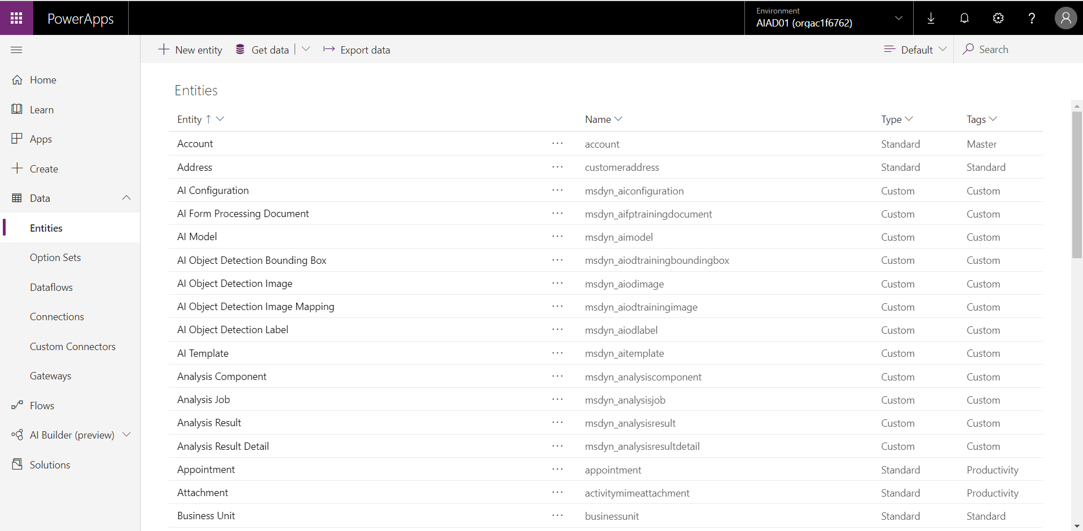

Search for prospects in the top right and you will see that there is an entity that has been created. If you do not see your “Sleigh Sighting” entity, do the following:

1. Make sure you are in the correct Environment (See the first step in Lab 1)
2. Refresh the entire maker Experience web page if you do not see your newly created entity

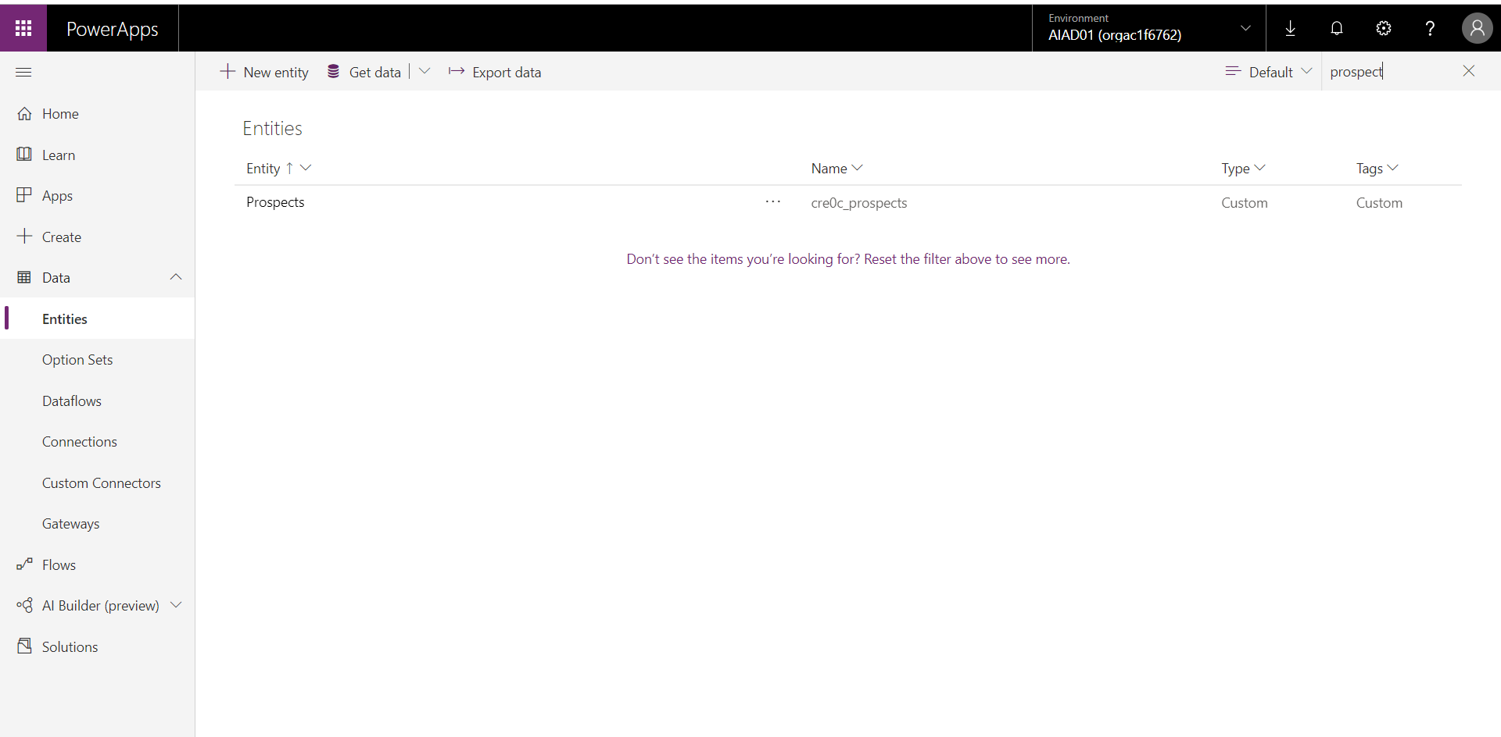

When opening the Prospects Entity, you will see a list of the fields that have been added to the entity.

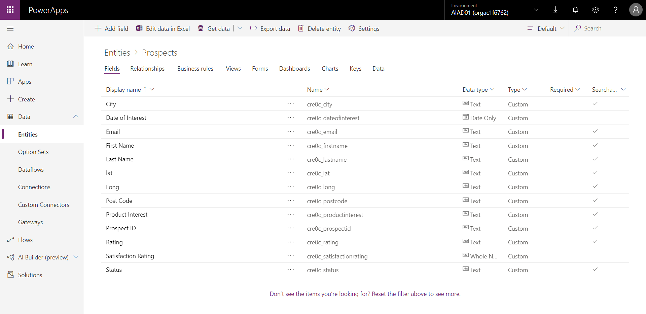

### Form Configuration

Forms are the mechanism used to capture and display data in Model Driven Applications. Select the “Forms” option from the tab headings.

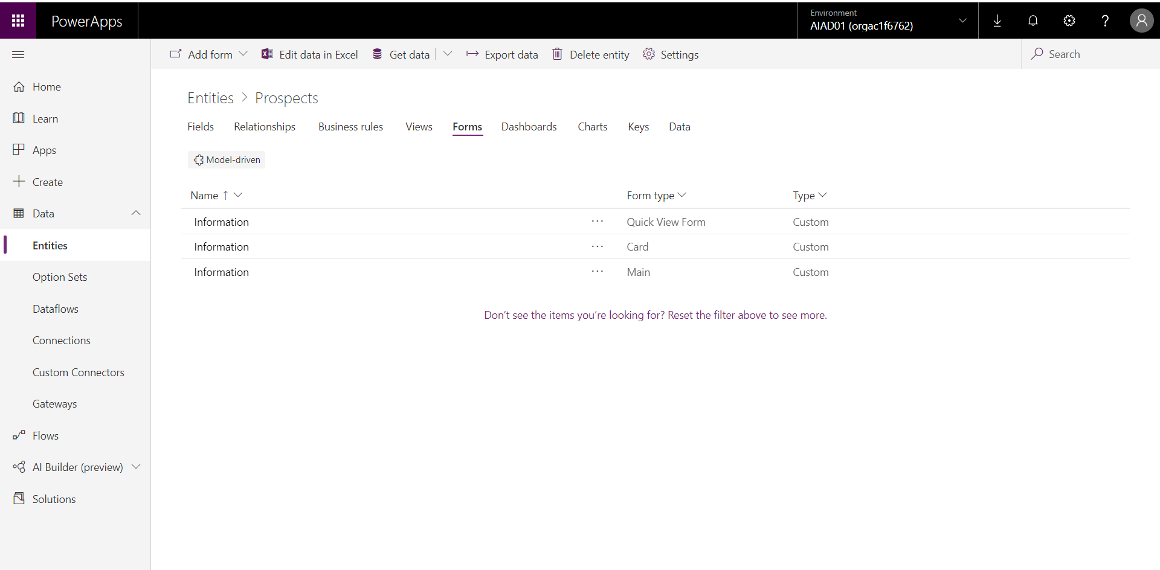

Open the main information form to enter the form editor.

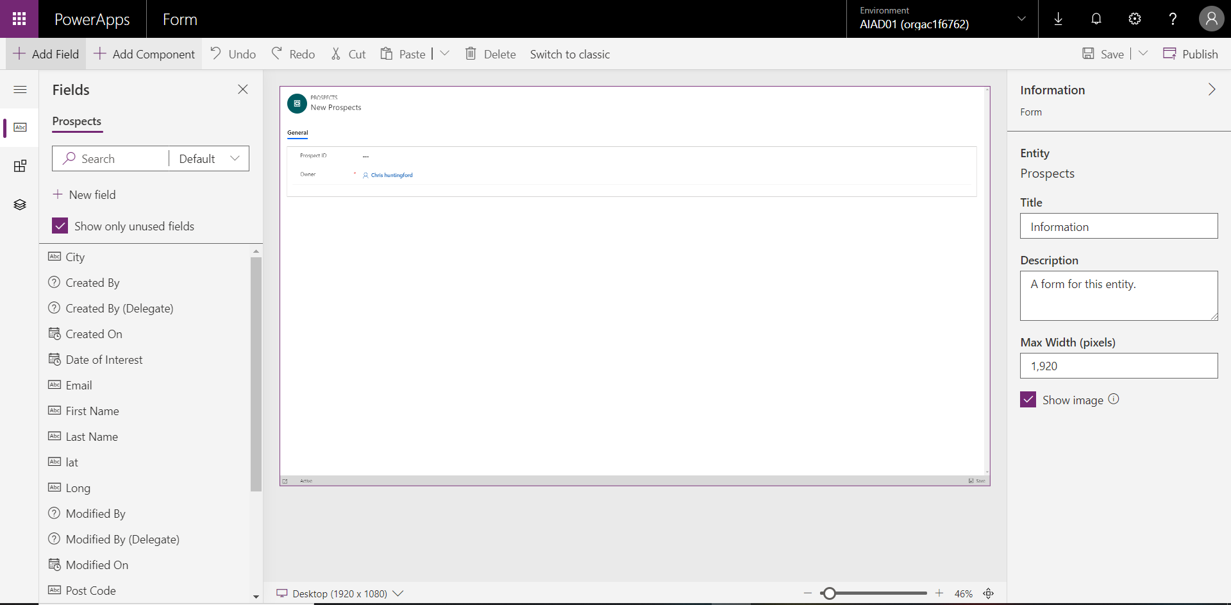

Drag and drop the following fields onto the form:

1. First Name
2. Last Name
3. Email
4. City
5. Post Code
6. Date of Interest
7. Product Interest
8. Satisfaction Rating
9. Rating
10. Status (there are 2 status fields, make sure you select the TEXT version of the field)

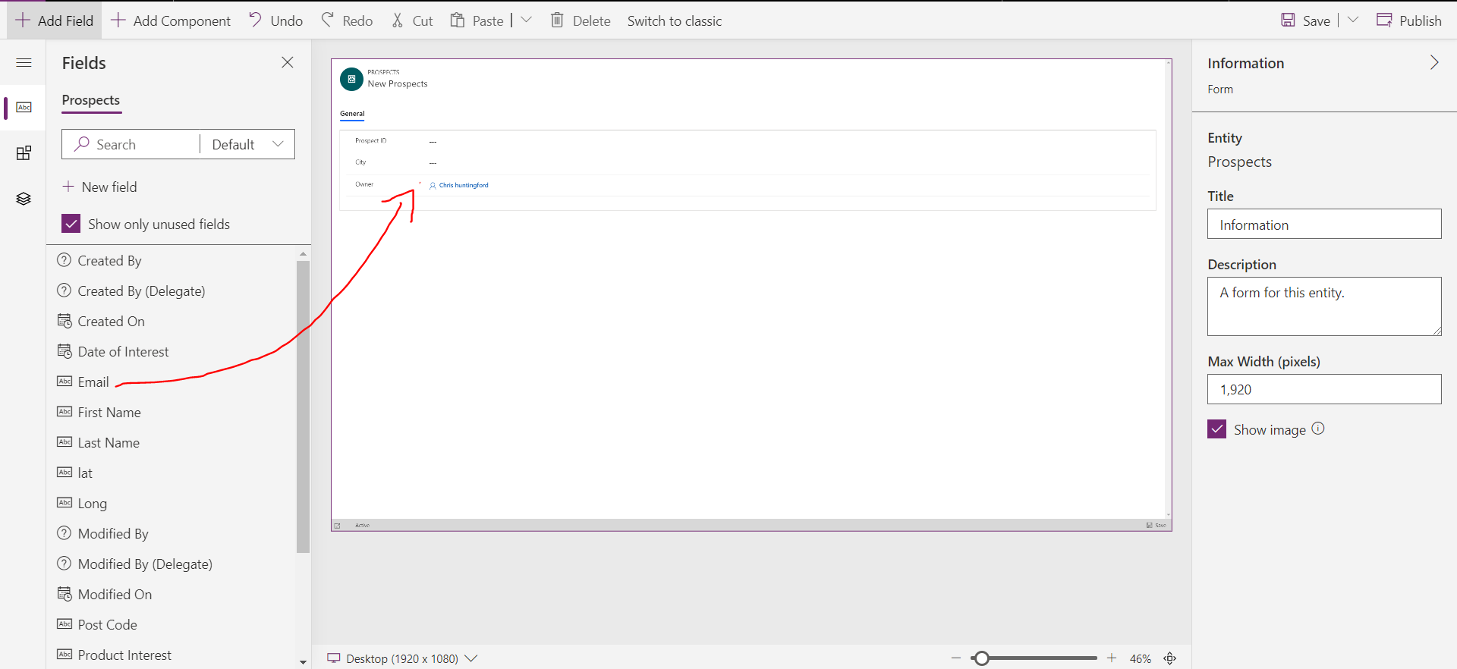

**Save and Publish the newly edited form.** You MUST do this before you navigate back to the main entity screen.

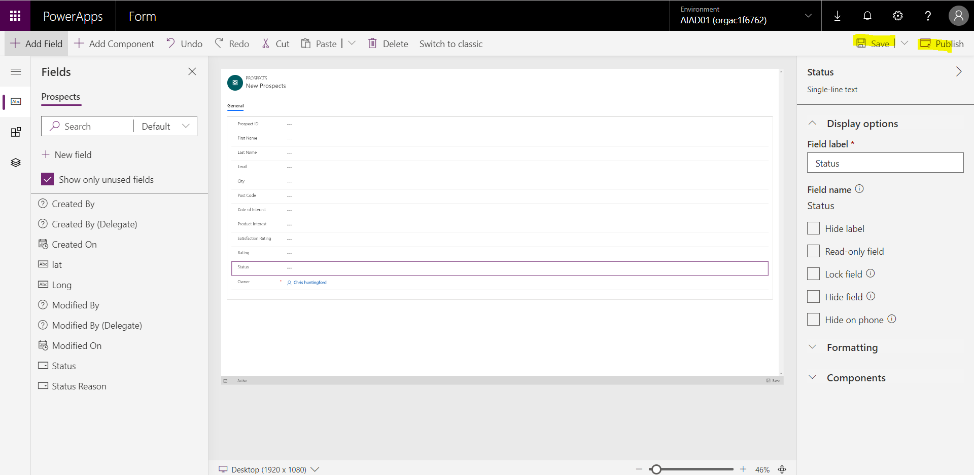

Click the Browser Back button to navigate to the main entity screen.

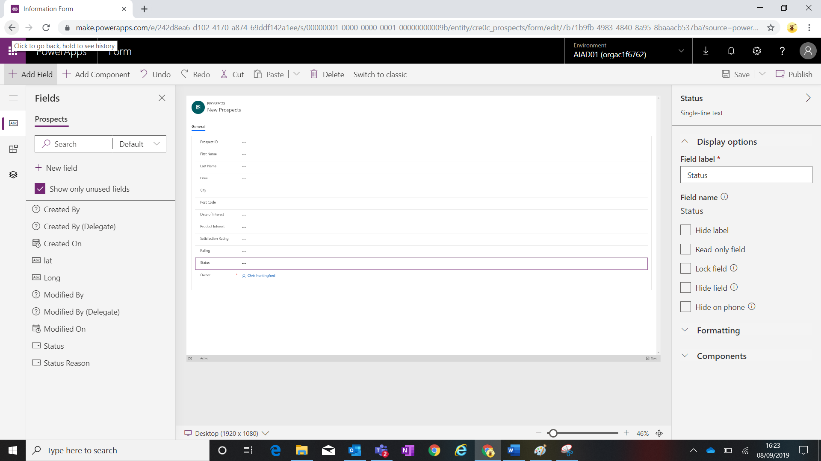

### View Configuration

Views are the mechanism used to view lists of data within all application types within the Power Platform. Select the “Views” tab from the menu.

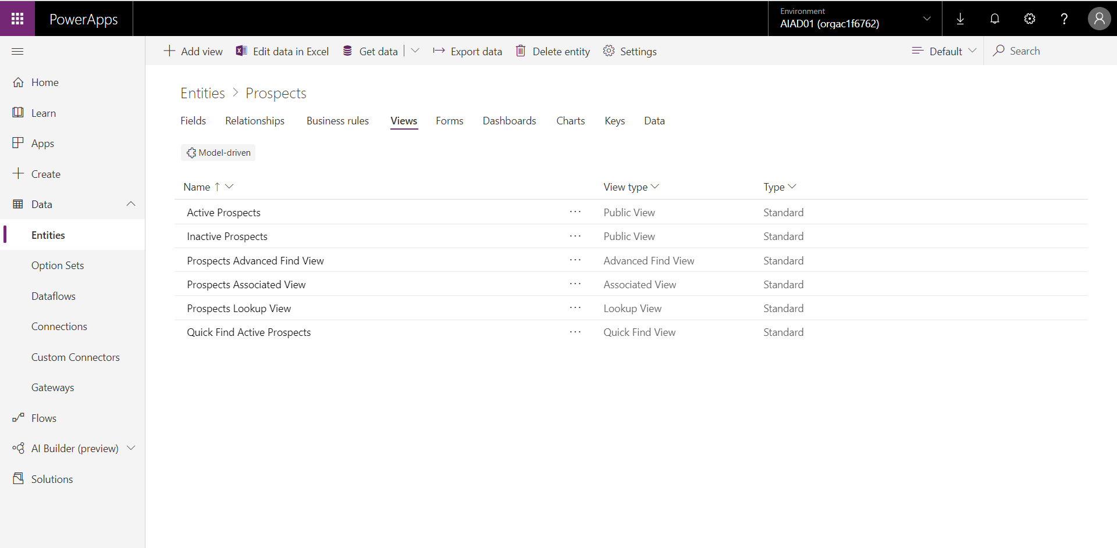

Open the “Active Prospects” view from the list.

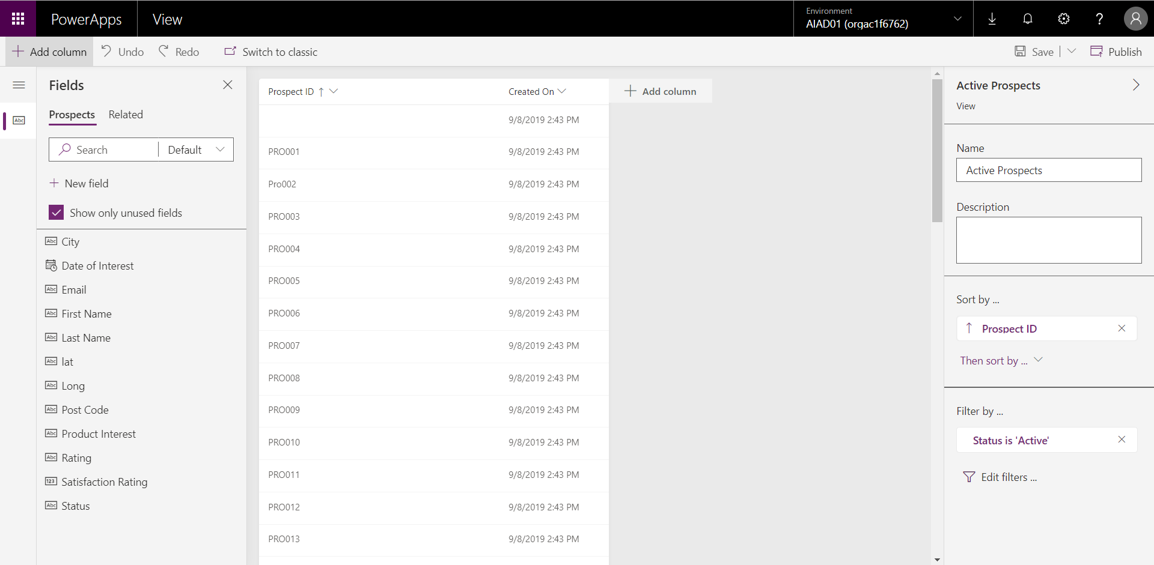

Drag and Drop the following fields into the main view hears section:

1. First Name
2. Last Name
3. City
4. Satisfaction Rating
5. Product Interest
6. Status

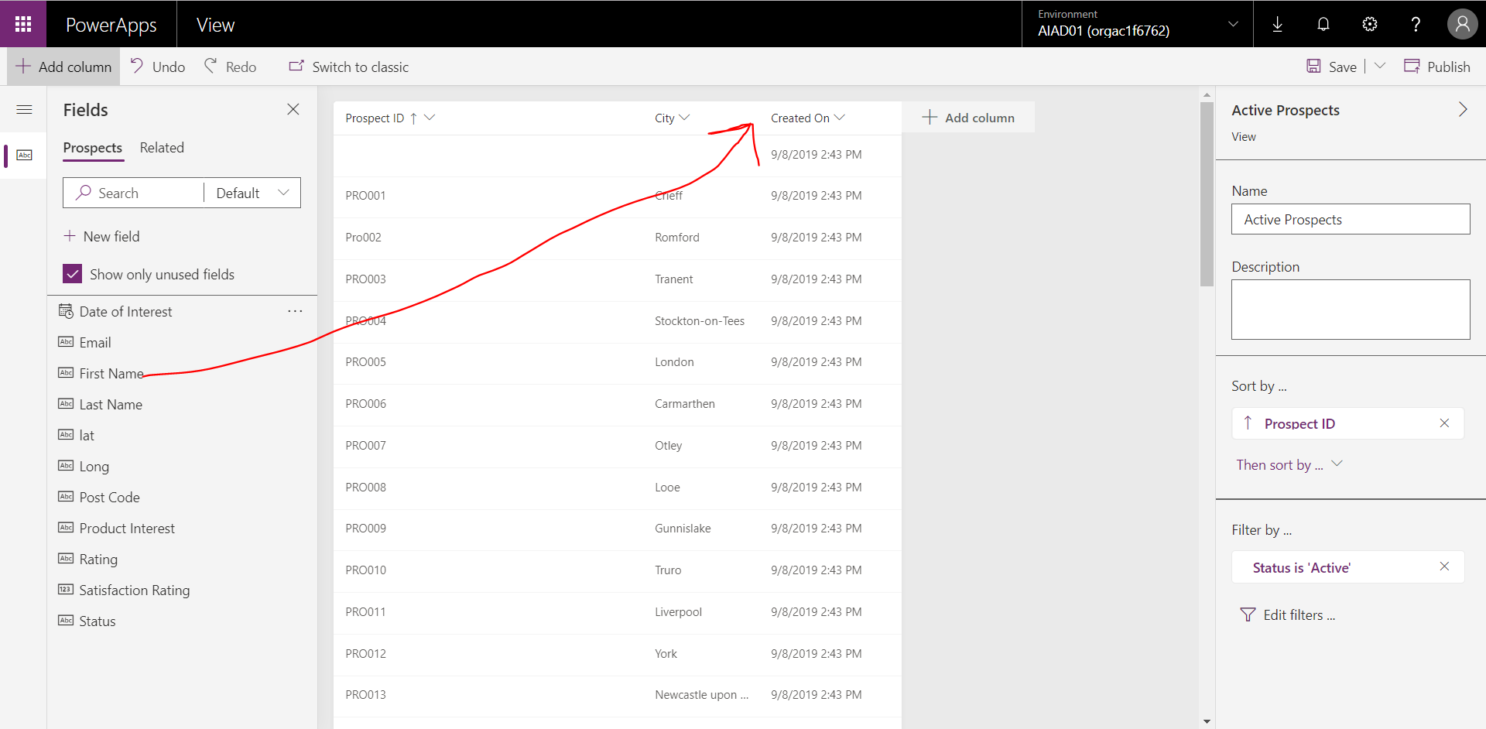

Resize the product ID column to a smaller size to make sure there is less white space in the view.

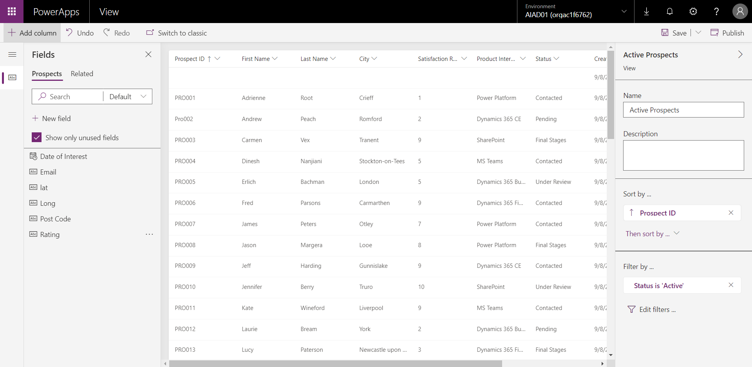

Save and Publish your changes to the “Active Prospects” view. Please do this before you navigate back to your main entity screen.

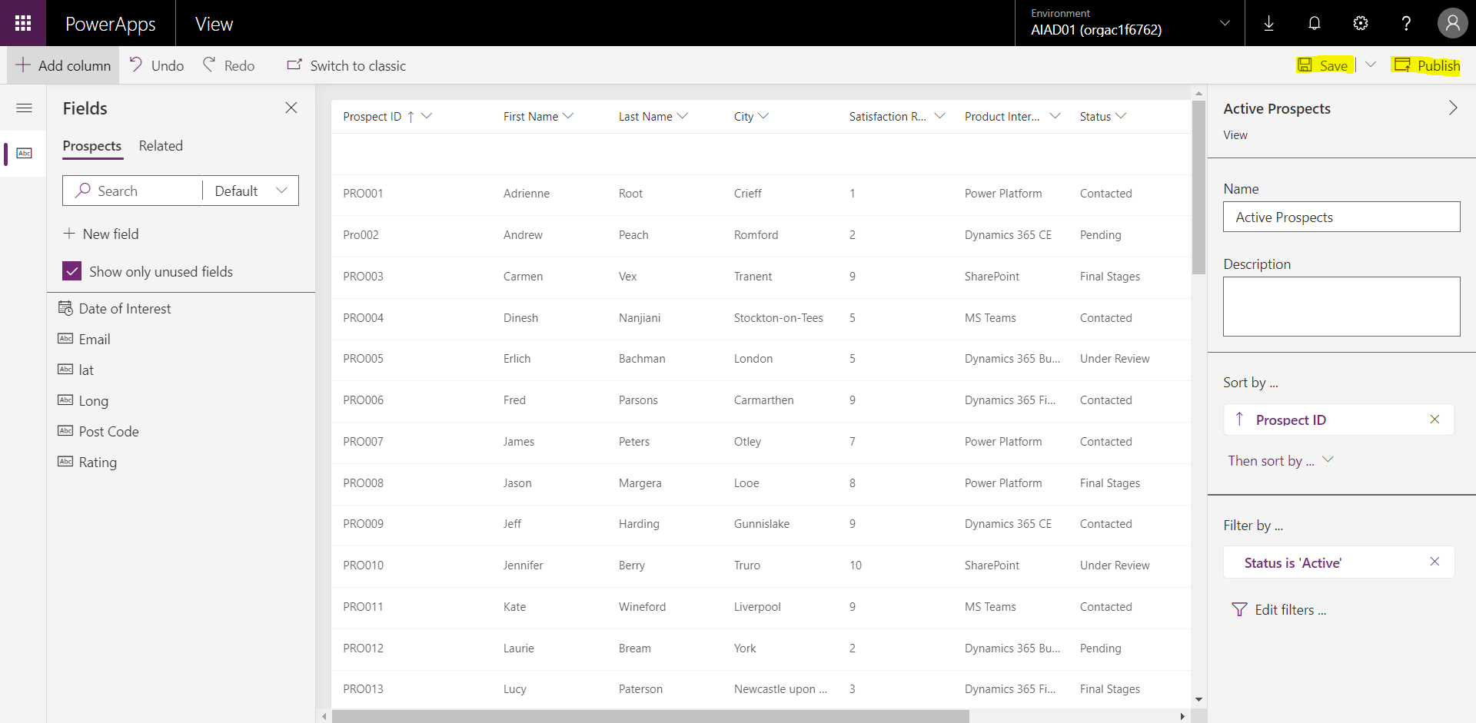

Once you have Saved and Published, use the back button in the browser to navigate back to the main entity screen.

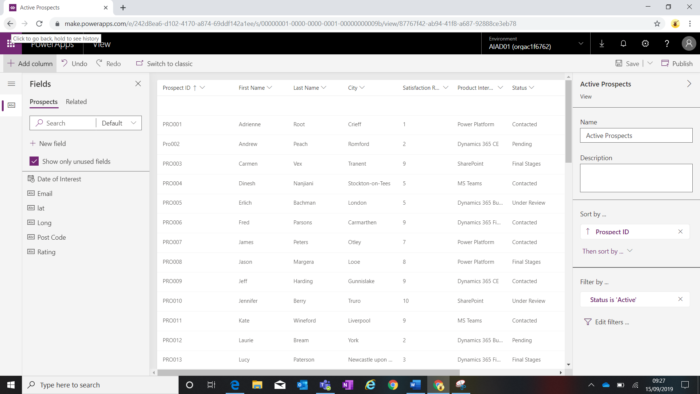

After navigating back, you will find yourself on the main entity where you can see a list of the views associated to the Prospect Entity.

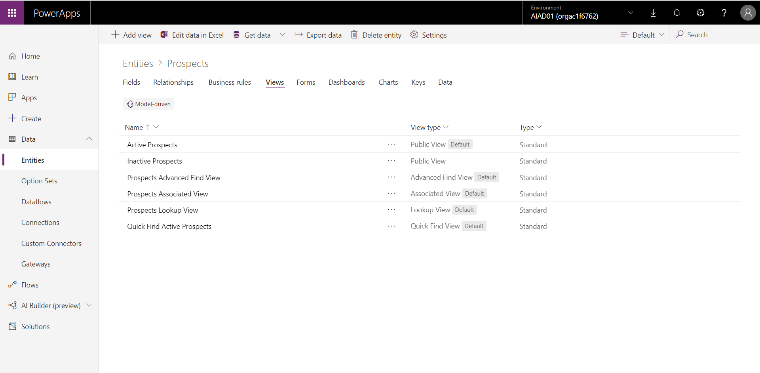

### Charts Configuration

Charts are a mechanism to enable users the ability to understand and interact with data in a more visual format. Select the “Charts” tab from the menu. You will see that there are no charts currently available within the Prospect entity.

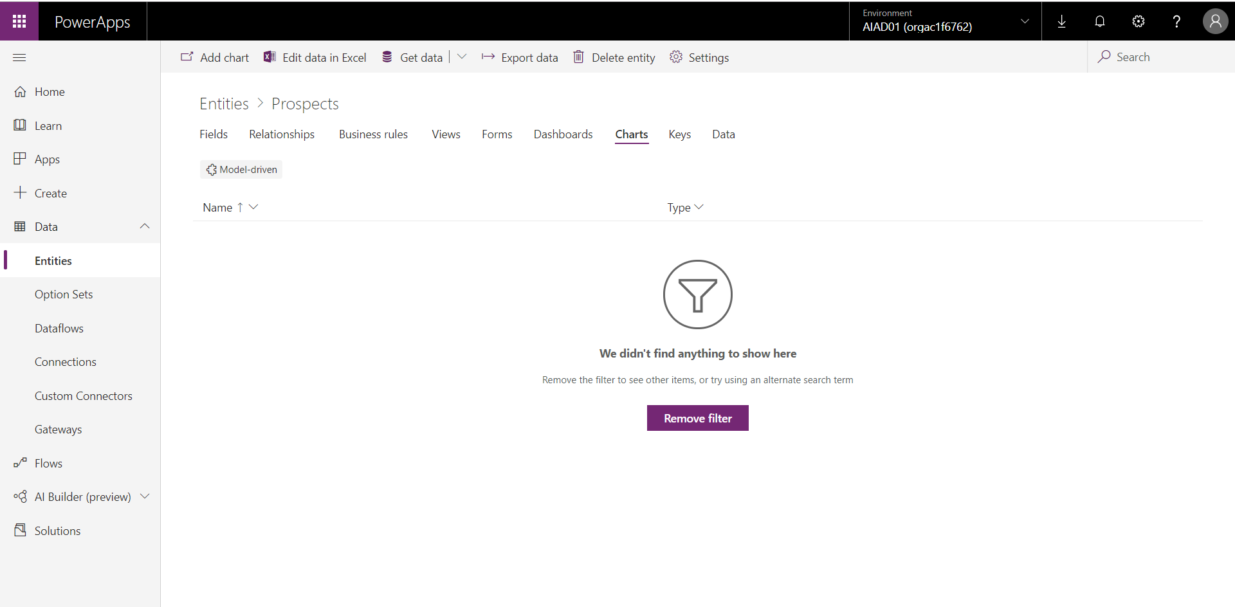

Let’s start by adding a new chart. Select “Add Chart” on the top left of the chart page.

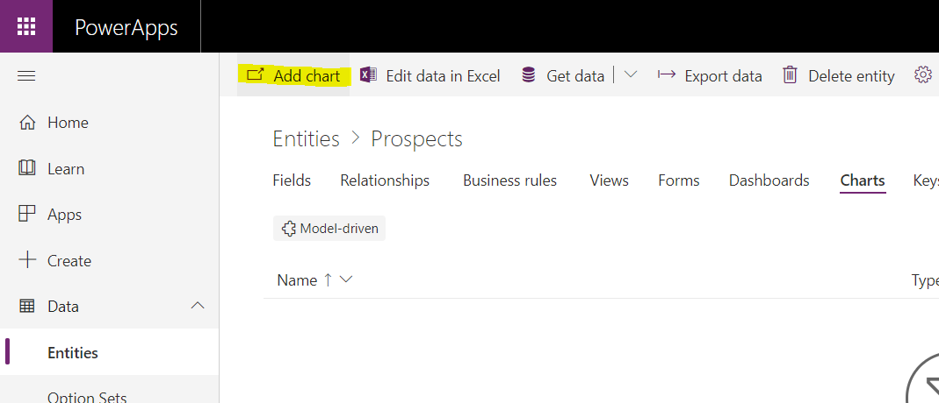

The Chart editor will open in a separate page.

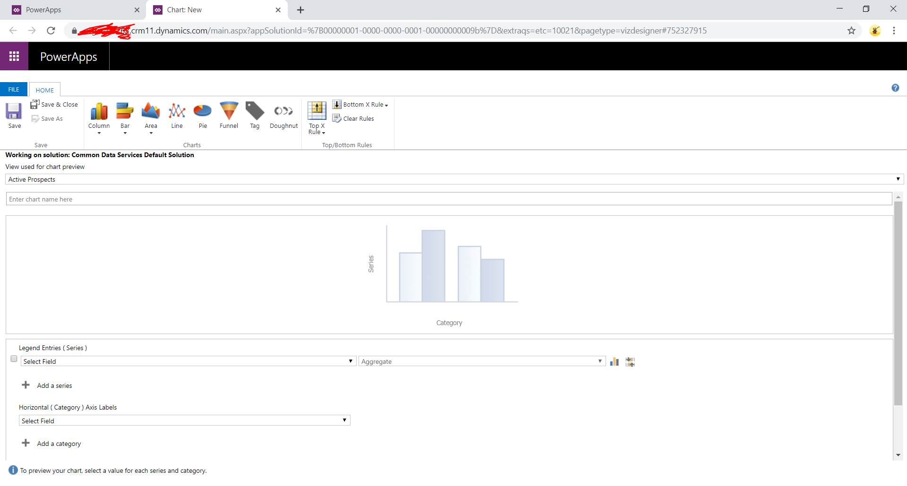

In the first chart we are going to display the number of prospects interested in different product types. Select the following from the various option sets:

1. View : “Active prospects”
2. Legend Entries : Prospect ID
3. Horizontal Axis Labels : Product Interest
4. Count : All
5. Chart Type : Pie Chart

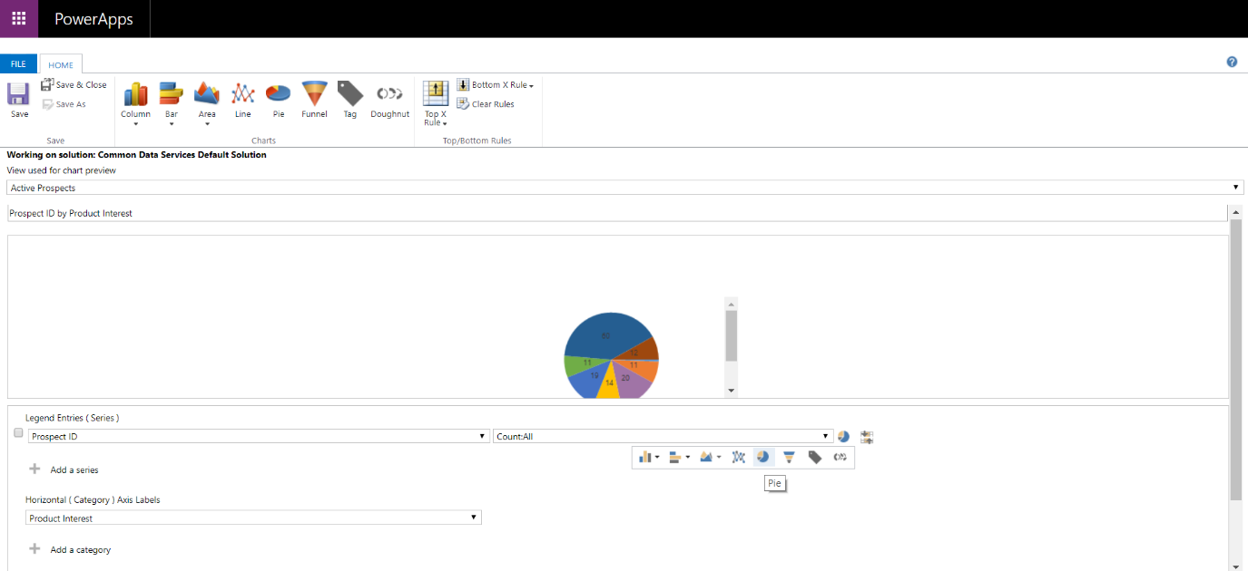

Once you have completed the above steps, select “Save & Close”.

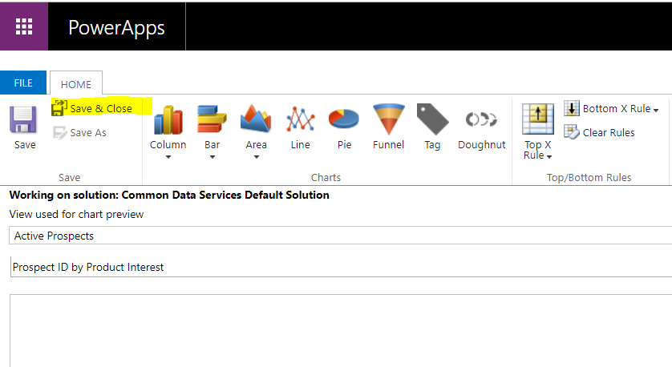

After saving, you will be navigated back to the Chart screen within the entity, where you will see that a new chart is being created. Select “Done”.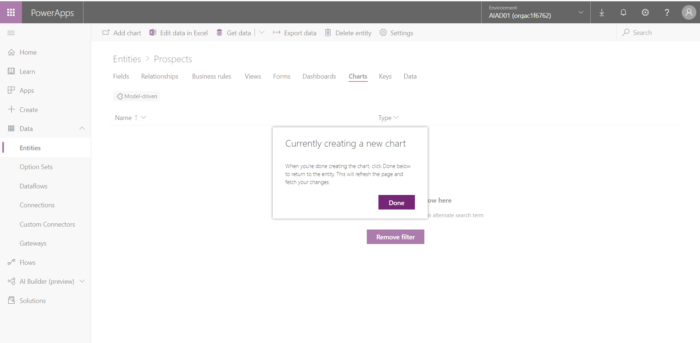

You can now see your chart in the chart list.

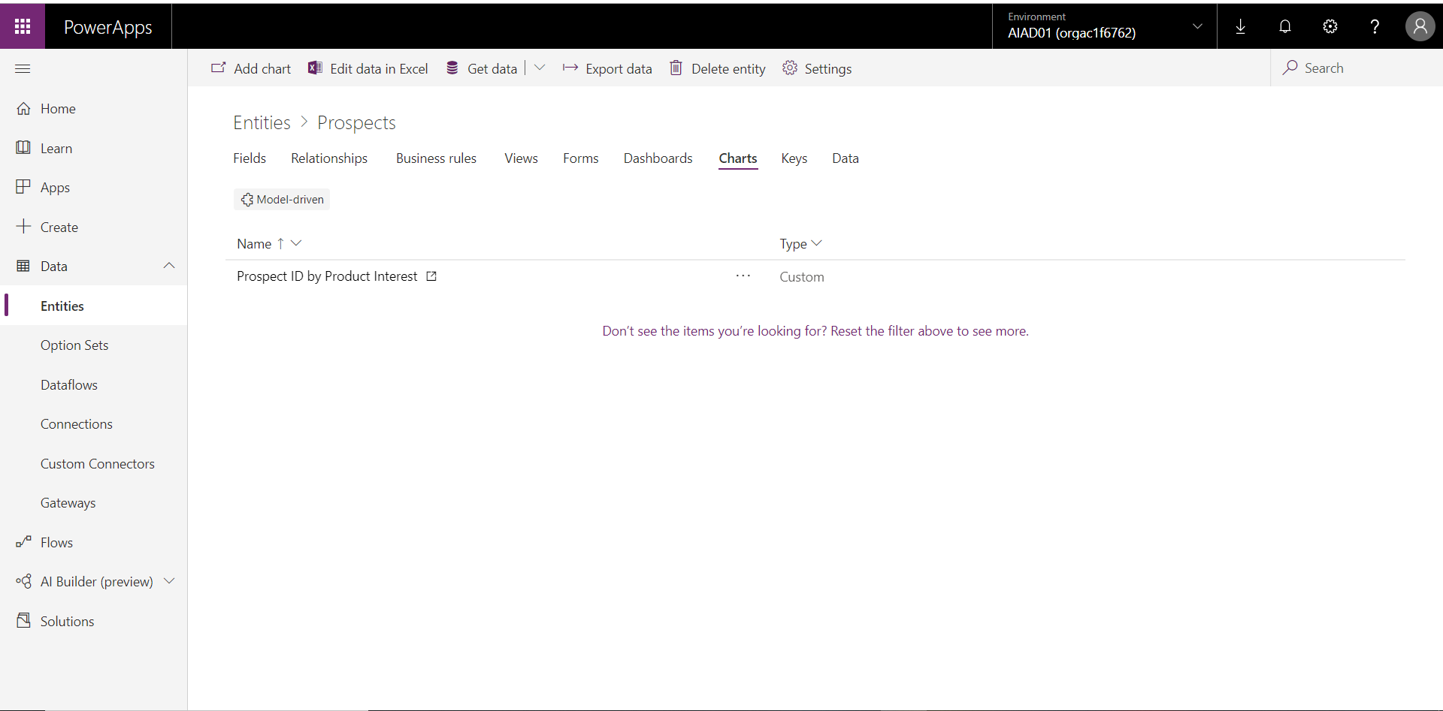

Follow the same steps as above to **create 2 more charts**:

In this chart we are going to display the number of prospects currently within a certain status type. Select the following from the various option sets:

1. View : “Active prospects”
2. Legend Entries : Prospect ID
3. Horizontal Axis Labels : Status
4. Count : All
5. Chart Type : Bar Chart

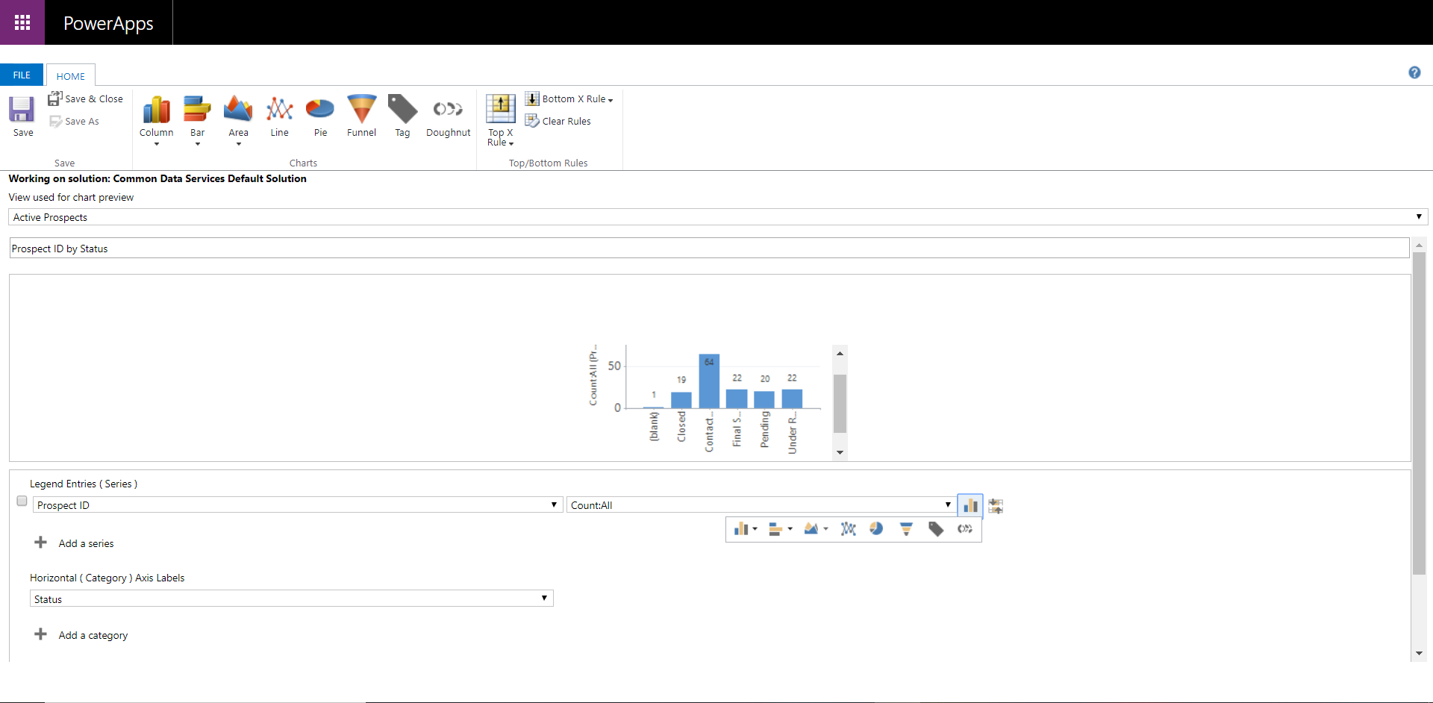

In this chart we are going to display the rating of prospects by the date of interest (Month). Select the following from the various option sets:

1. View: “Active prospects”
2. Legend Entries: Rating
3. Horizontal Axis Labels: Date of Interest (Month)
4. Count: All
5. Chart Type: Area Chart

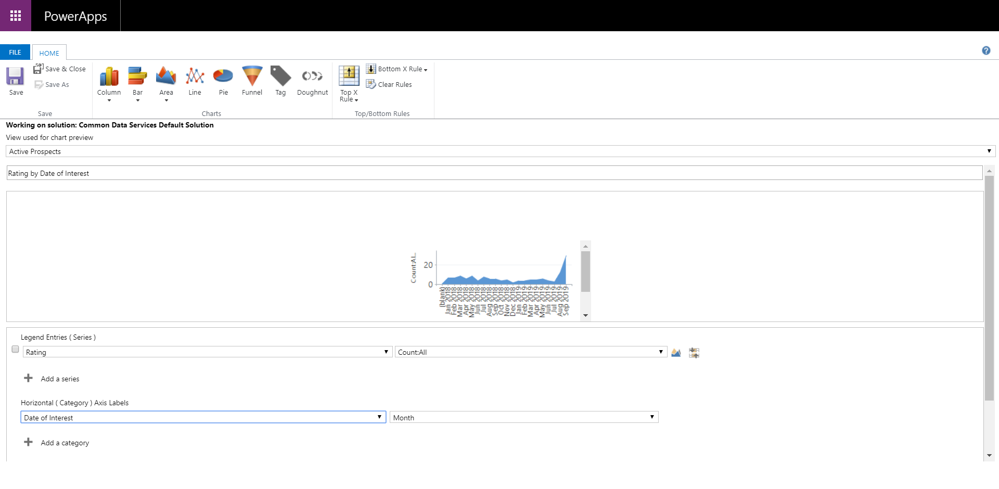

After completing this you should have 3 new charts in your list:

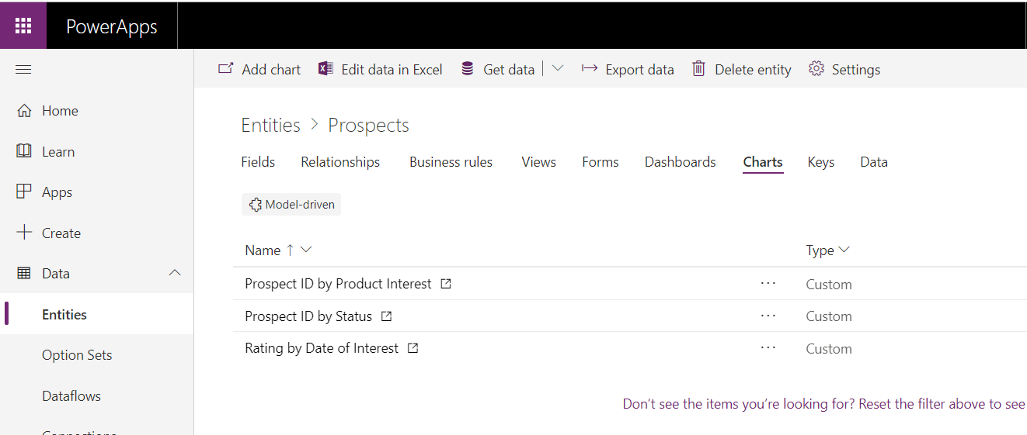

# Lab 3: Configuring your Business Process Flow and Model Driven App experience

In this lab we will configure a Model Driven application for the mid office users who will be controlling the collaboration with the Prospects and managing the flow of information

***Please Note:***

***Many of the elements in this lab are is reliant on the completion of Lab number 2. If you do not complete Lab number 2, the forms, graphs and views will not work in the same way. This is especially relevant in the Dashboards section.***

## Solution Components

PowerApps (Model Driven Applications)

Microsoft Flow : Business Process Flow

PowerApps (Classic Dashboards)

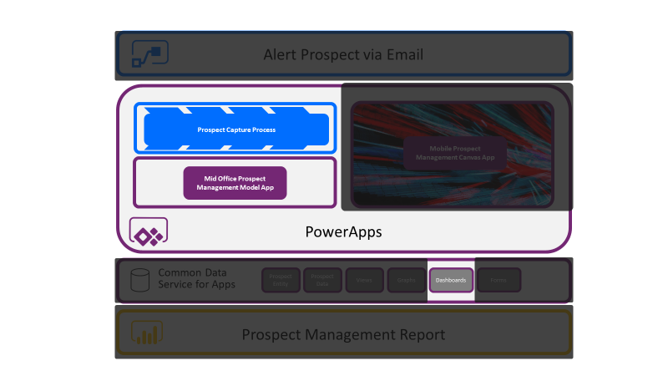

## Let’s Begin

### Business Process Flow

We will be creating a basic step by step process for the mid office user to follow when interacting with the prospect data captured by the sales user at the event.

Navigate to make.PowerApps.Com and navigate to “Flows” from the left-hand menu, then select “business Process Flows” from the tabs at the top. Depending of if you decided to load sample data when you created your new environment, your list of Flows may or may not be empty.

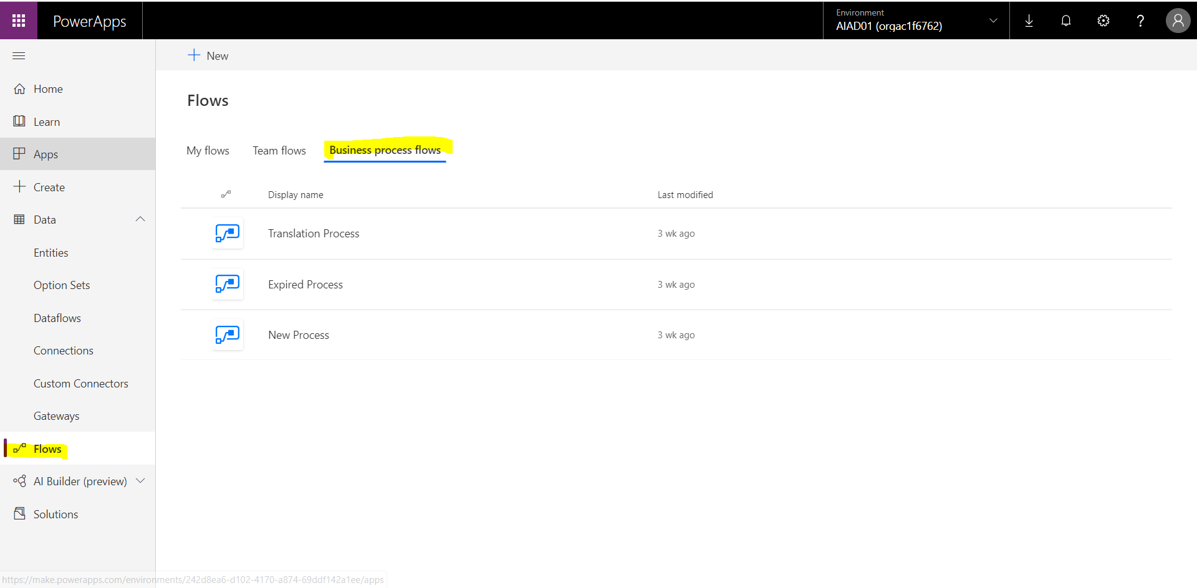

Select “New” at the top left of the Flows page to start creating a new Business Process Flow. Call the new process Flow “Prospect Management” and select the Prospect Entity. Select “next” to continue.

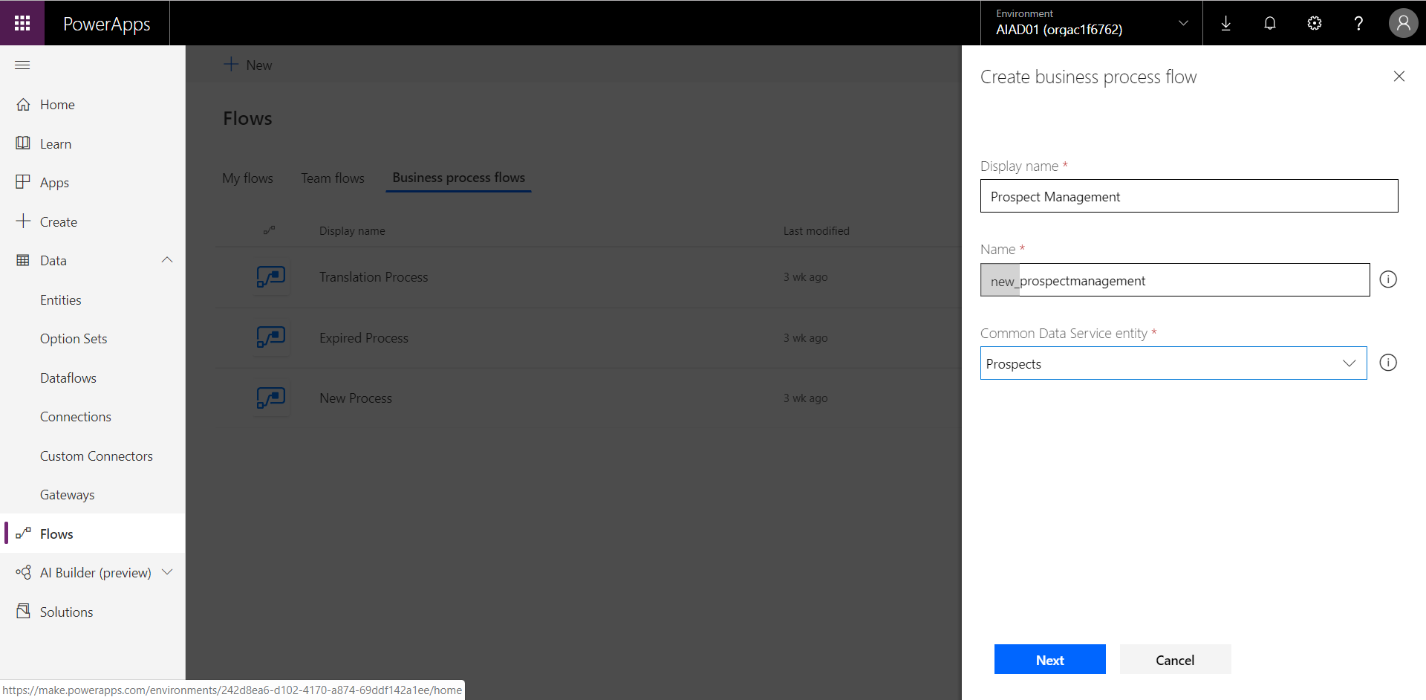

You will then be directed to a new browser tab that will expose the Flow Business Process Designer. The designer provides a drag and drop experience which really enables users to understand what the process will really look like.

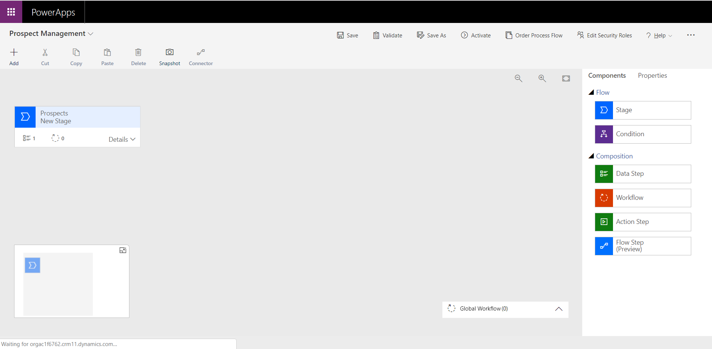

To start off configuring the Prospect Management process, select the first Prospects stage. On the right-hand side, in the “Properties” tab enter in the following information:

1. Display name : “Capture Data”
2. Category : Qualify
3. Entity : Prospects

You MUST hit the “Apply” button at the bottom of the properties tab.

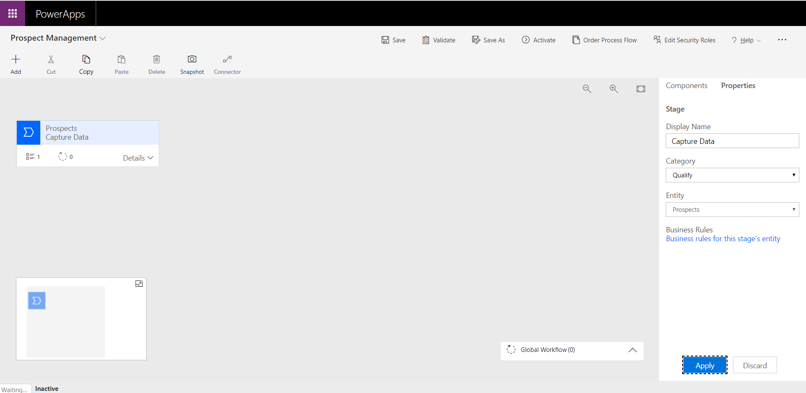

Expand the first stages details section to view the various Data Steps. Select the first Data Step to view the properties pane on the right-hand side.

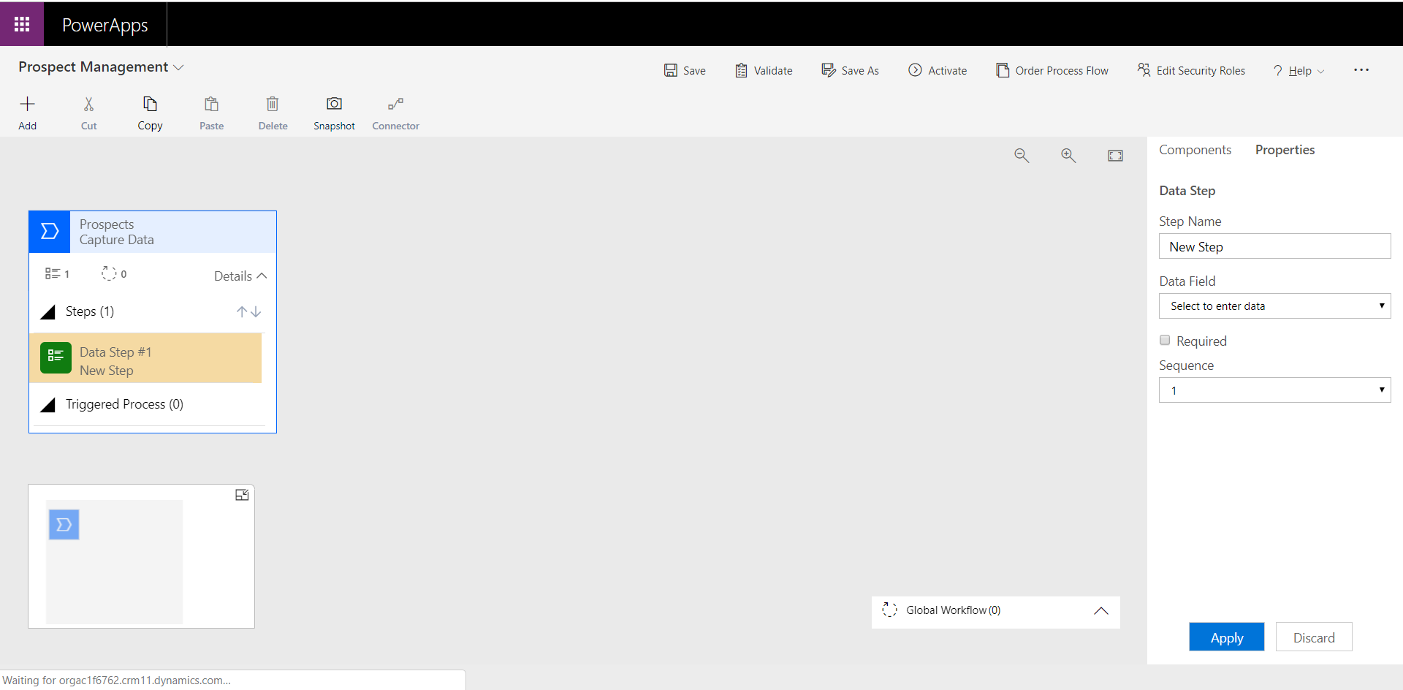

Expand the Data Field option set and select “First Name” value.

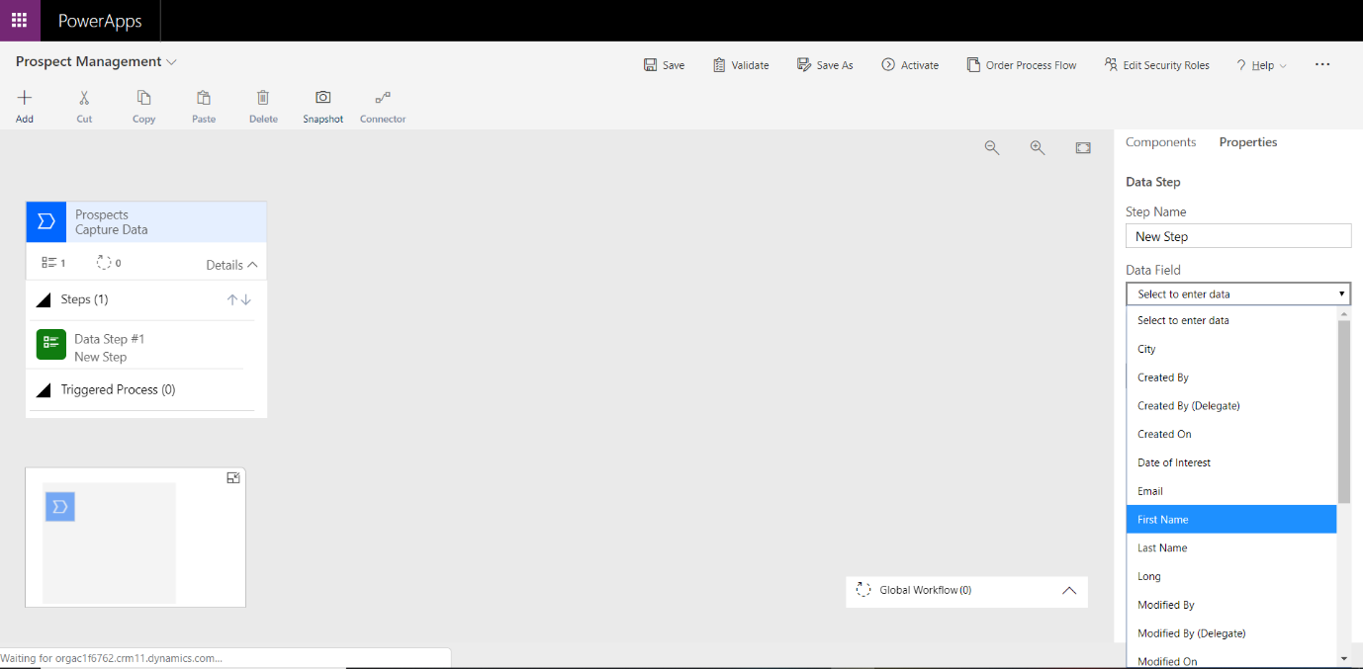

Once selected the “Step Name” property will automatically be changed to the value selected in the “Data Field” property. Select “Apply” at the bottom of the properties pane to apply this update to the data step.

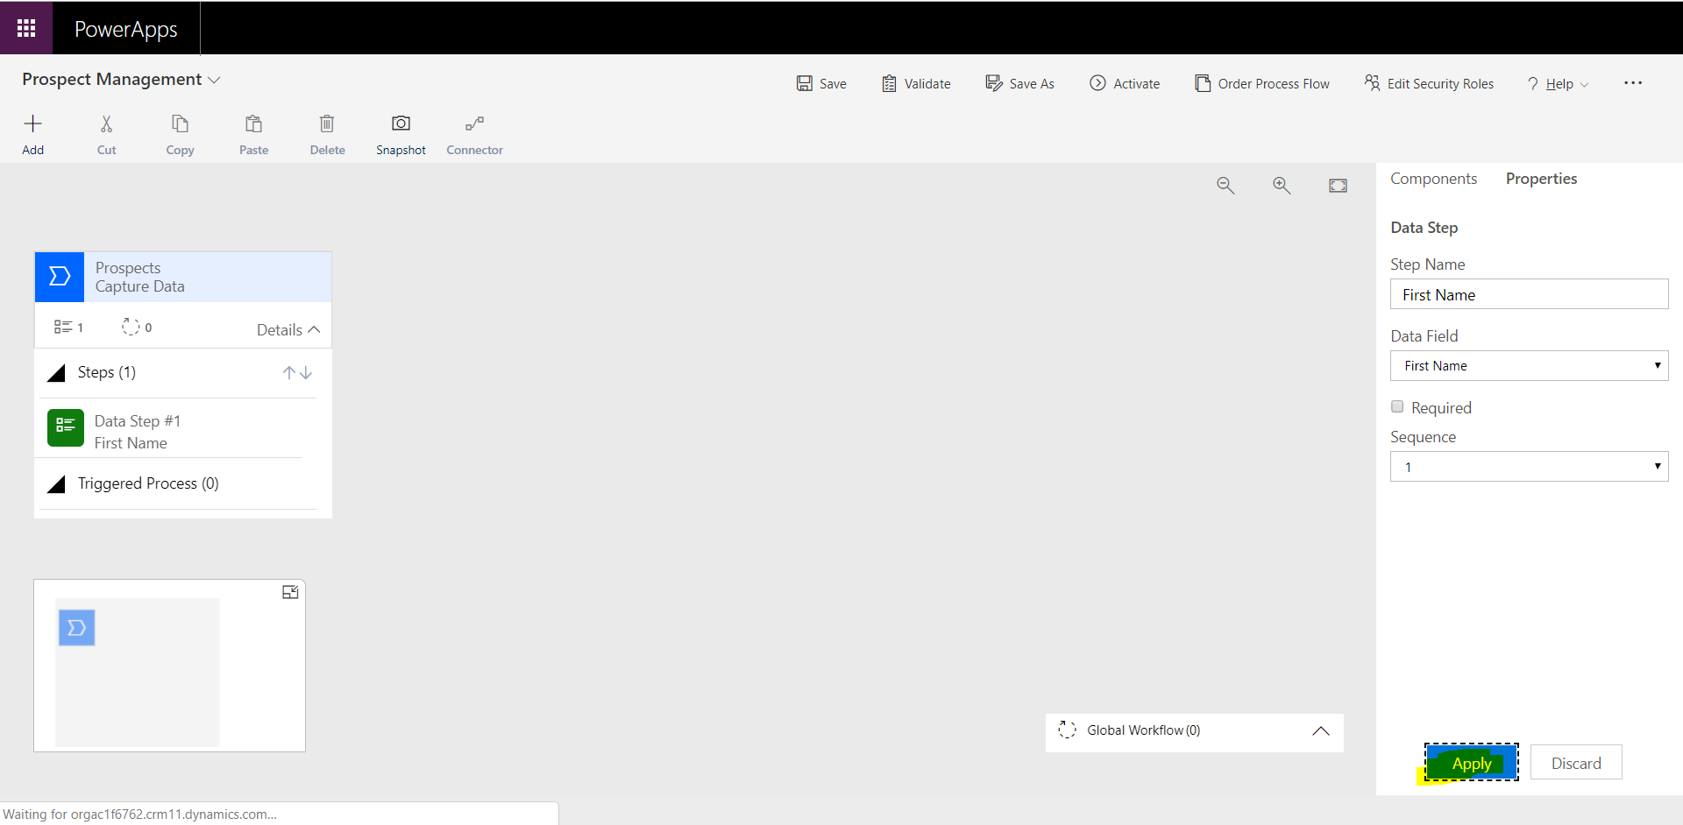

To add a new Data Step to the list of steps within the Process, drag a new Data Step into the area underneath the first step.

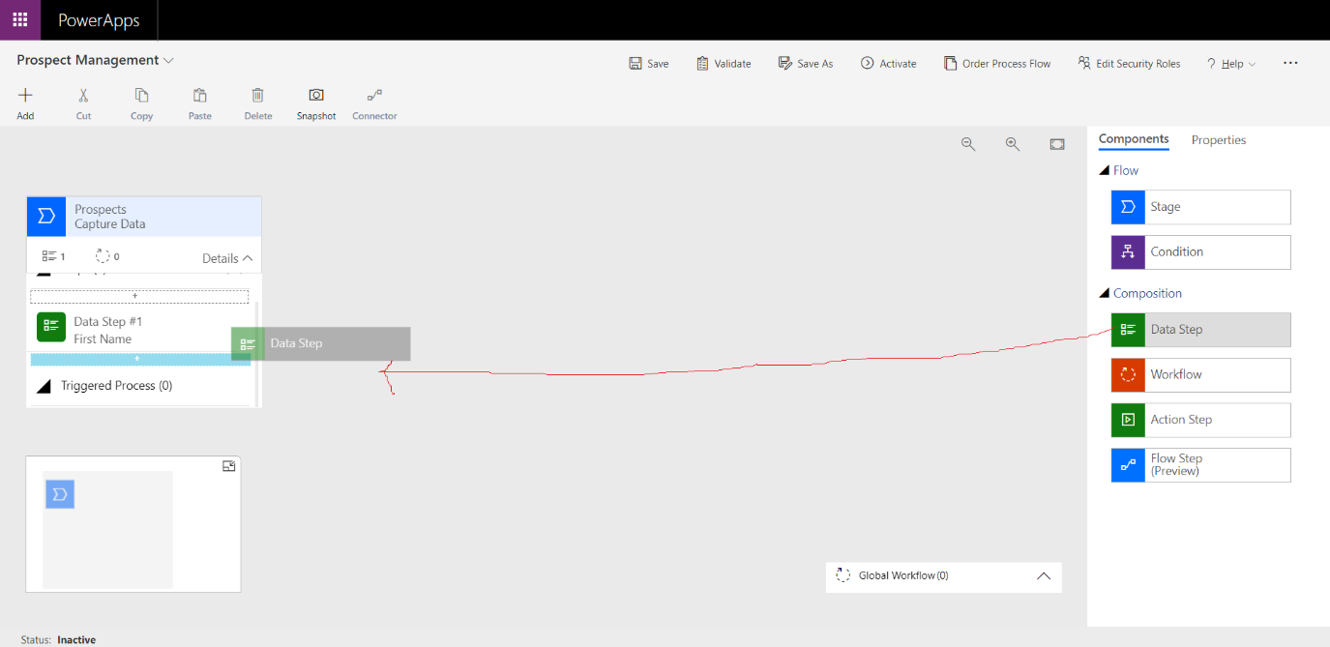

Select “last Name” as the value in the “Data Field” property. Apply this change using th3 “Apply” button at the bottom of the properties pane.

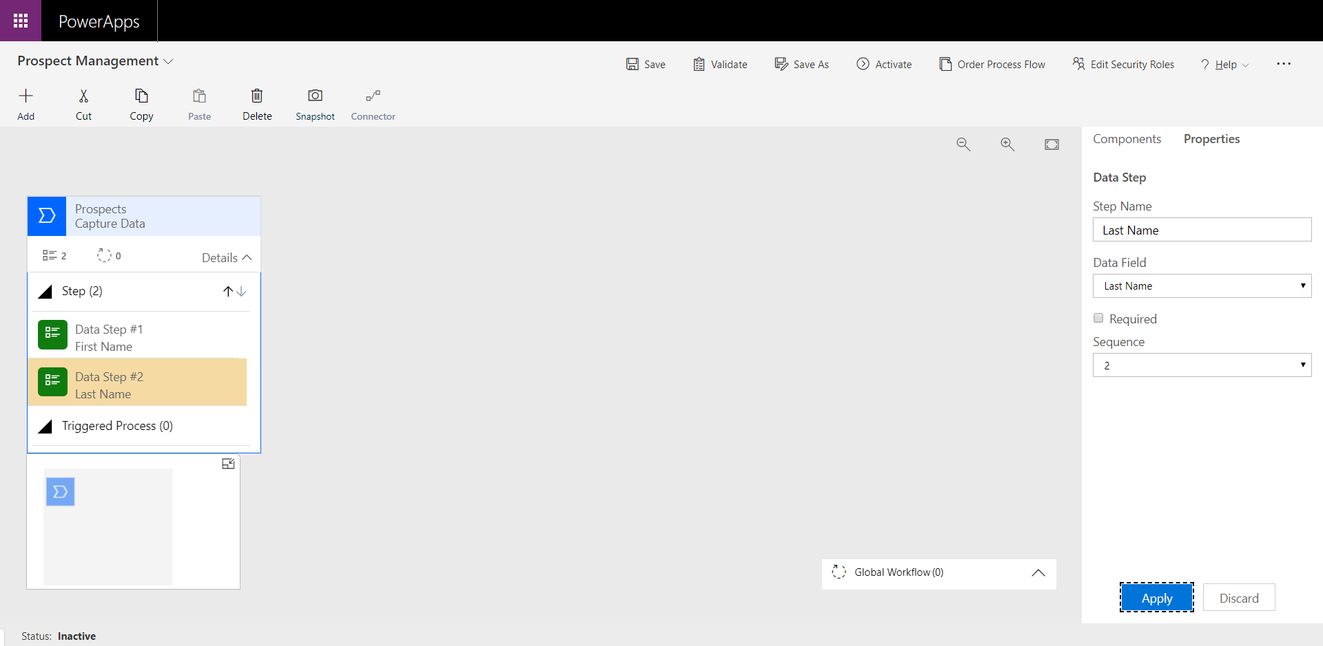

Follow the Exact same process as above by adding the below data steps to the first stage:

1. City
2. Email Address
3. Prospect ID

Save your Business Process flow by selecting “Save” from the toolbar at the top of the page.

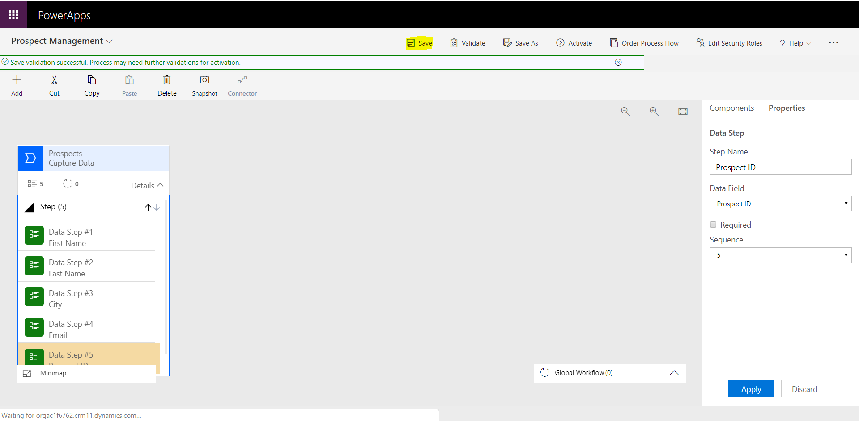

You are now ready to add another stage to your Business Process Flow. Select the “Components” pane from the right-hand side of the page and drag a new stage into the area on the right of the first “Capture Data” stage.

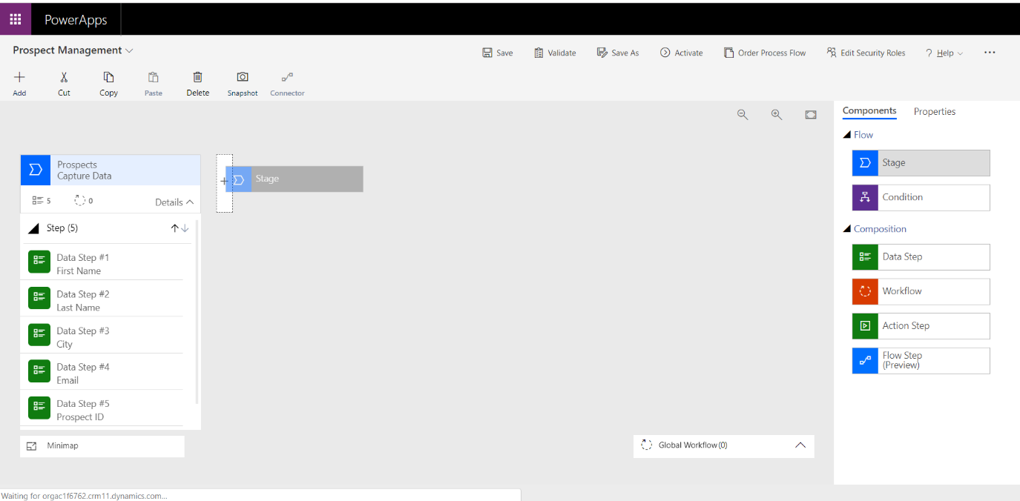

Update the new stage properties with the following information:

1. Display name: “Develop Prospect”
2. Category: Develop
3. Entity: Prospects

Make sure you Apply your changes before adding your data steps.

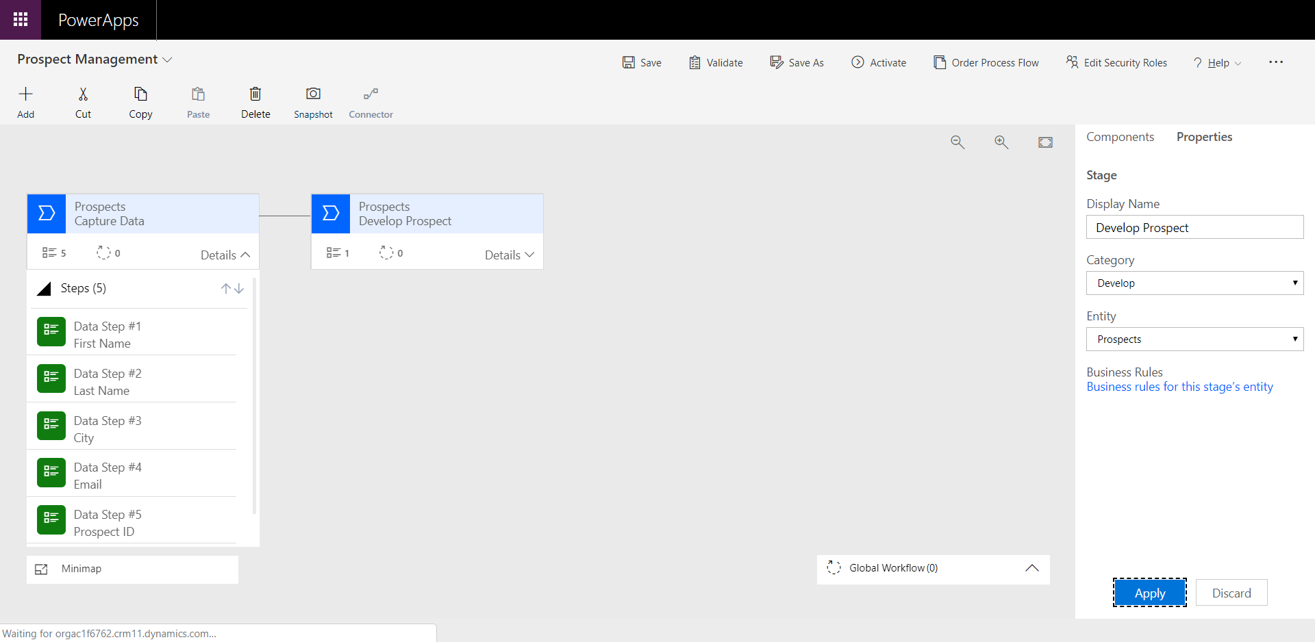

You now need to add new data steps. As in the previous data step addition section, add in the following Data Steps to this specific stage:

1. Post Code
2. Date of Interest
3. Rating

To complete the process, add in one final stage by following the same process in the previous Process Stage addition section. Add I the following properties:

1. Display Name: “Complete Prospect”
2. Category: Resolve
3. Entity: Prospects

Add in the following Data Steps:

1. Satisfaction Rating

Remember to Apply all changes on all stages and steps and save all changes to the process.

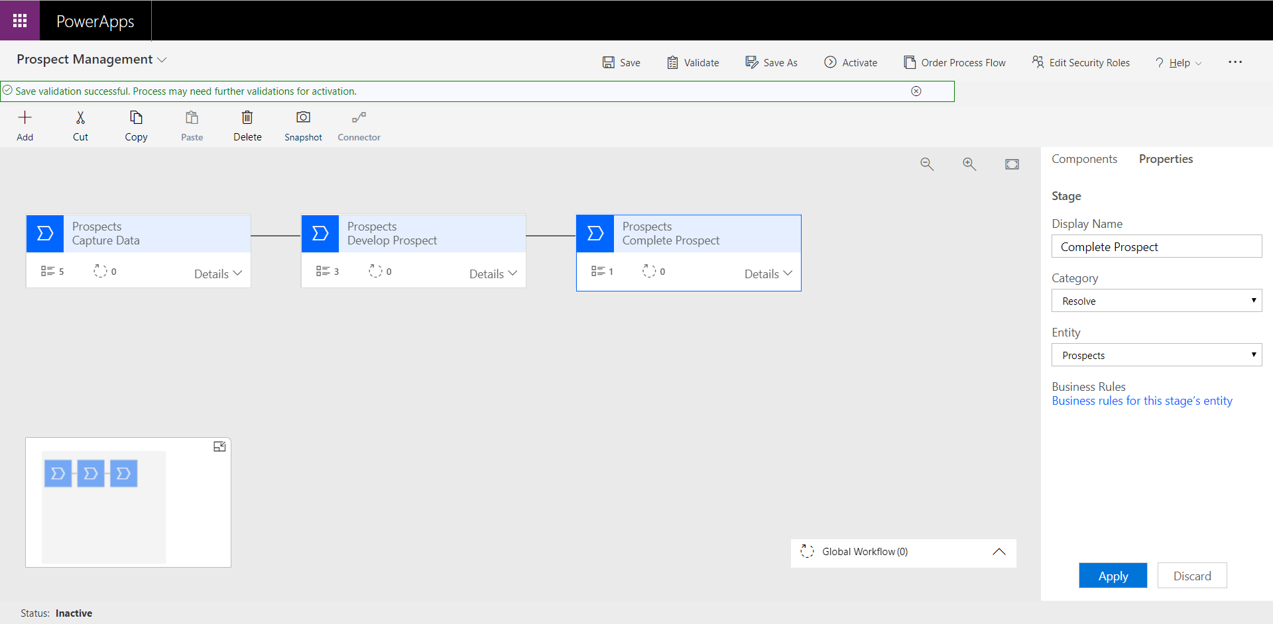

Finally, to activate the business process flow, select the “Activate” button from the toolbar.

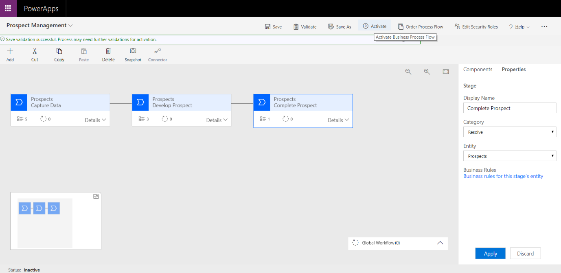

This will start the activation process. Select “Activate” from the popup.

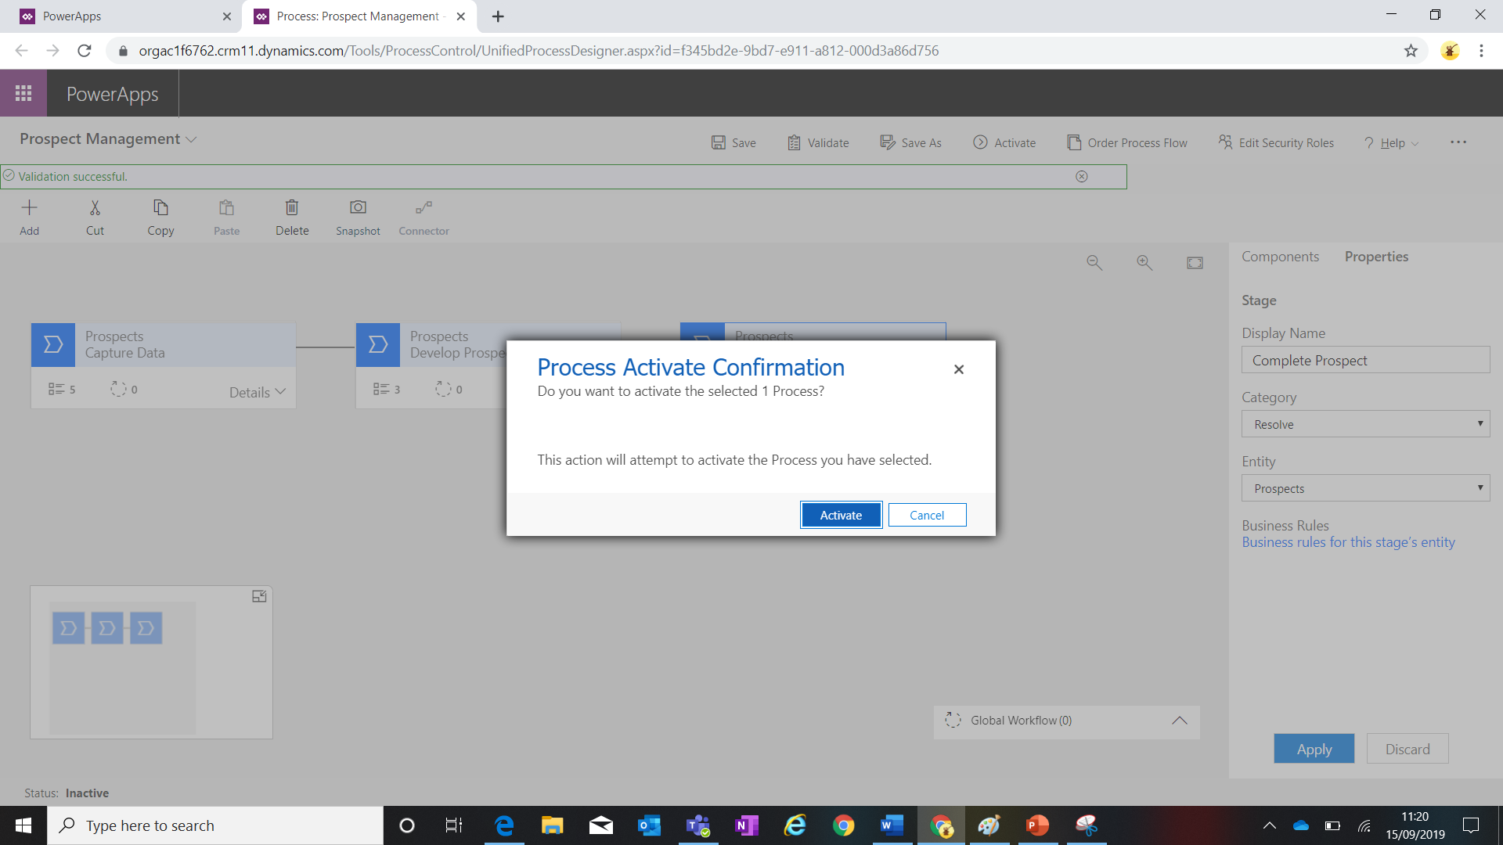

You will see the process starting to activate.

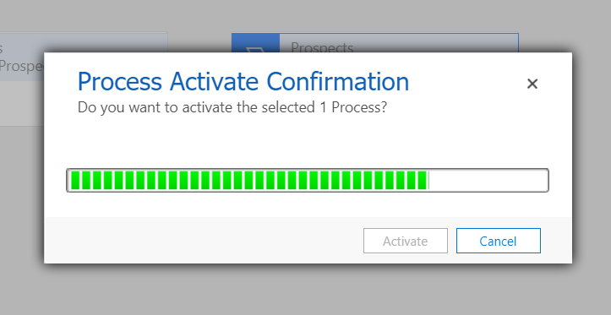

Once activated the “Deactivate” button is then visible in the toolbar in the associated Business Process Flow.

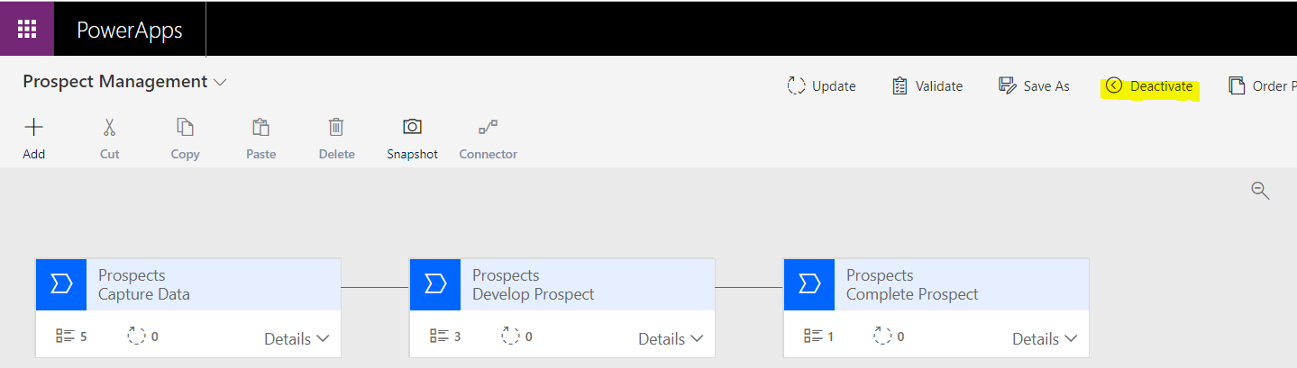

### Model Driven Application

Now that we have created the business process flow, we need to generate the Model Driven Application that will display this to the mid office user.

Open the maker Experience at “make.PowerApps.com” and Navigate to the Apps section in the menu on the left.

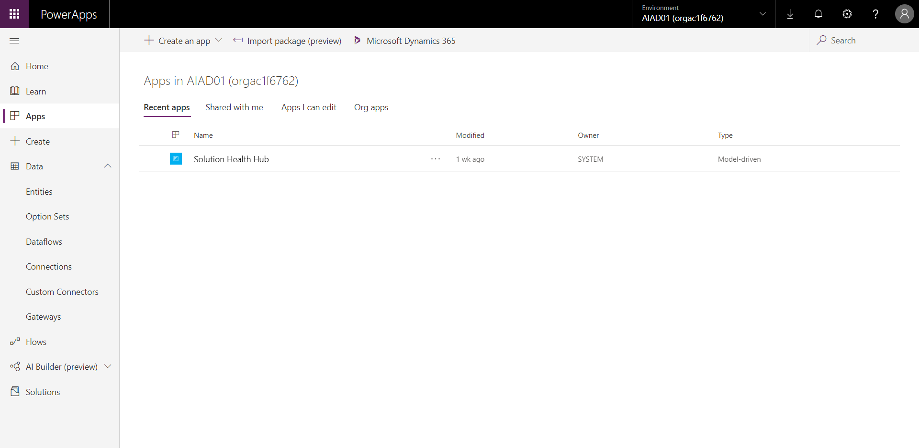

To create a new Model Driven Application, select “Create an App” from the top left of the App screen and then select “Model Driven App”.

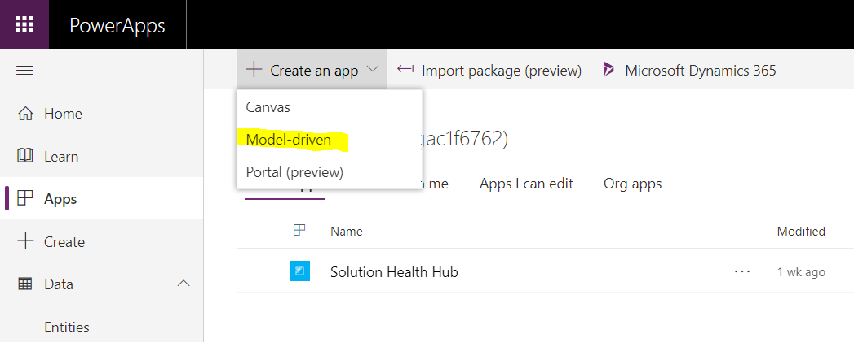

You will then be taken to a new browser tab where you are able to enter in the relevant model-driven application properties to create a new app.

Call the model-driven app “Prospect Management” and select the “Done” button on the right-hand side of the page.

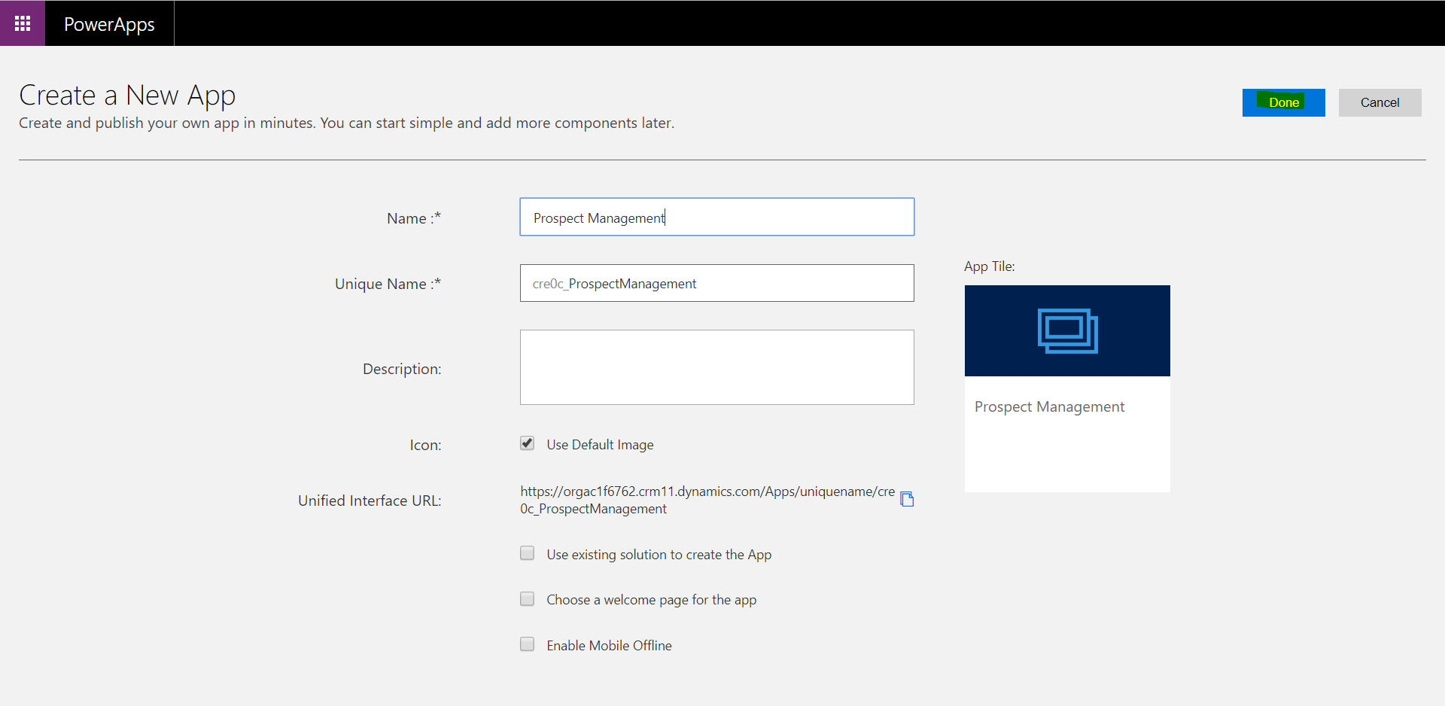

The model-driven app designer screen will be made available to you to begin designing your new app.

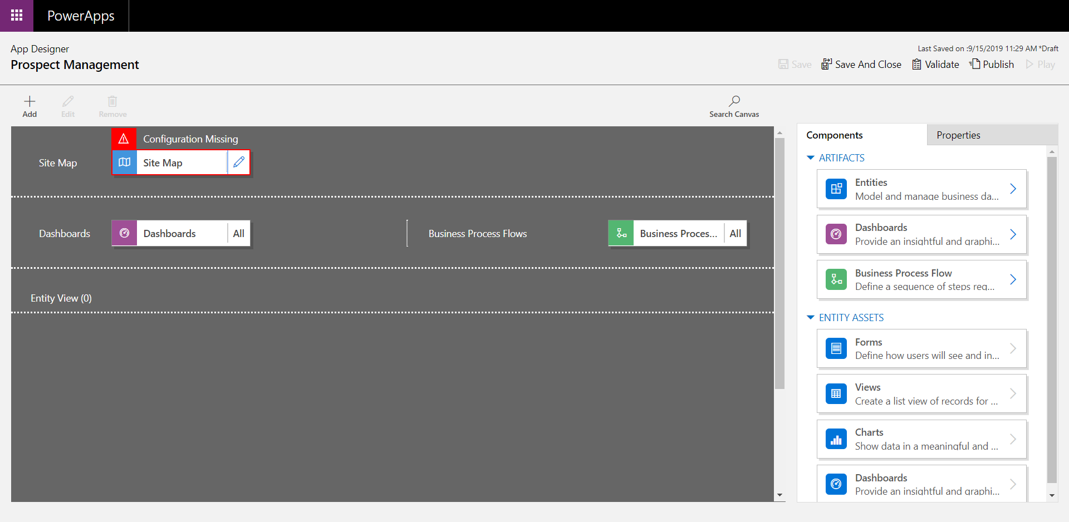

To begin designing your app select the “Edit” button on the right of the sitemap configuration node.

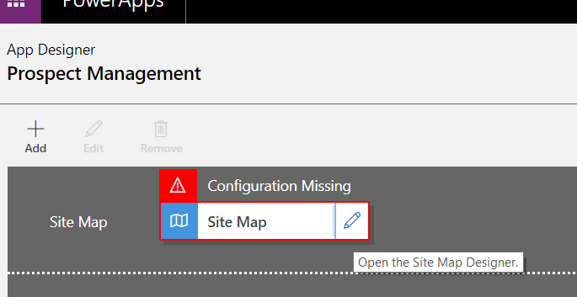

This will take you to the Sitemap designer. The experience is slightly similar t that of the business process flow designer. You can drag and drop components to the sitemap from the pane on the right of the page.

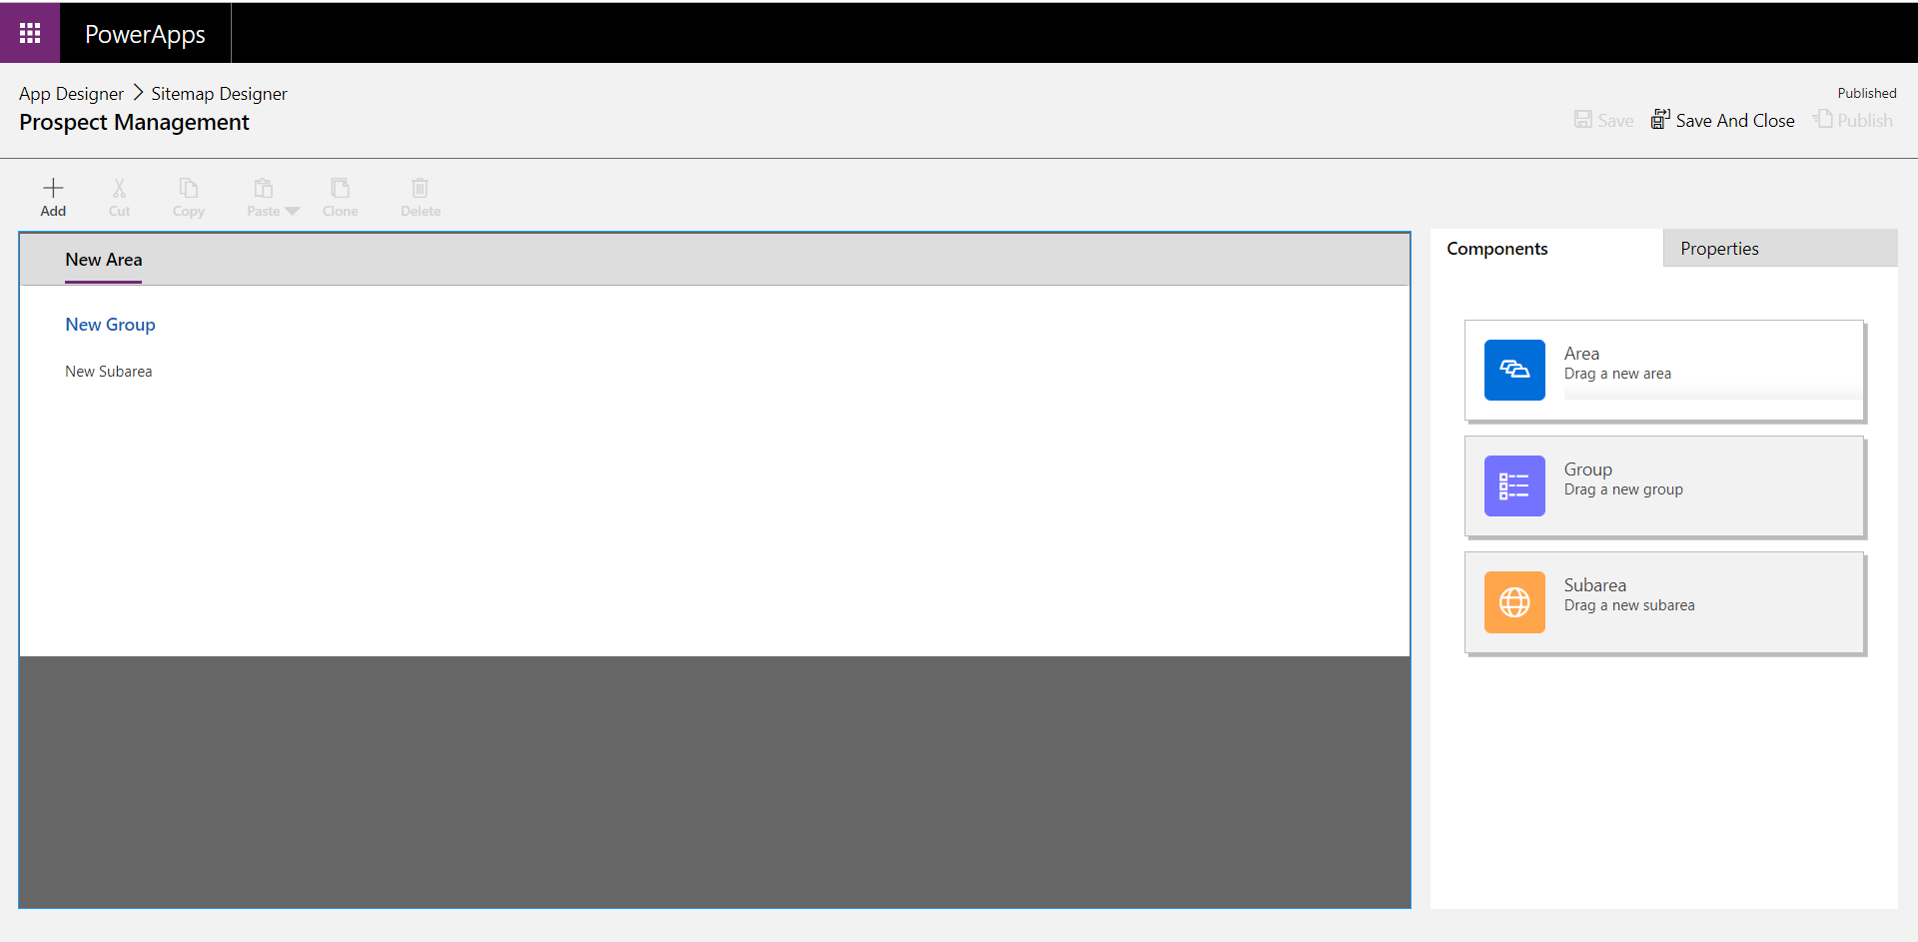

To start the configuration, select the “New Area” component in the sitemap.

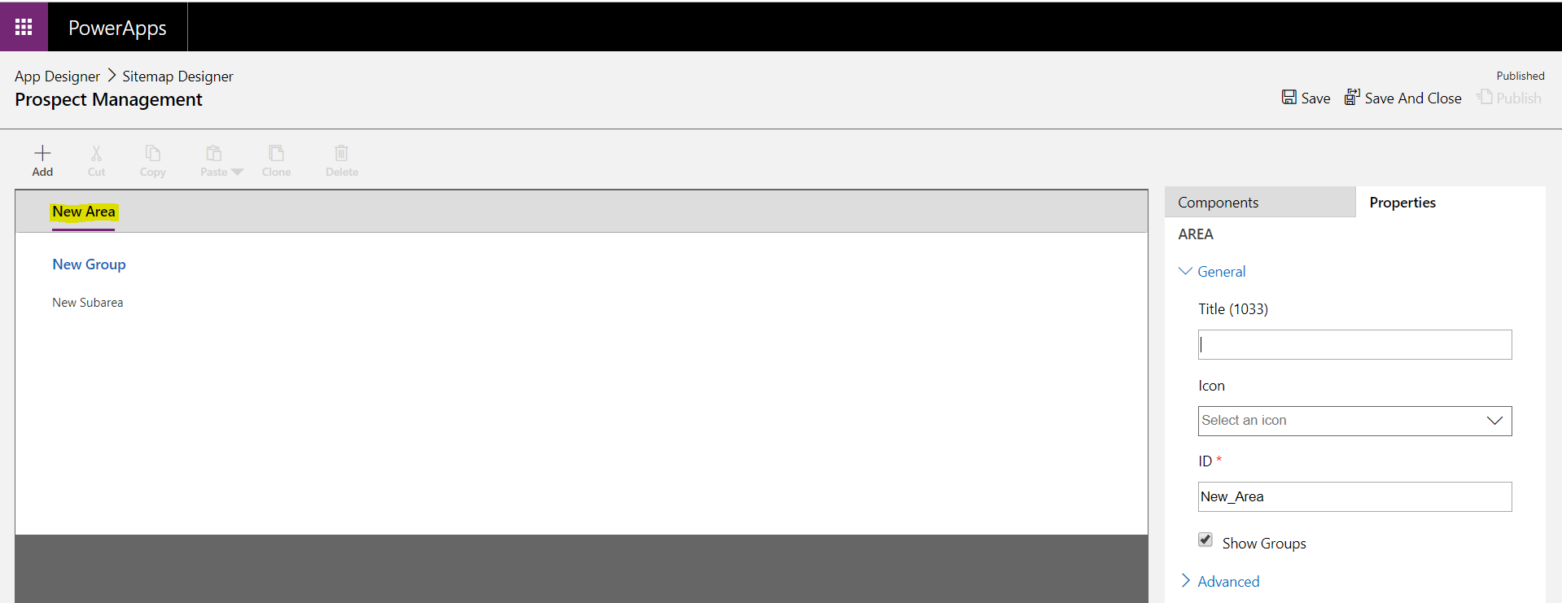

Change the Title to “Prospect Management”.

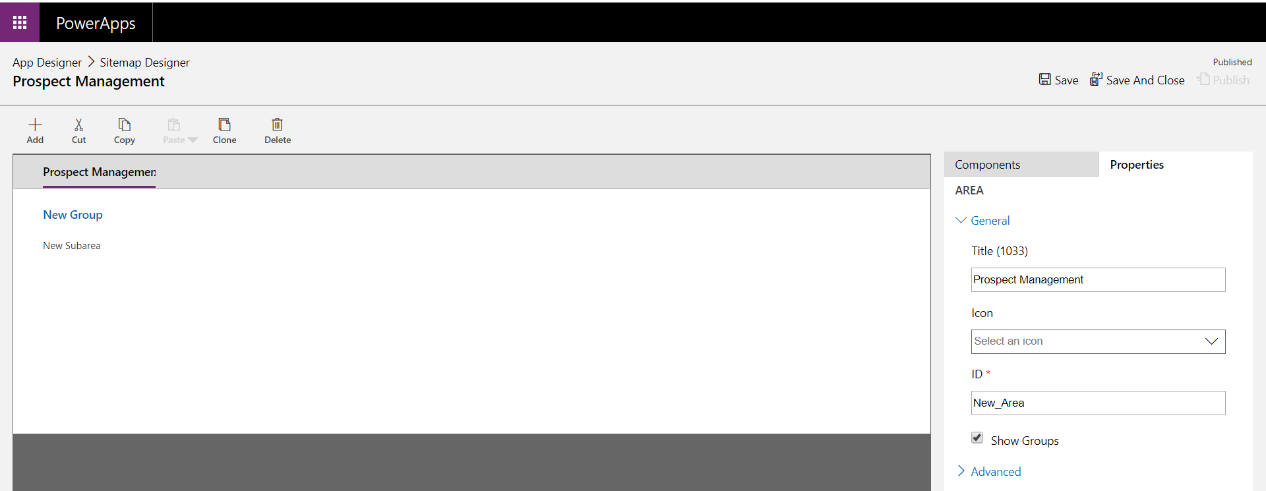

Select “New Group” and change this to “Management”.

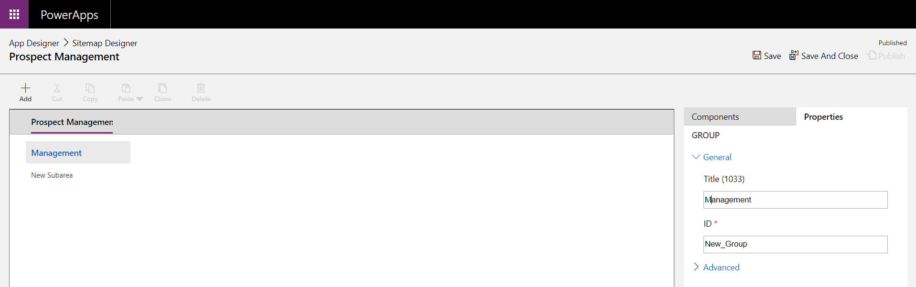

Select the “New Sub area” component

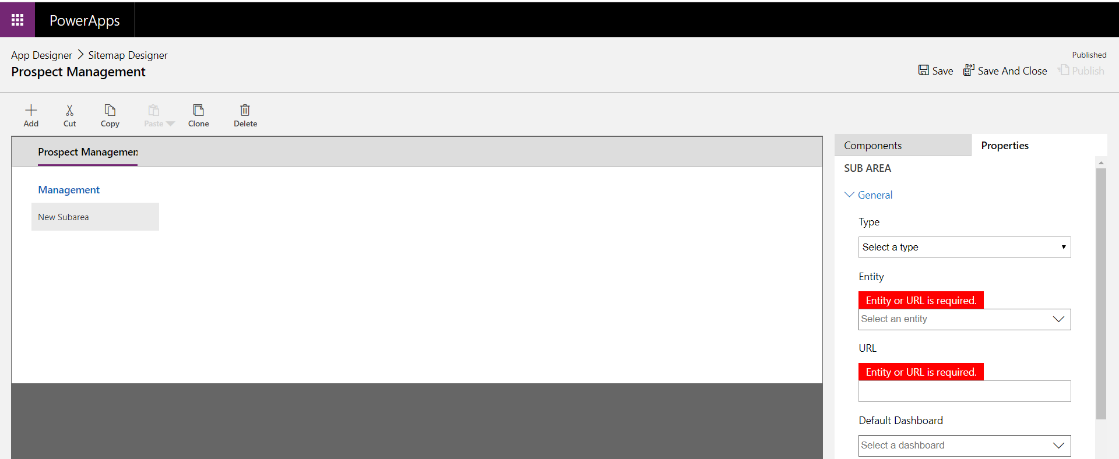

Change the Entity to “Prospects. (you may see another entity in there called Prospect Management, do not select this).

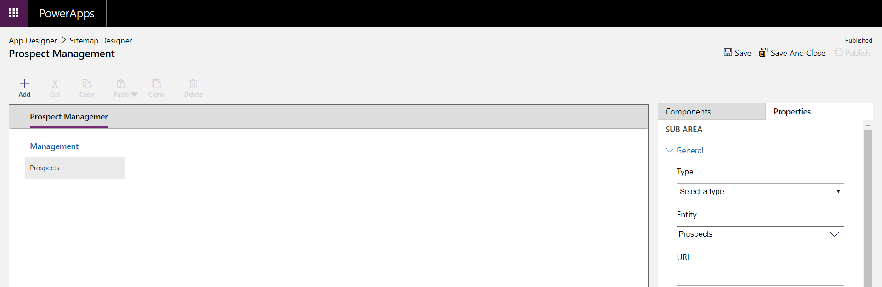

You are going to add a new “Sub Area” component to the Sitemap. Click o the “Prospects” sub area component that you just added. Navigate to the “Components” pane on the right-hand side of the page. You will see that the “Subarea” component is not greyed out.

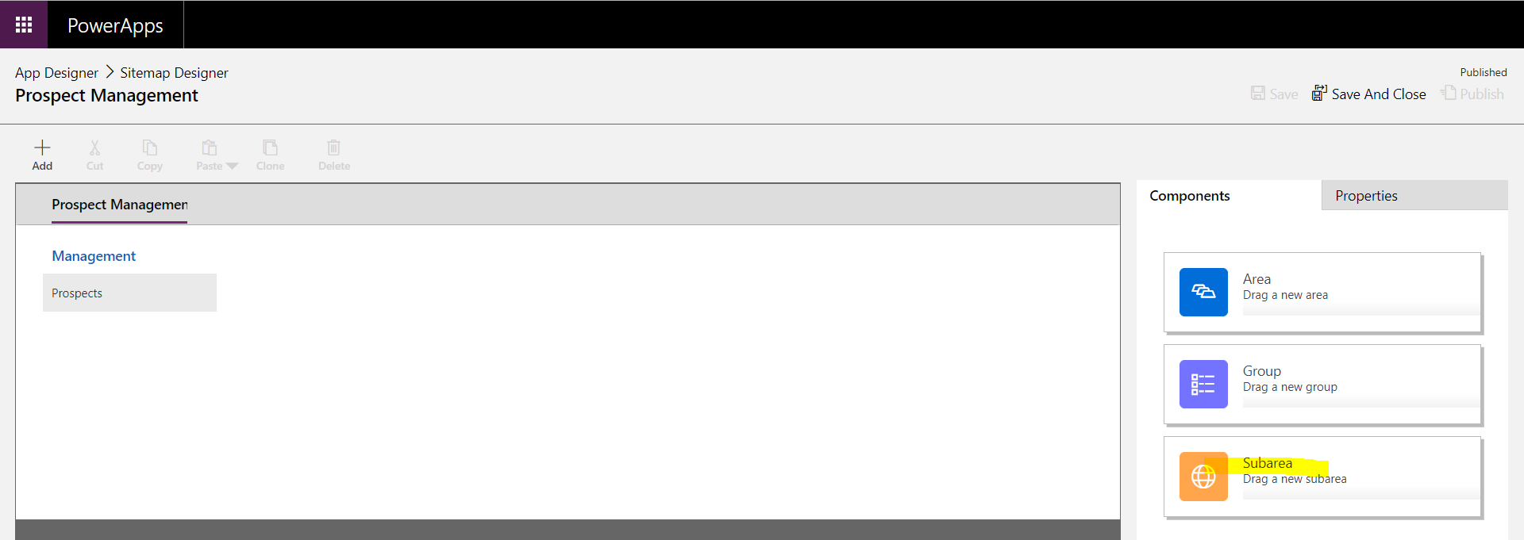

Drag and drop a new “Subarea” component under the Prospects component in the sitemap.

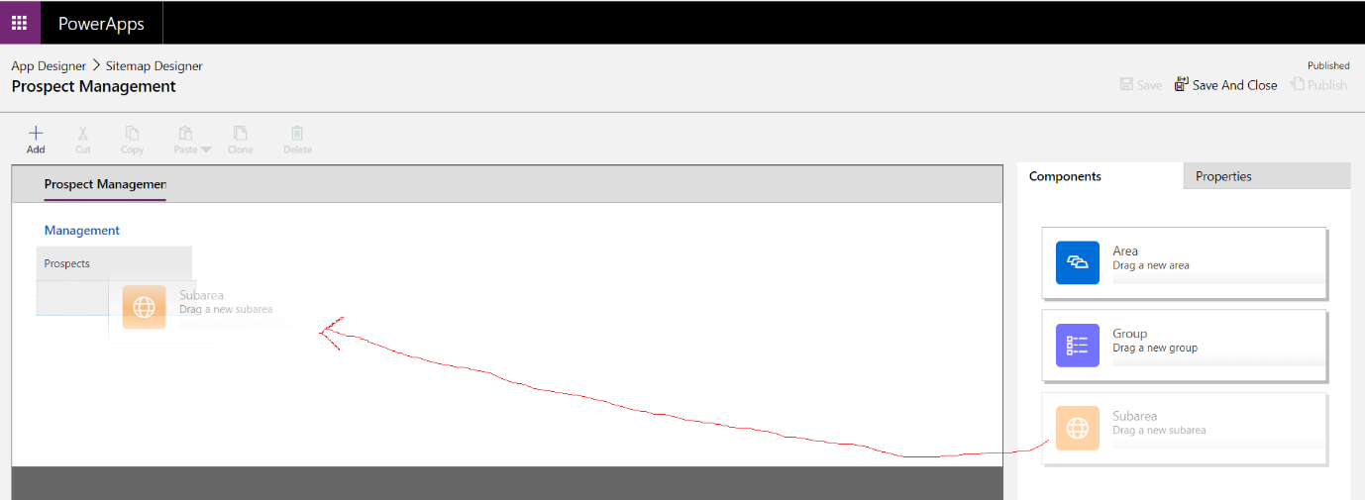

Update the following Subarea properties:

Type: Dashboard

Title: “Dashboards”

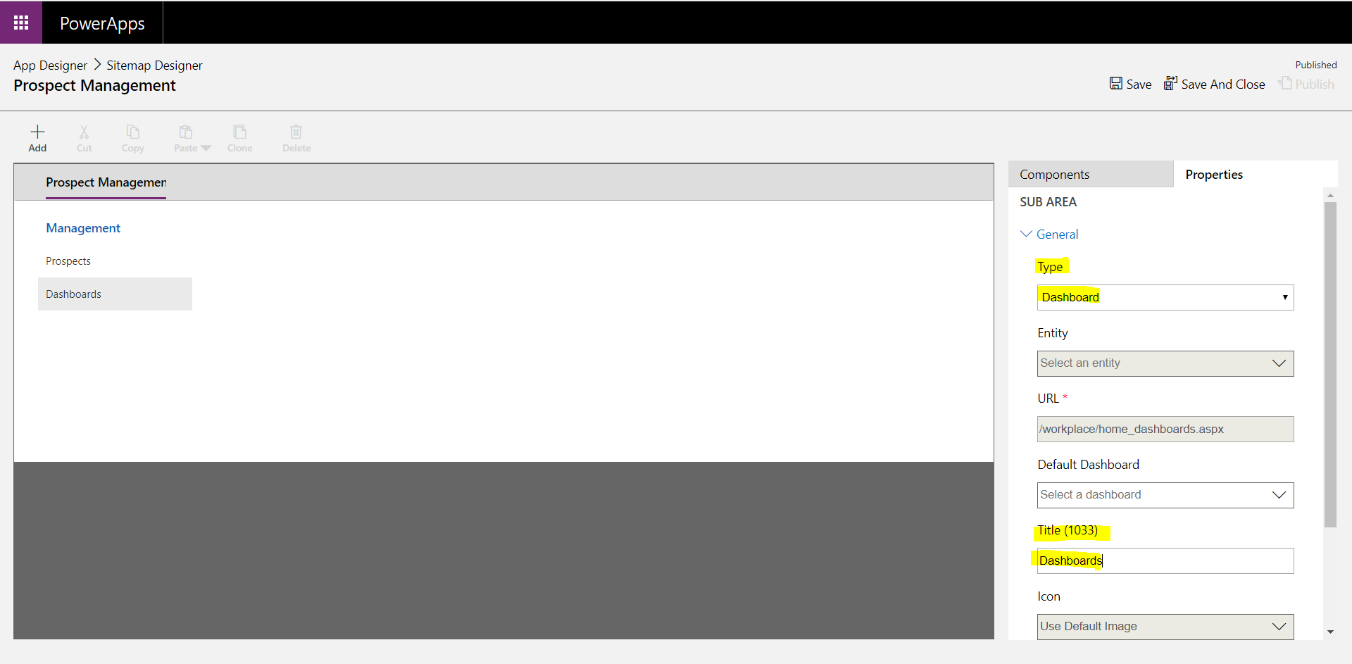

Save and Publish your sitemap changes.

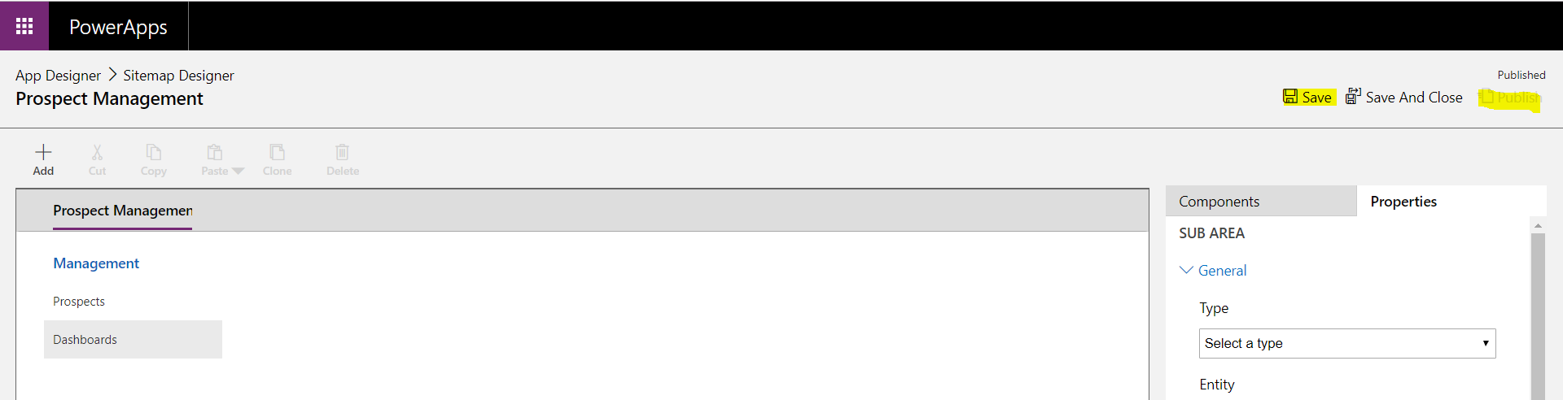

Once this has been published, Save and close your form

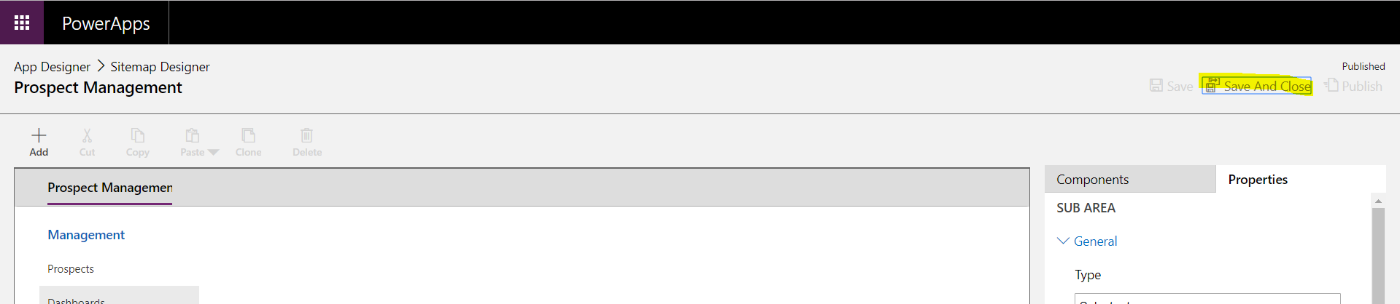

You will now see that the prospect Entity has now been added to your entity list in your application:

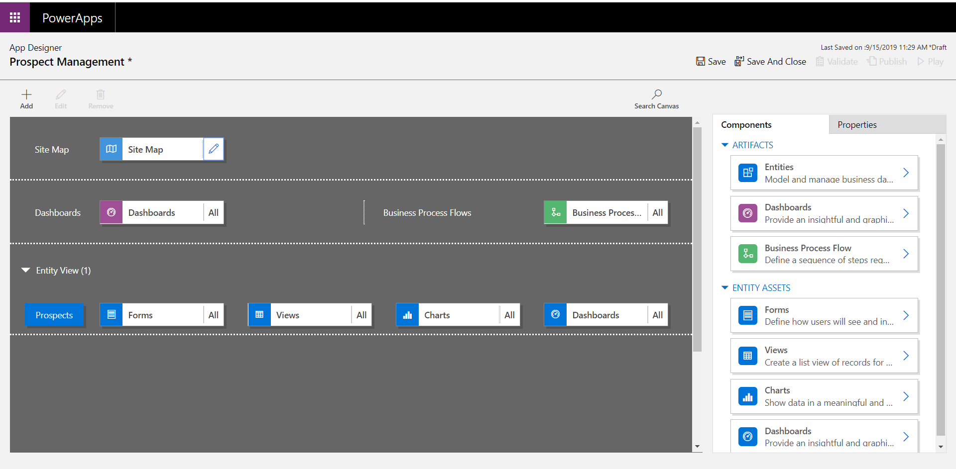

### Dashboards

We now ned to make sure a consolidated view of data is exposed to the users in a more interactive and visual manner. This will require the creation of Dashboards.

Select the “Dashboards” component from the App Designer and you will see all the available system dashboards on the right in the Components pane.

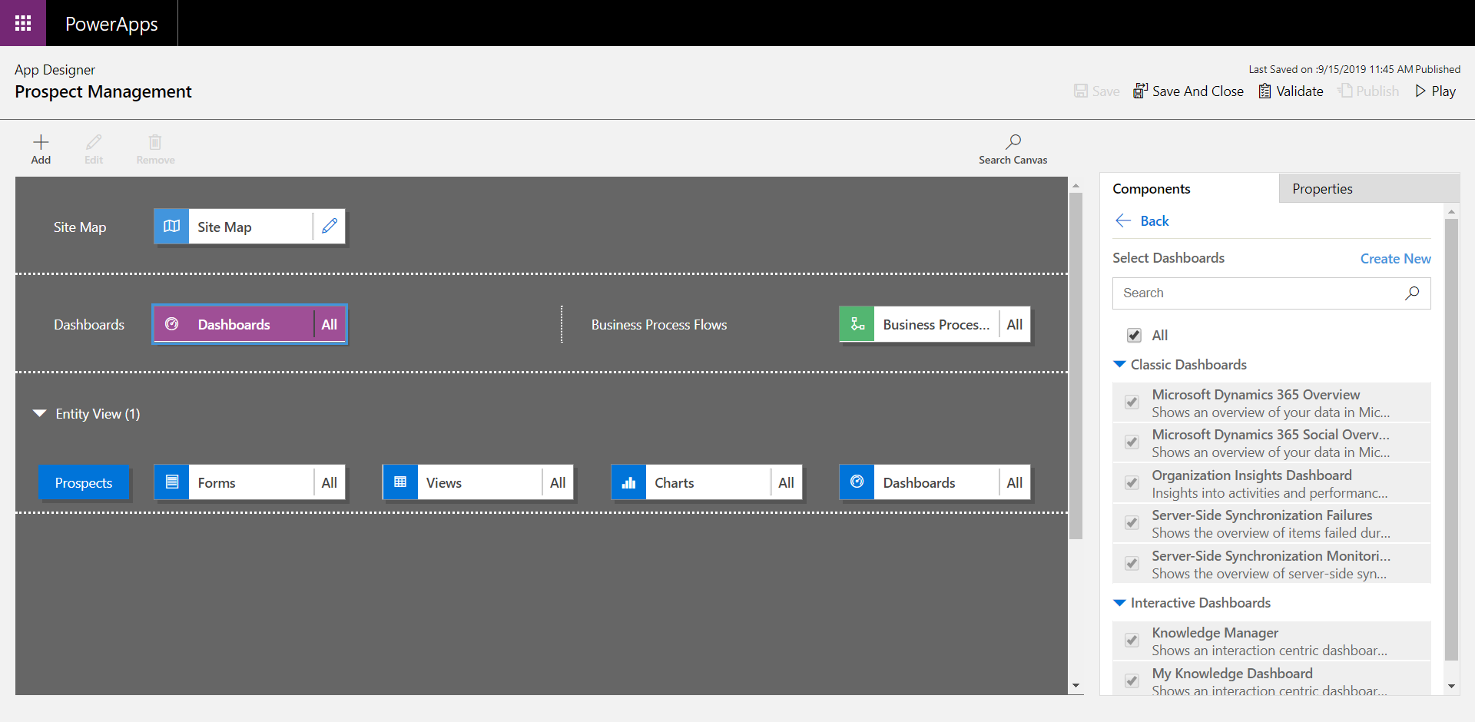

Select “Create New” and then select “Classic Dashboards”.

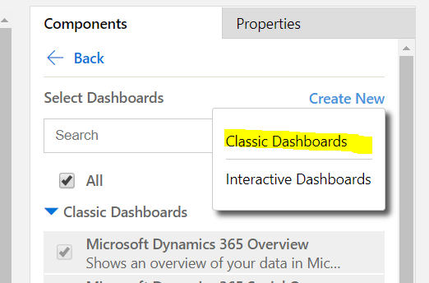

Select the “2 Column Regular Dashboard” from the layout list and click the “Create” button on the bottom right of the layout selection page.

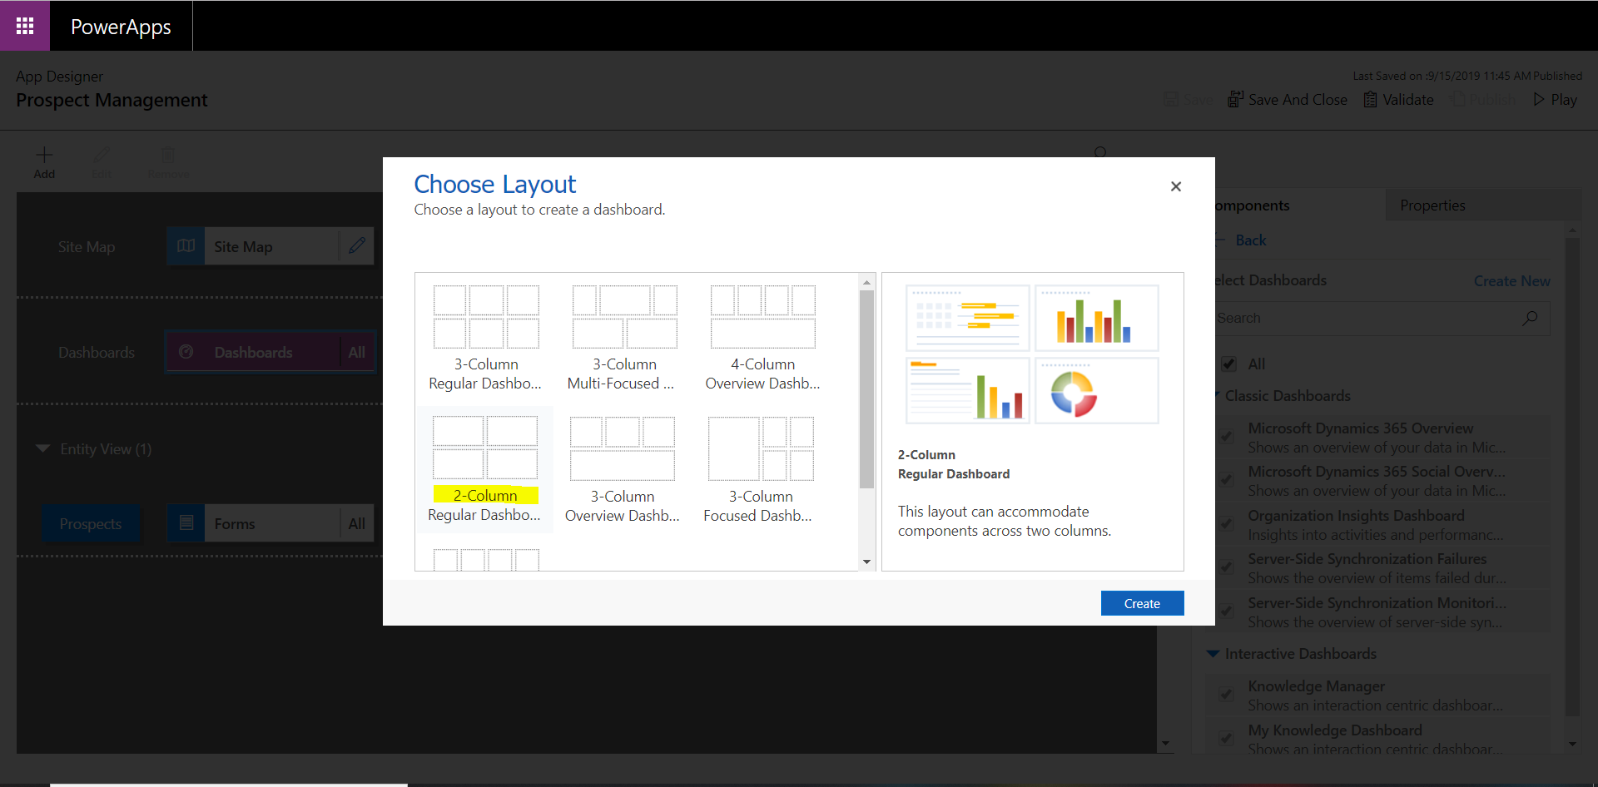

A new separate browser page will be opened with the Classic Dashboard Designer. Enter in the name for your new Dashboard : “Prospect Management Dashboard”

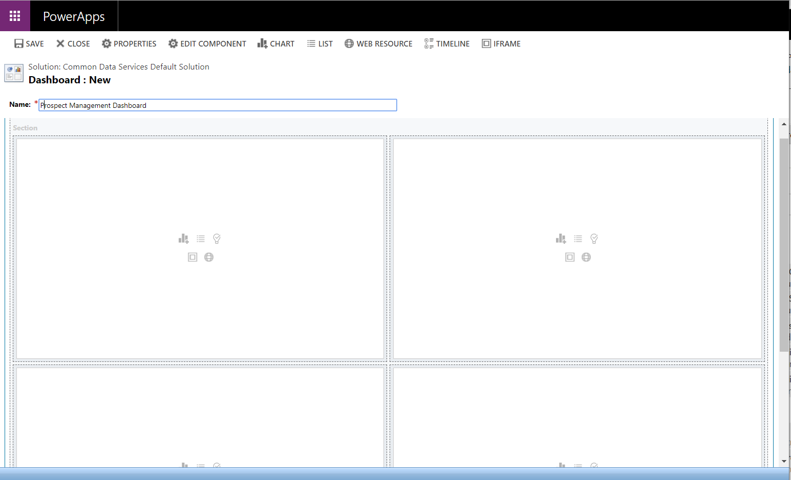

We are going to add some new lists and charts so that the Mid Office prospect management team have a better understanding of the data that is available to them.

In the first left pane of the designer select the “List” option.

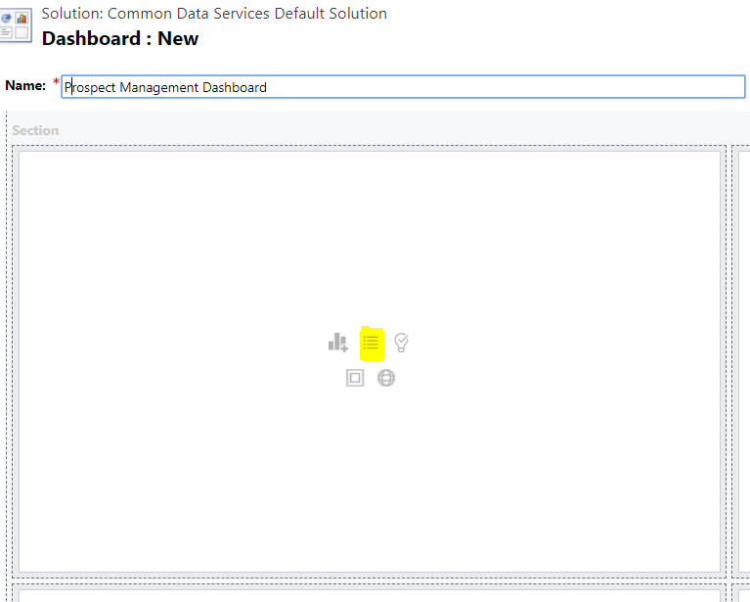

A component selector will then be displayed where you are now able to select the list you would like to add. Select the following:

1. Record Type: Prospects
2. View: Active prospects

Then select “Add”.

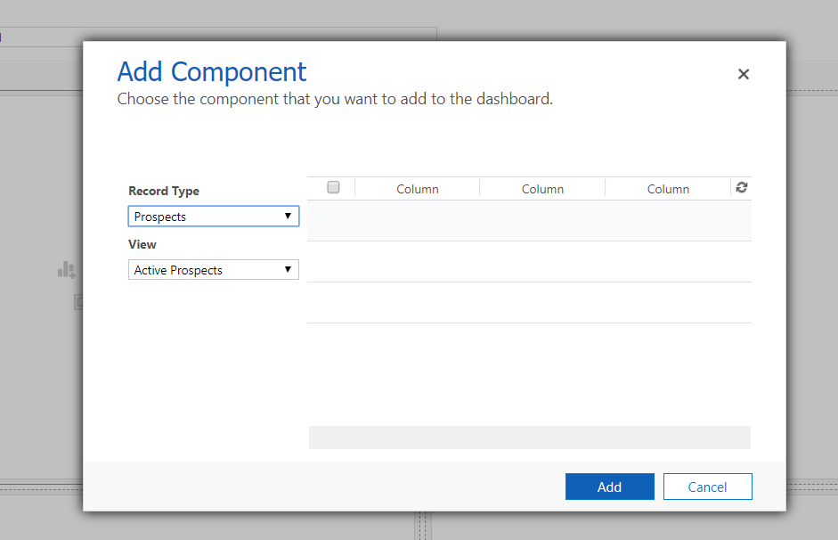

Move onto the top right panel in the Dashboard Designer and select the “Chart” option in the panel.

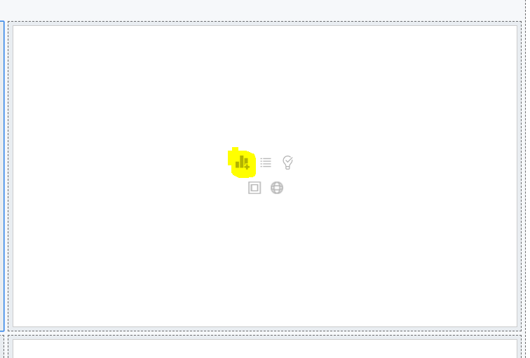

This will display the Component Selector., where you will be able to select the char that you would like to use. Select the Following Options:

1. Record Type: Prospects
2. View: Active prospects
3. Chart: Prospect ID by Product Interest

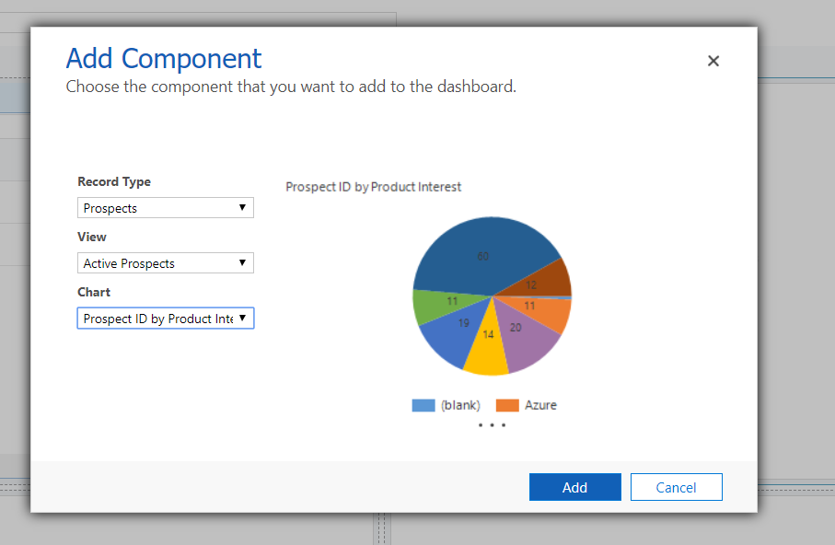

Do the same for the next two panes by selecting the following options:

Third Pane:

1. Record Type: Prospects
2. View: Active prospects
3. Chart: Prospect ID by Status

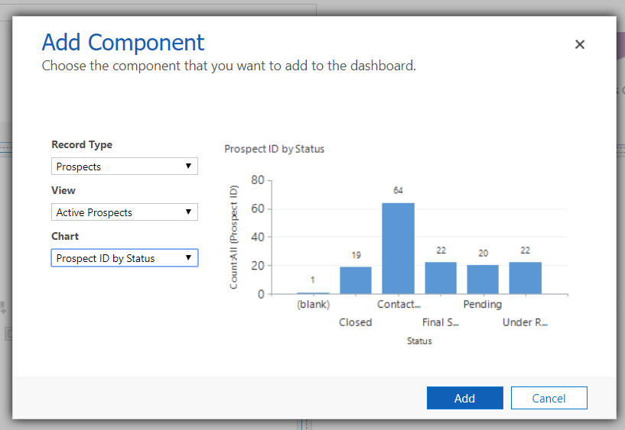

Fourth Pane:

1. Record Type: Prospects
2. View: Active prospects
3. Chart: Rating by Date of Interest

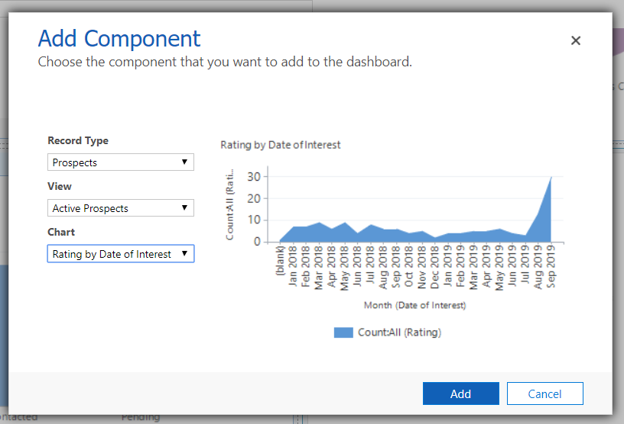

Ultimately, your Dashboard should look like the image below. Save your Dashboard and then hit the “Close” button.

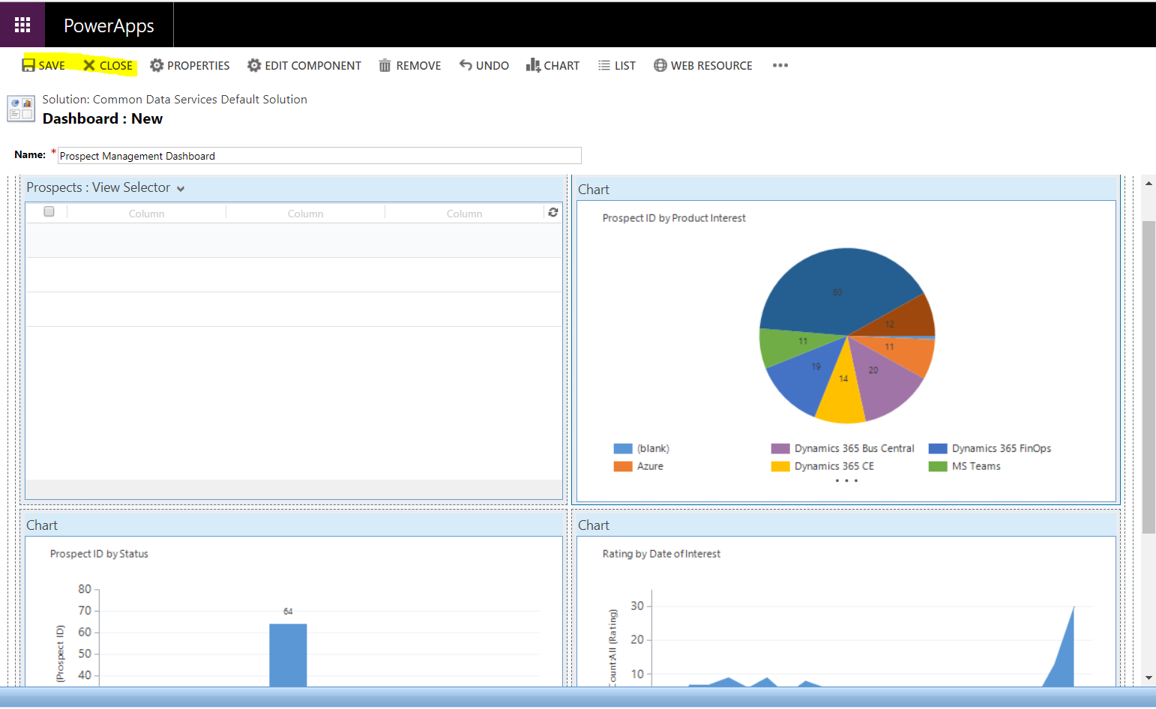

You will then be taken back to the model-driven App Designer experience where you will see your dashboard in the list with the other dashboards. If you do not see it there, simply select another component on the page and then click back into the Dashboards component.

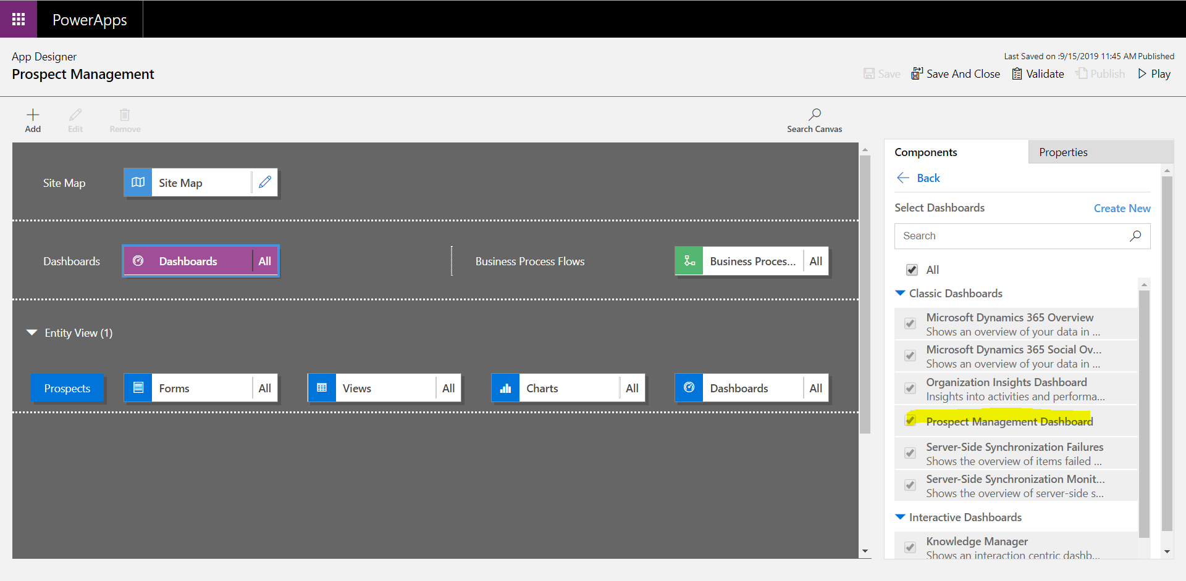

To improve the user experience and only show users information that is relevant to them, deselect all of the dashboards and ONLY select the “Prospect Management Dashboard from your list.

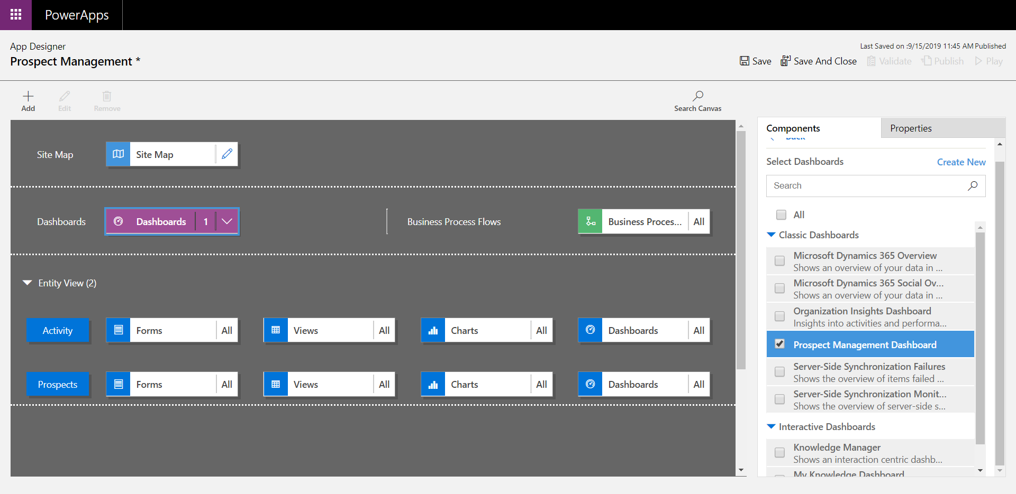

Click to edit your sitemap once again

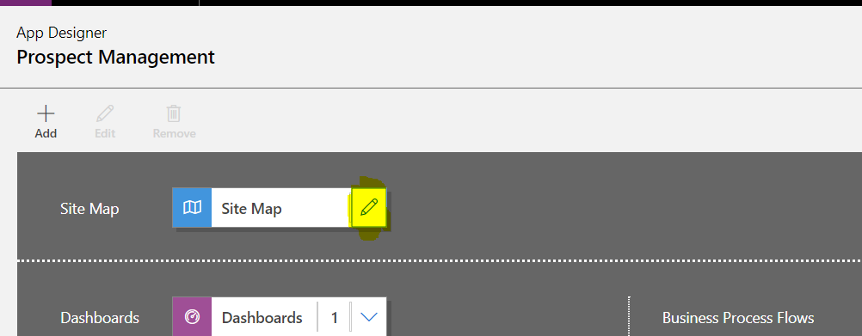

Select your “Dashboards” subarea component from the sitemap and update the default dashboard to “Prospect Management Dashboard”.

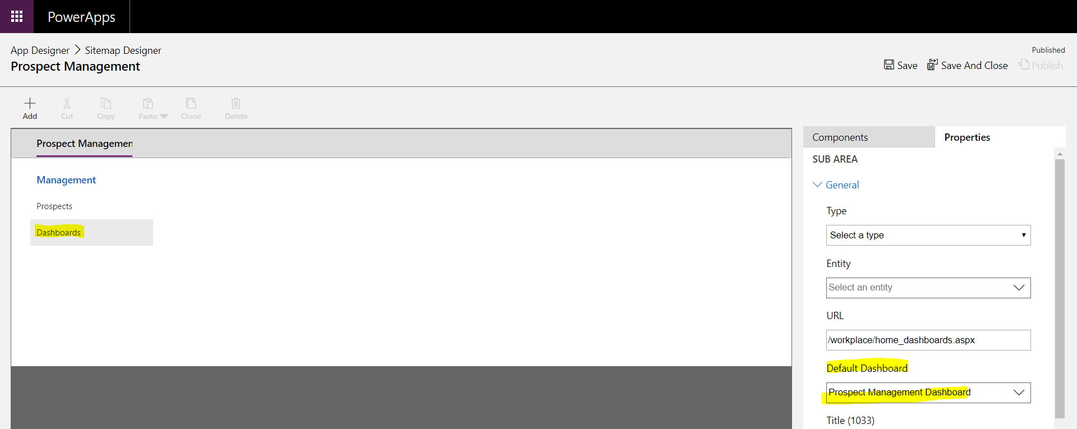

Save and Publish the Sitemap as you did previously.

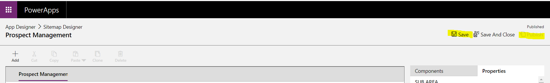

To complete and test your app, firstly “Save” your changes.

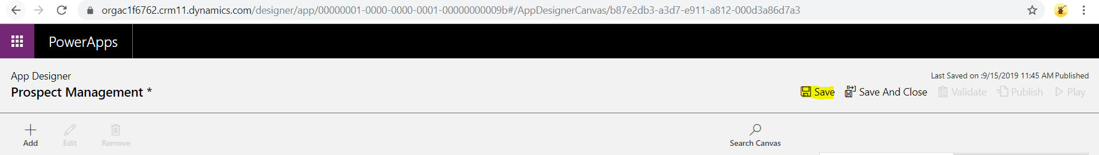

Then “Publish” your changes.

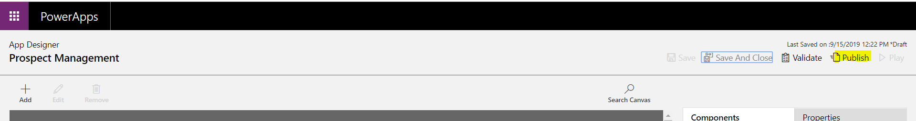

Finally, do a global publish by navigating to the maker Experience (make.powerapps.com) and then to “Solutions. Select “Publish all Customisations”. This will publish all the customisations in the system.

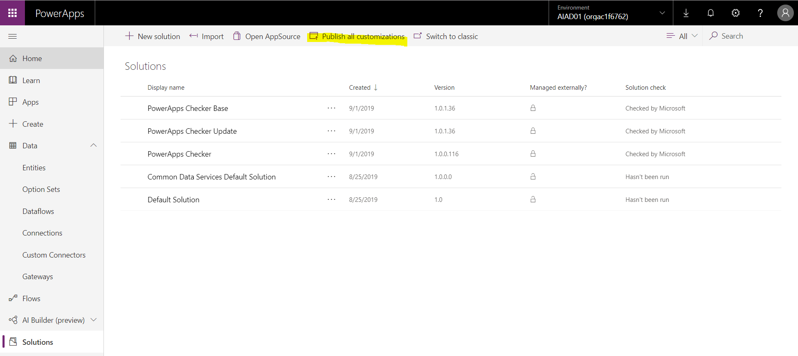

To test the applications, navigate to the Maker Experience (make.PowerApps.com) and select “Apps” from the menu. Click on the “Prospect Management” App.

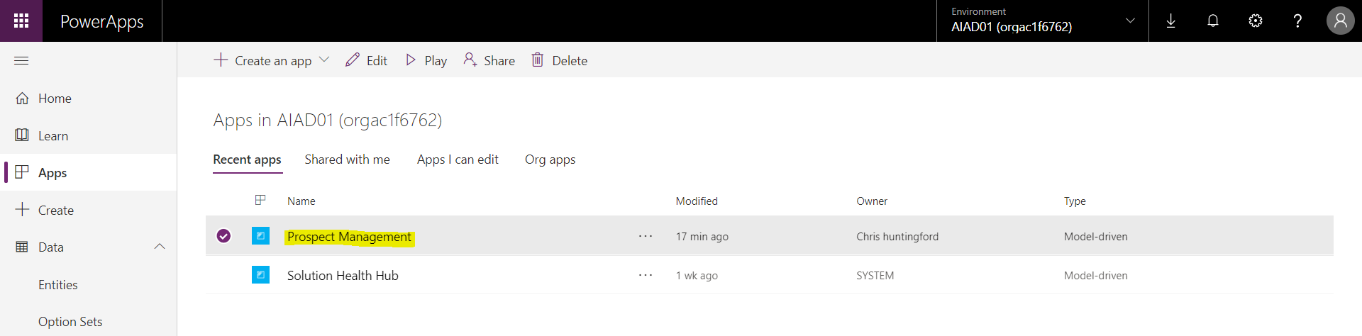

You will be taken to the main Prospect Management App page. This is where you can manage the prospects that get sent to the solution via the sales application. Copy the core page URL and place this into OneNote. It will be in this format : <https://orgac1f6762.crm11.dynamics.com>. You will need this in the Power Bi section.

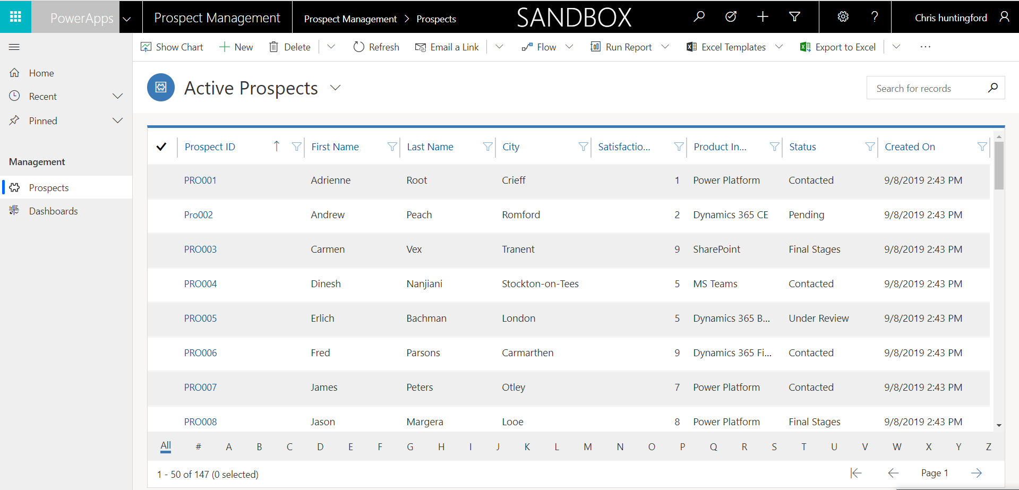

Navigate down to the “Dashboards” to view the data in a different format.

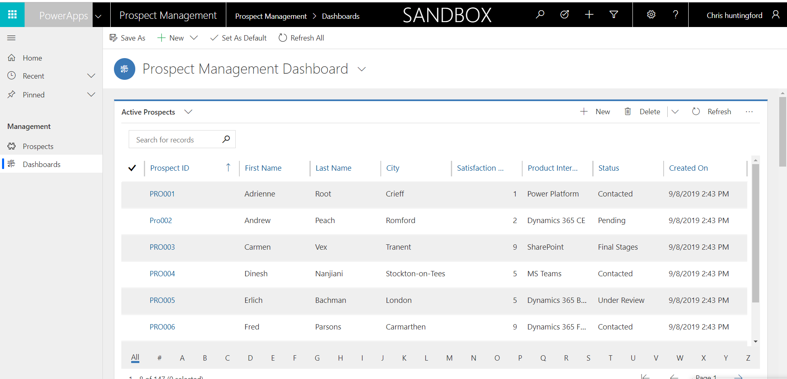

Use the scroll bar to view the relevant charts associated to the prospect entity.

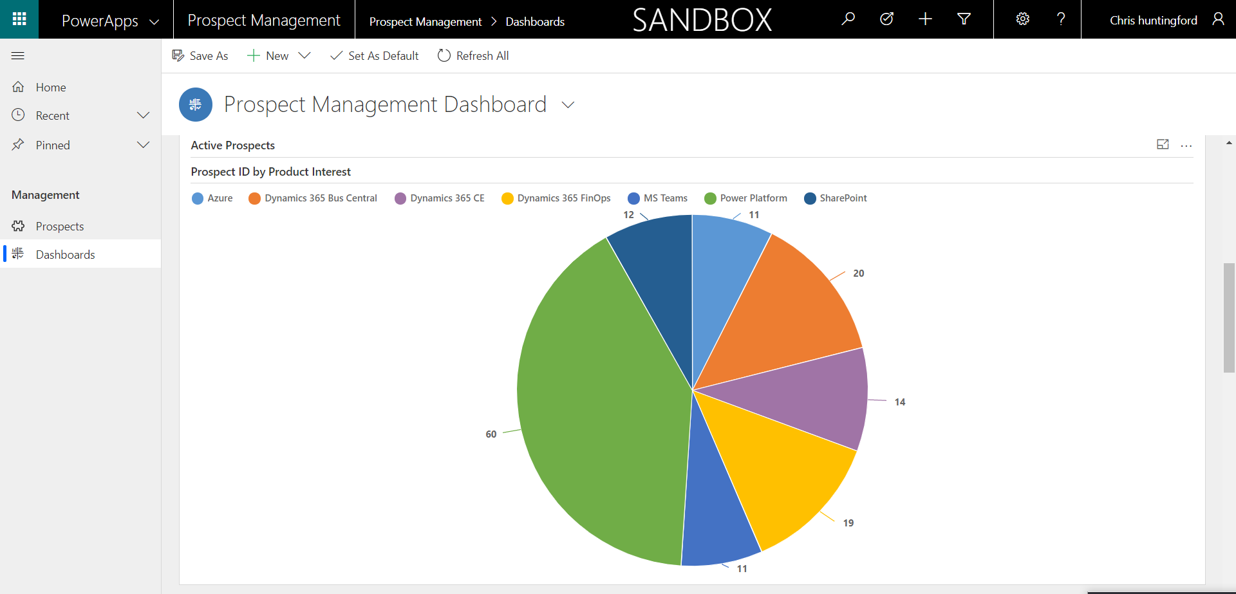

# Lab 4: Configuring your Microsoft Flow Notifications*

In this lab we will configure an Automated Flow to alert the captured prospect that their information has been captured and that they are being taken through the prospect qualification process.

***Please Note:***

***This lab can be completed independently, with only Lab 1 being and no support of the other labs.***

## Solution Components

Microsoft Flow

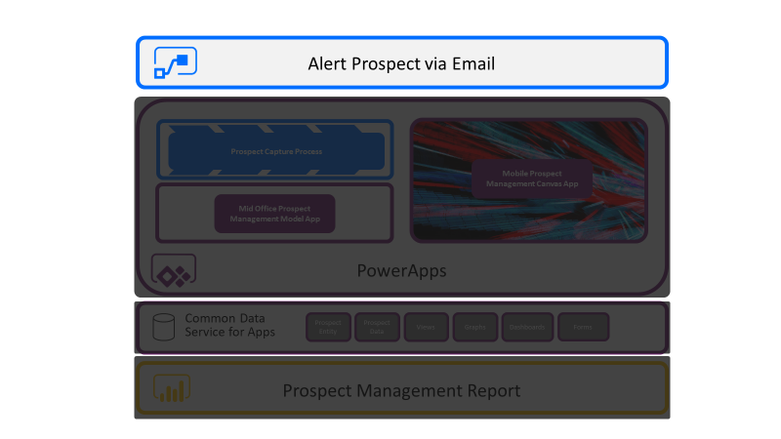

## Let’s Begin

### Microsoft Flow

Navigate to the maker Experience (make.powerApps.com) and select Flows from the menu on the left.

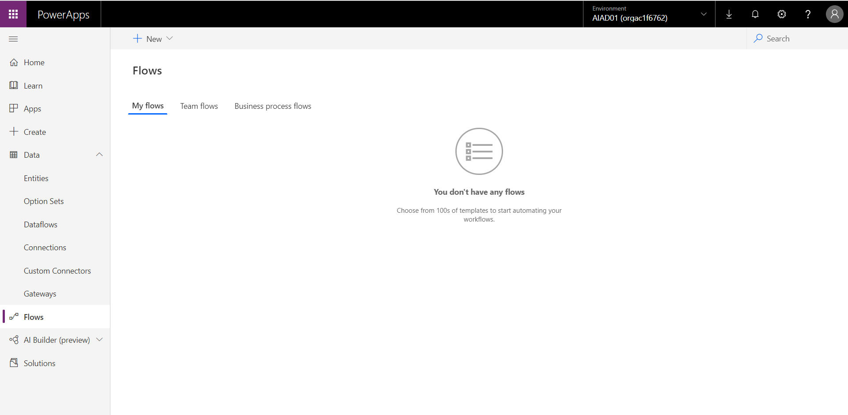

Select “Automated – Create from Blank”.

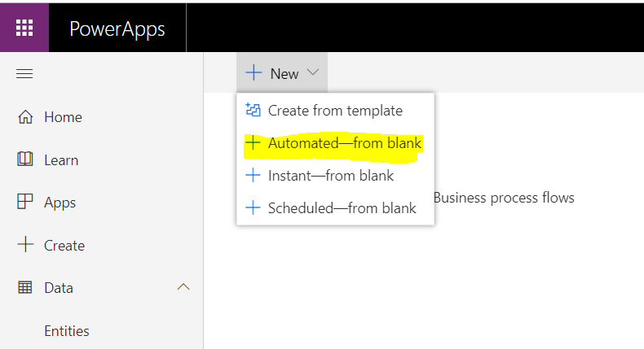

Enter in a name for your new Flow: “Alert Prospect” and select “When record is created” as the trigger. Then elect “Create”

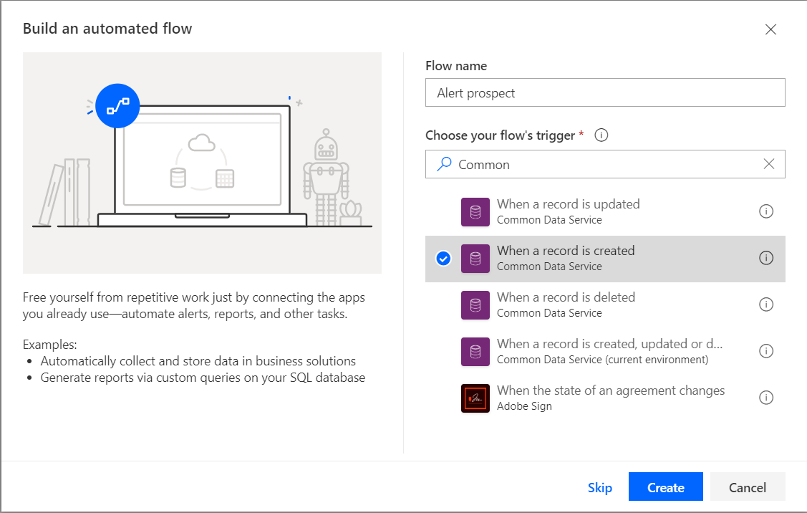

The flow designer will appear with various points I the trigger that need to be defined. The following properties need to be completed:

Environment:*The environment you Created”

Entity name: Prospects

Scope: Organisation

Once these have been filled in, add in a new step below this trigger by selecting “new Step”.

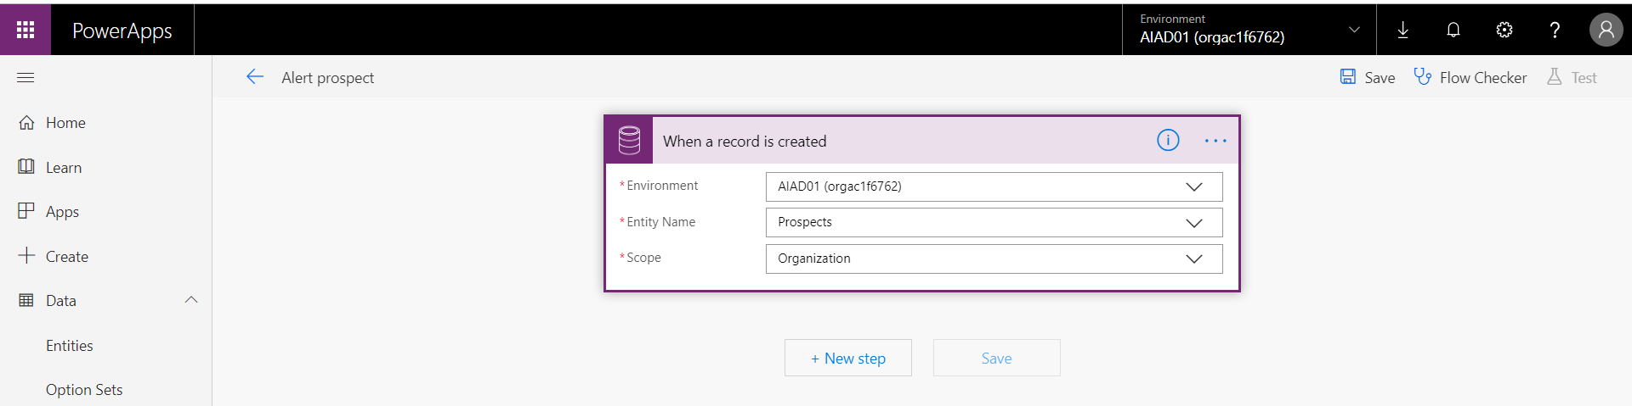

In the action search for “Send Email” and select “Send Email V2”.

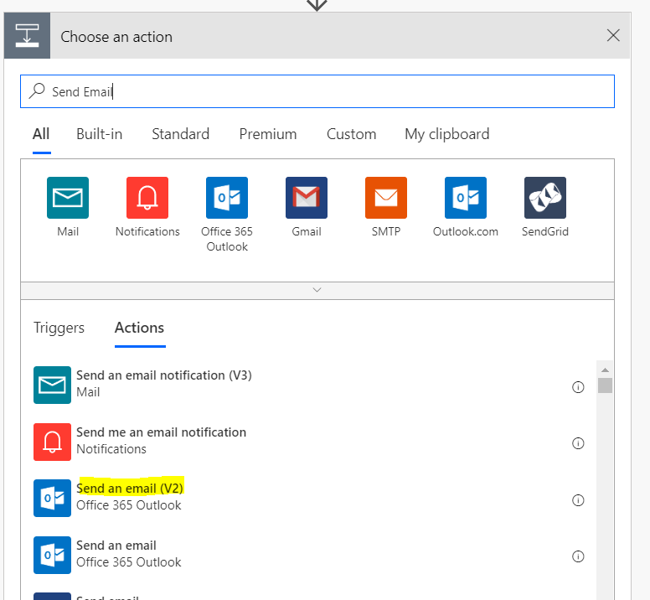

You will need to personalise the email you are going to send to the prospect. Fill in the following by leveraging both Free Text as well as the dynamic content provided from the Common Data Service provided on the right.

1. To: Email (From Dynamic CDS content)
2. Subject: “Qualification process Underway”
3. Body: “Good Day Firstname (From Dynamic CDS content) Lastname (From Dynamic CDS content)

Thank you for sharing your interest in our products and services. We would like to let you know that we are processing your information and will be in touch shortly.

Kindest Regards”

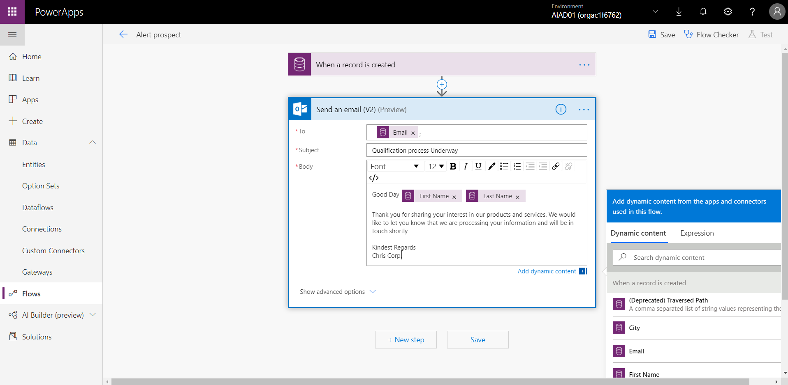

Save your Flow.

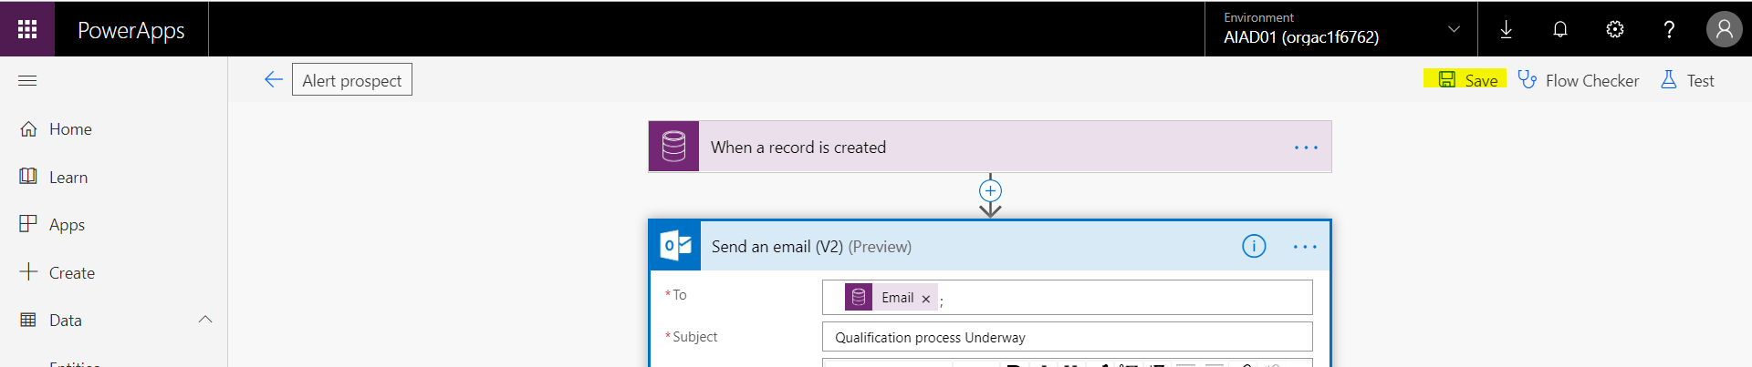

Select the back-arrow button on the left of your Flows name and then agree to exit the screen. PLEASE SAVE before you do this.

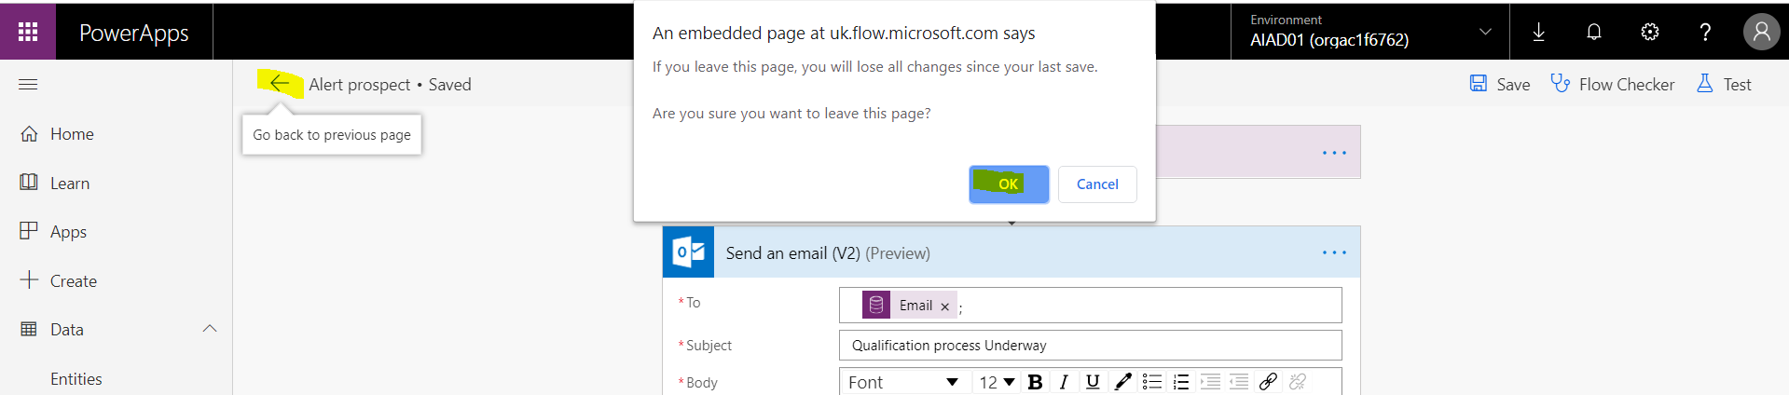

You will now see that your Flow has been added to the list of flows within the Flow view.

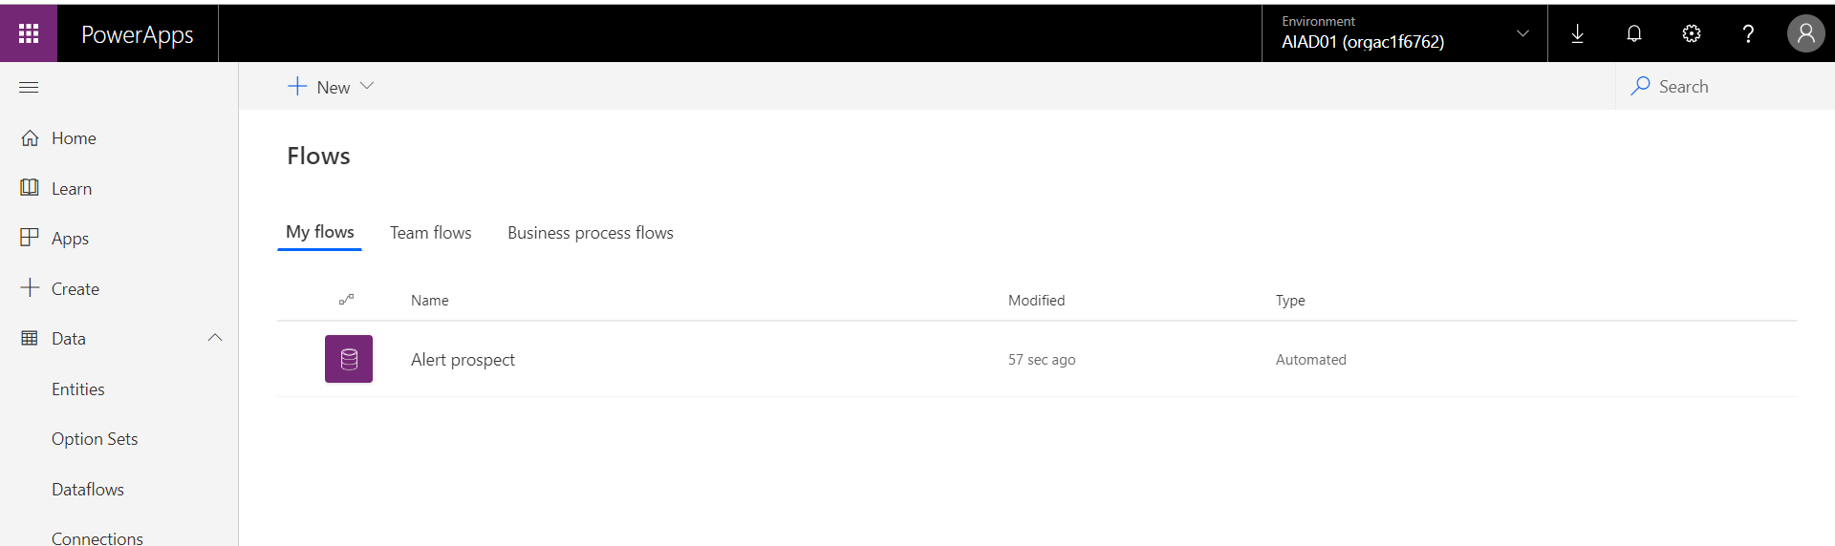

# Lab 5: Configuring a Basic Power BI Dashboard* (Optional)

In this lab we will learn how to configure a basic Power BI report and Dashboard in order to allow Mid office users the ability to view data in a format that is easy to understand and interactive.

***Please Note:***

***This lab can be completed independently, with only Lab 1 being and no support of the other labs.***

***This part of the hackathon is totally optional and instead of building this part, you can simply import the “Prospect Management01.Pbix” Power BI file into your environment and connect to it through the Canvas Apps user experience***

## Solution Components

Microsoft Power BI

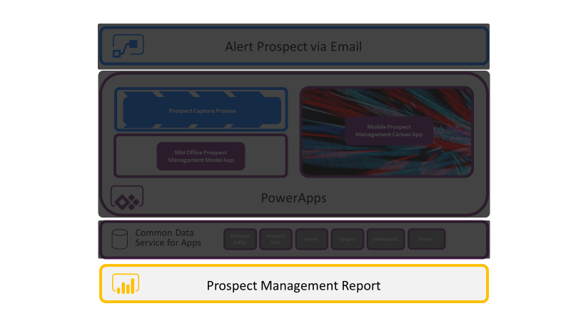

## Let’s Begin

### Power BI Desktop

Based on the prerequisites, you should have downloaded Power BI Desktop from the Microsoft App store. Please open this to start with. On arriving on the splash screen select the “Sign In”.

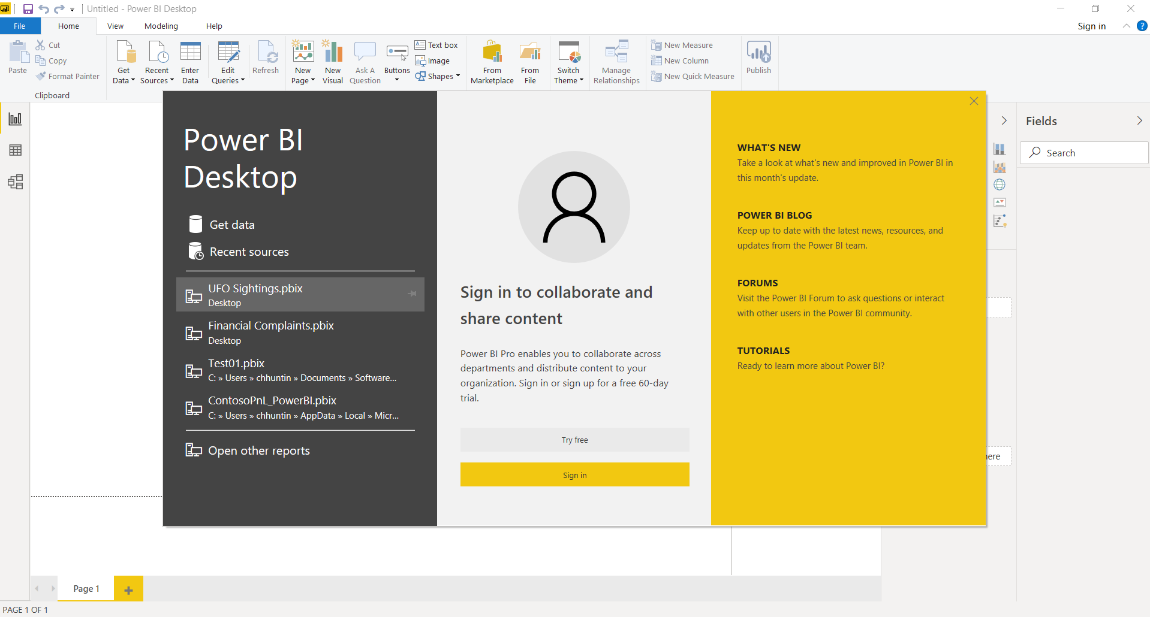

Enter in your trial environments user credentials.

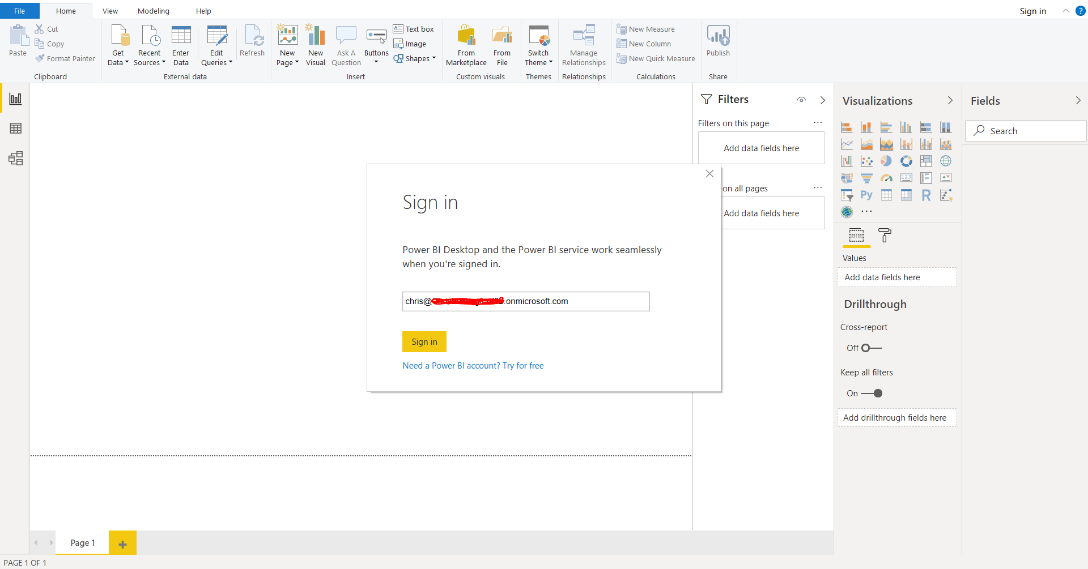

A password screen will appear.

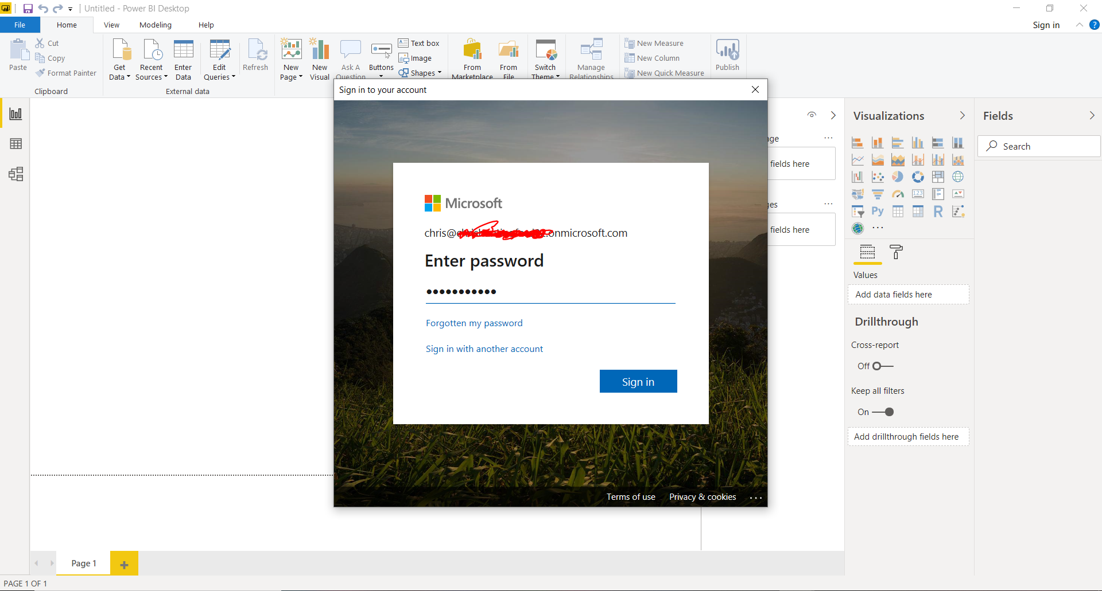

We will now select to get data from the Common Data Service so we can report on this using Power BI. Select “get Data” and then “More”.

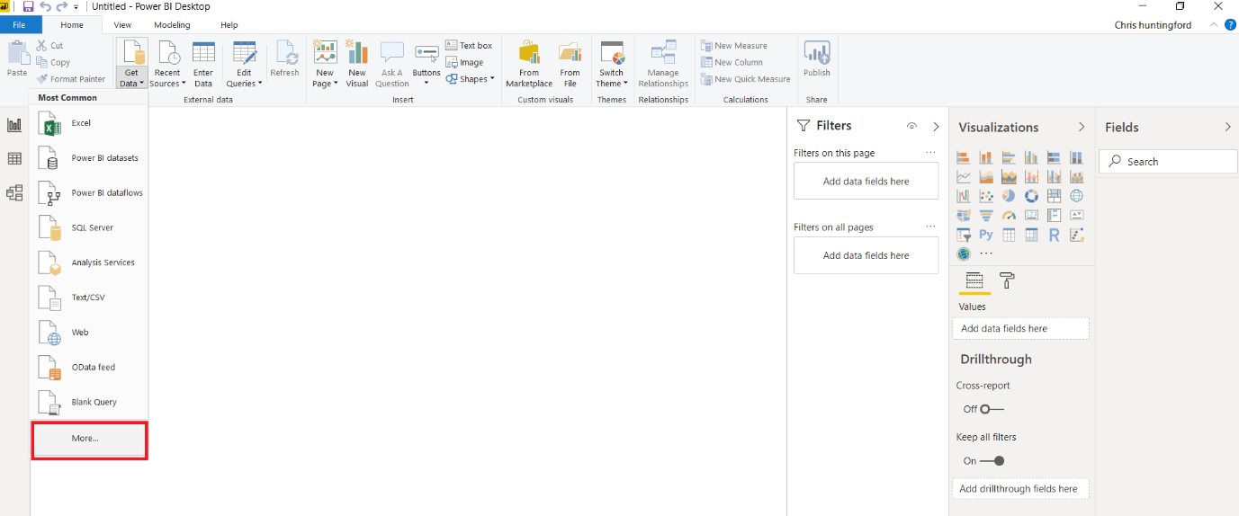

Search for the Common Data Service and then select “Connect” rom the bottom of the page.

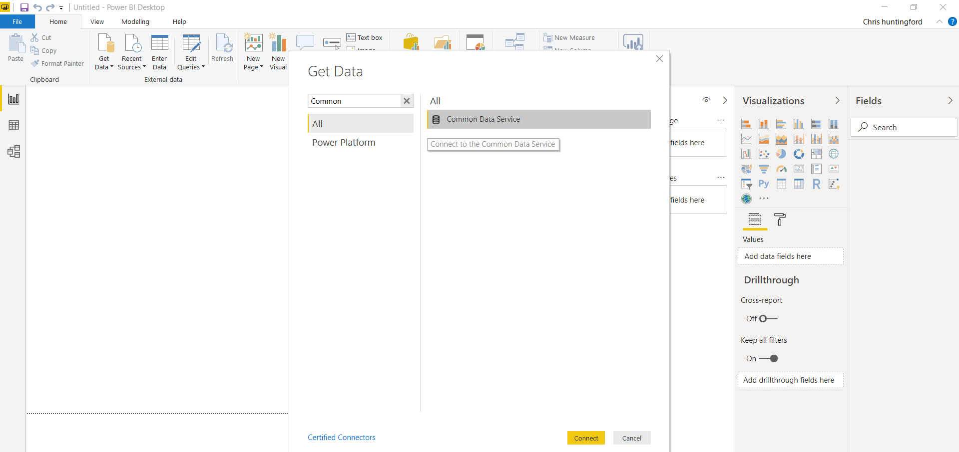

The Common Data Service connection screen requires a server URL to progress getting the data. You should already have this copied into a OneNote page from the previous section, but if not, open up the Prospect Management application you previously created and copy the URL in this format. Enter this into the connection URL and select “OK”.

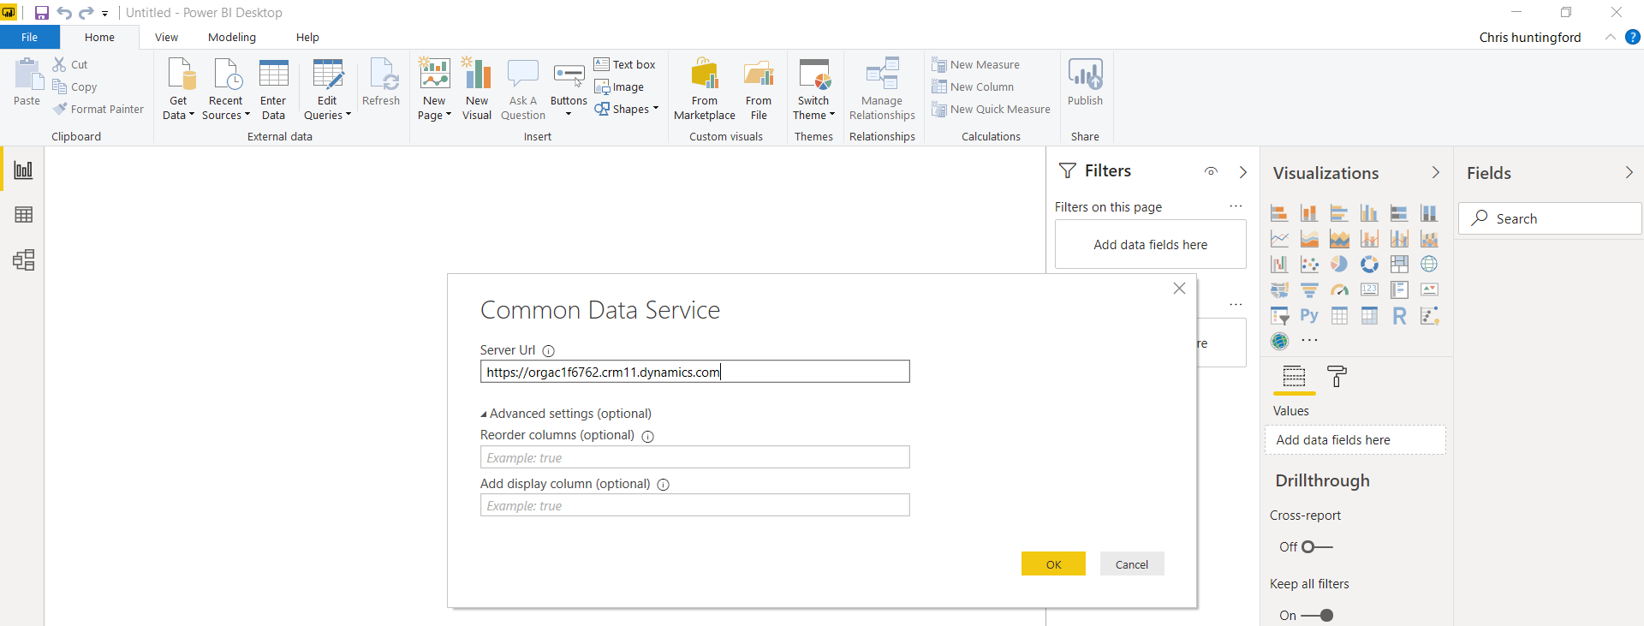

Power BI desktop may ask you to sign in again.

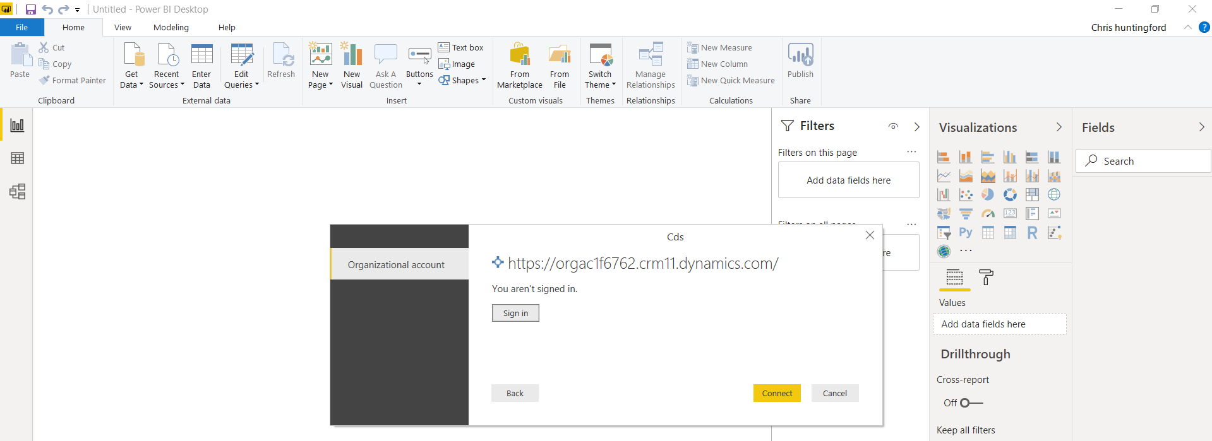

Enter in your username and password and continue.

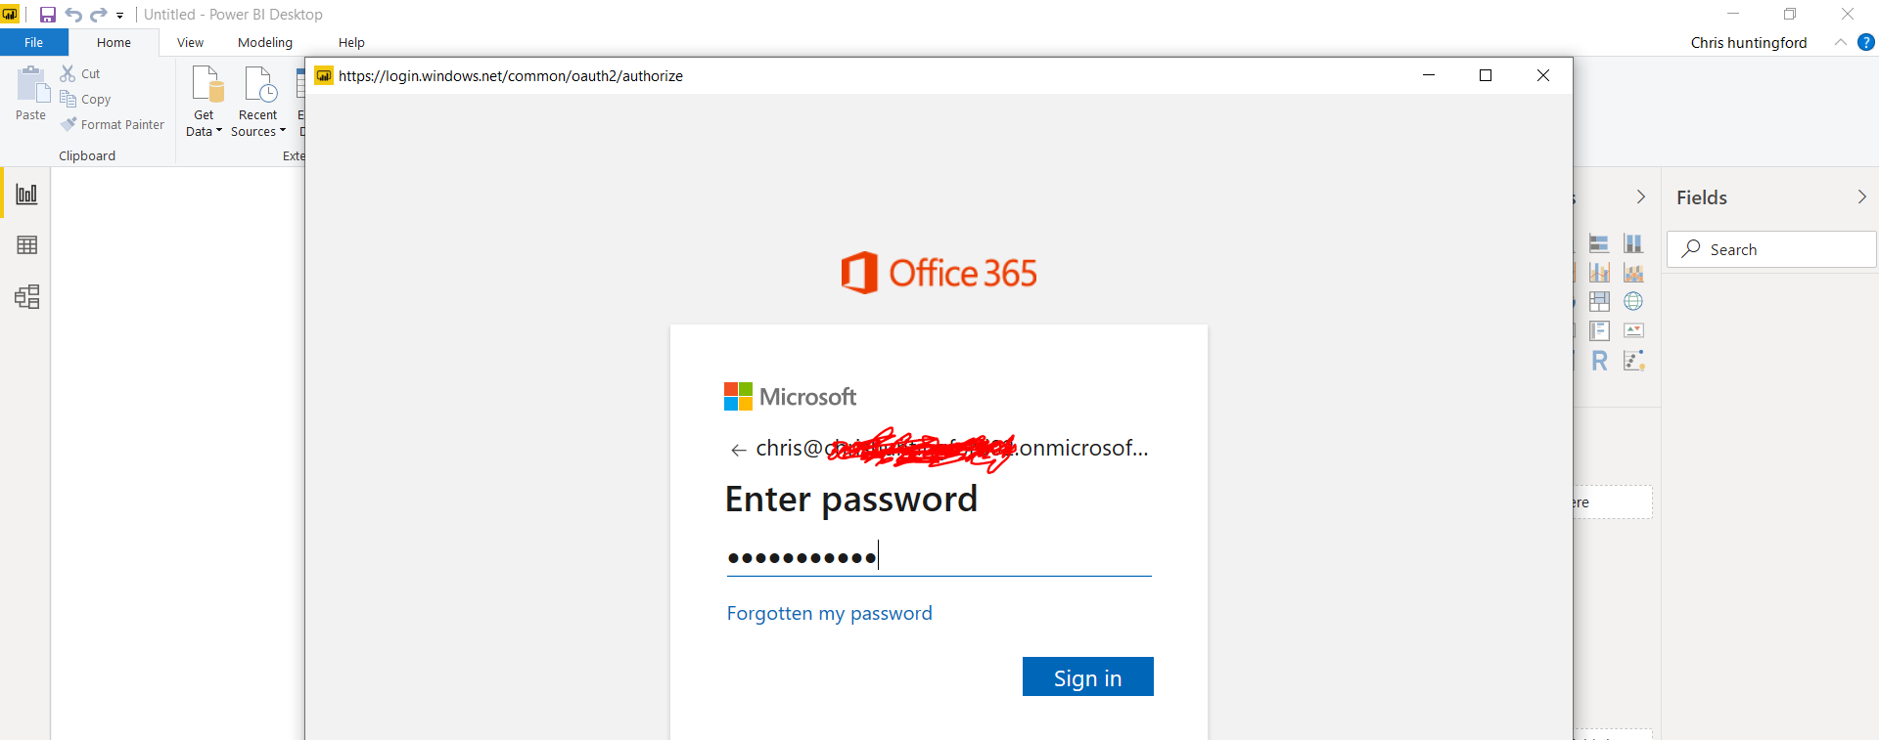

Once signed in, select “Connect” to continue getting access to the data.

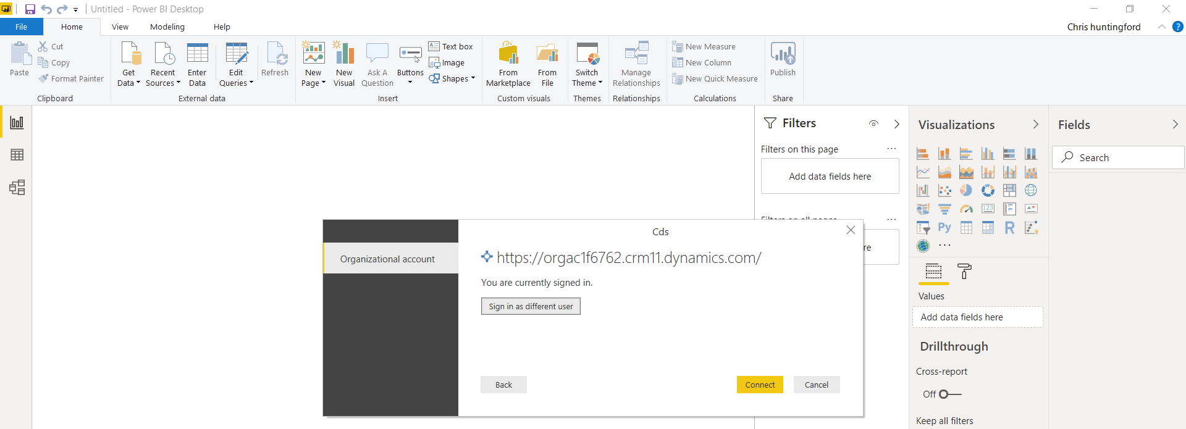

Drill into the Entities list and search for the prospect Entity. Select the relevant entity to preview the data to load to the data model. Select “Transform Data” at the bottom right of the page.

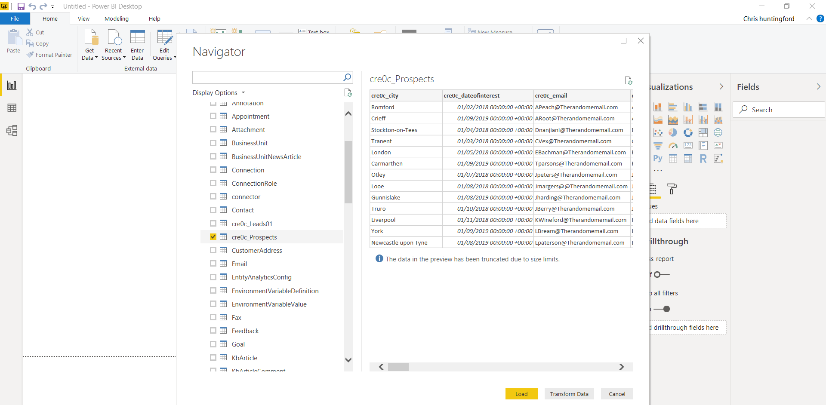

You will be taken to the “power Query” editor where you will now be able to transform the data before it is loaded to the data model. Typically, we only want real data we are going to report on.

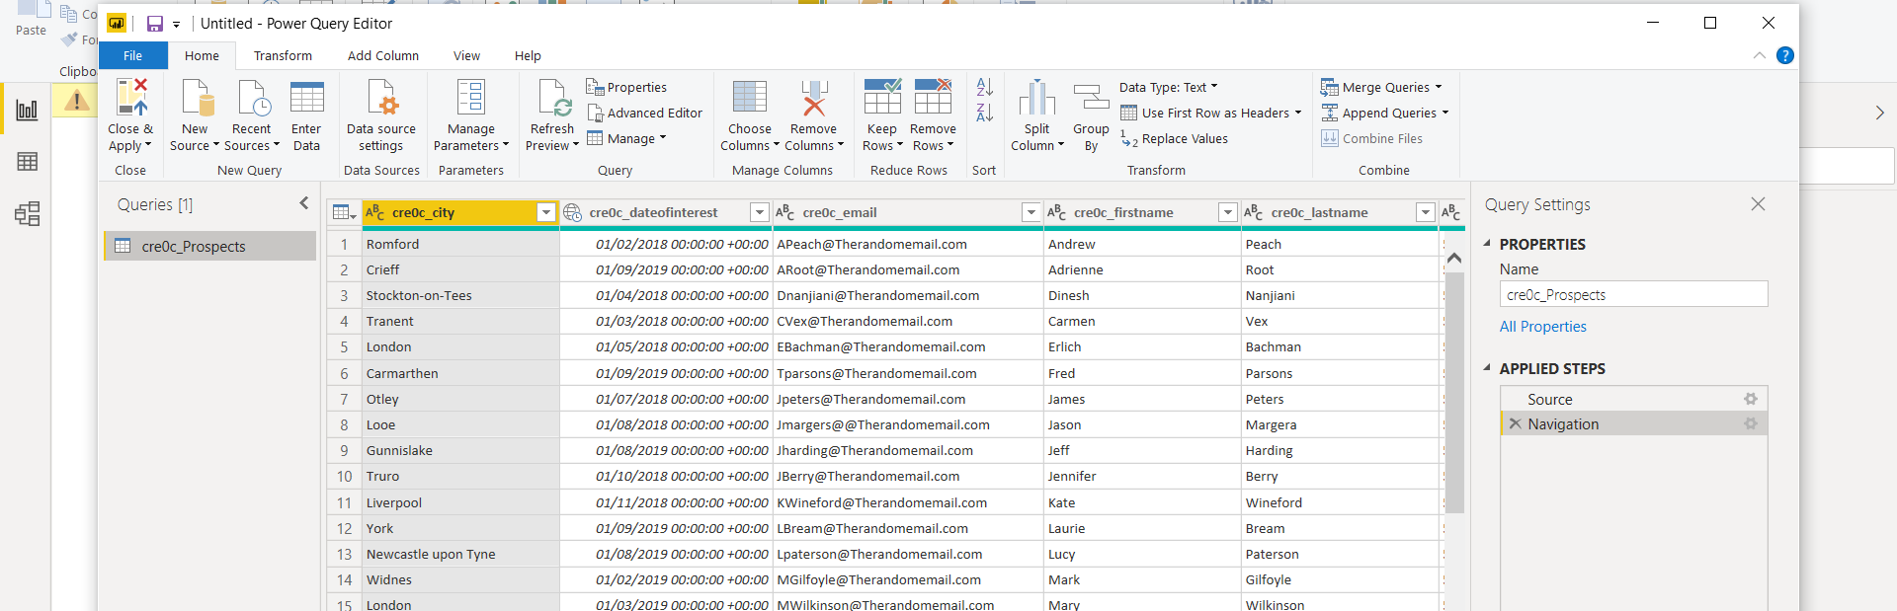

Select “Choose columns” from the ribbon to make sure we only select data we need.

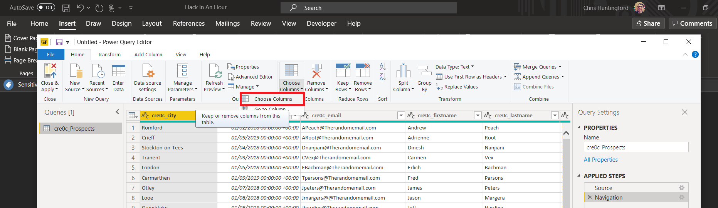

As a standard , all the columns are selected.

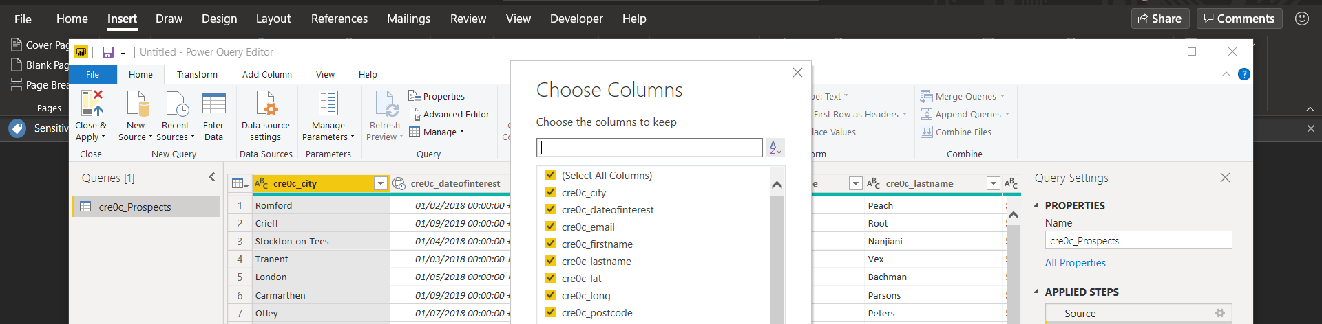

Deselect all the columns before we start our column selection.

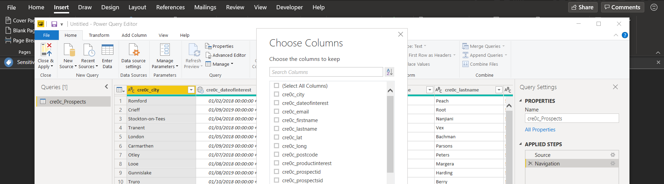

Select the following columns from the List (Please note, the fields in your list will have a prefix that will look some like this: cre0c_field name) :

1. Prefix_City
2. Prefix_DateofInterest
3. Prefix_Prospectid
4. Prefix_rating
5. Prefix_satisfactinrating
6. Prefix_status

Once you have chosen the columns, select “Ok”.

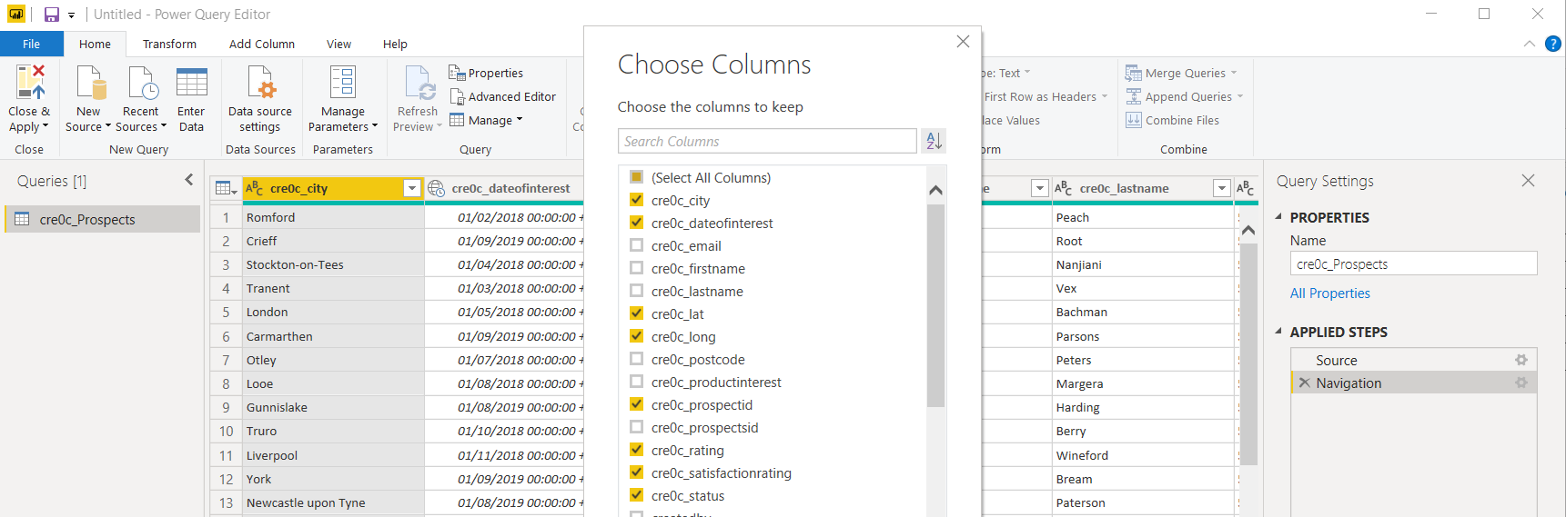

To load the data to the model, select “Close & Apply” from the ribbon.

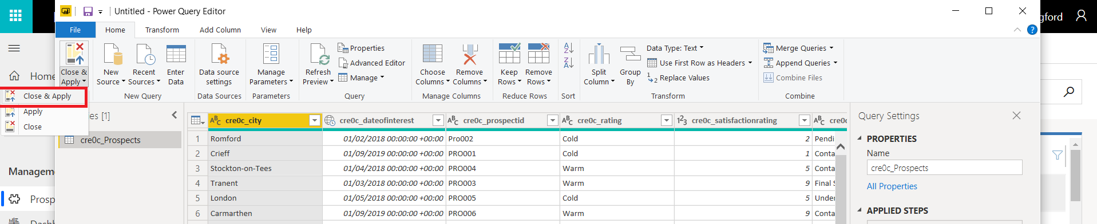

The data load will be initiated.

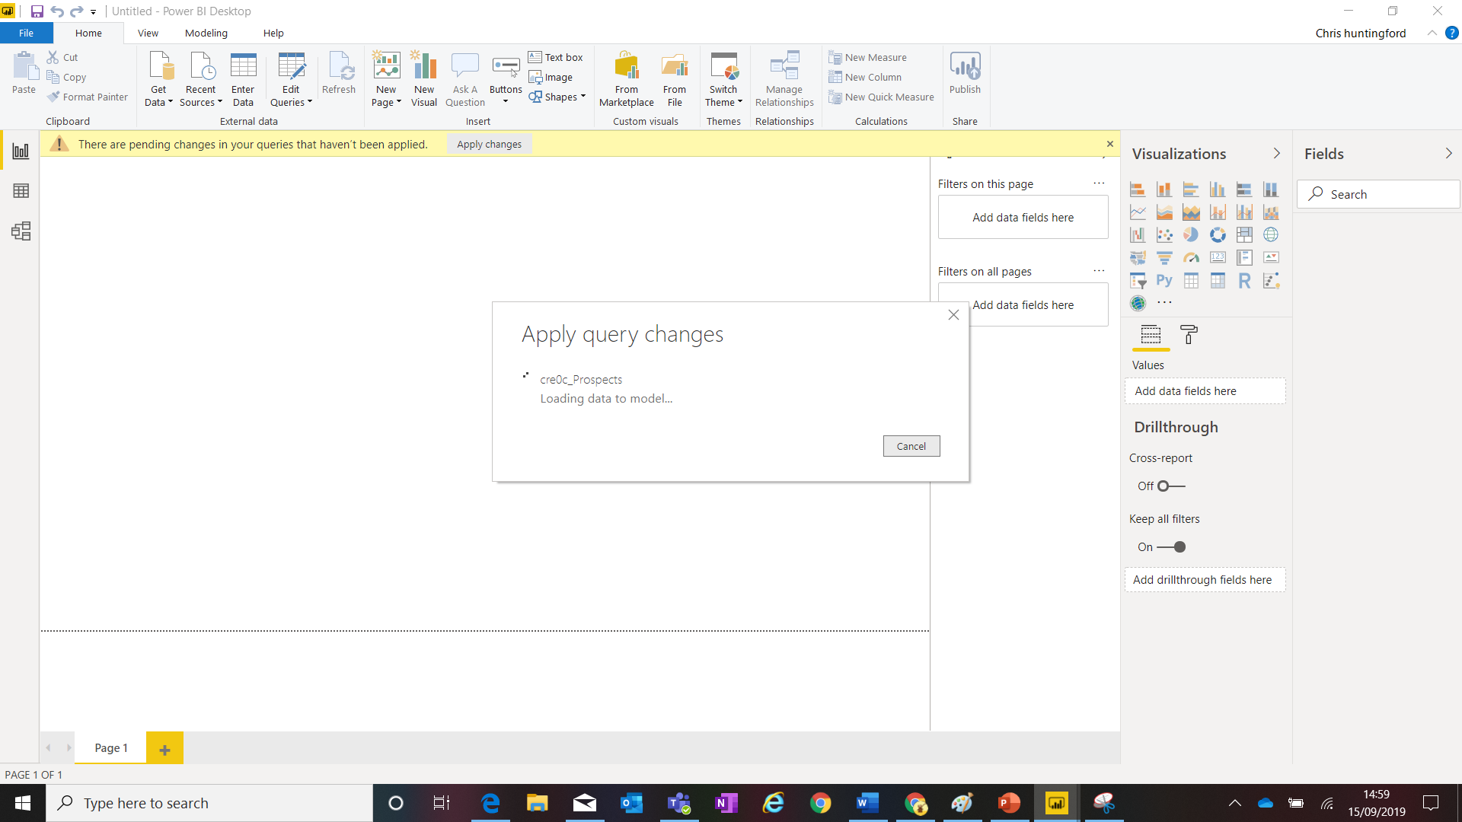

Once loaded, you will see your fields visible on the right-hand side.

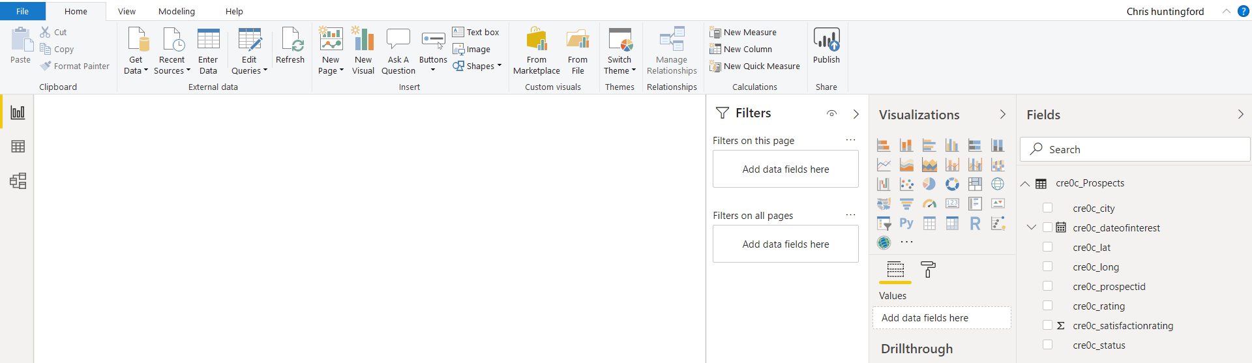

To start creating our visuals, lets start with adding a map to the form. Select the Map component from the visualisation panel on the right.

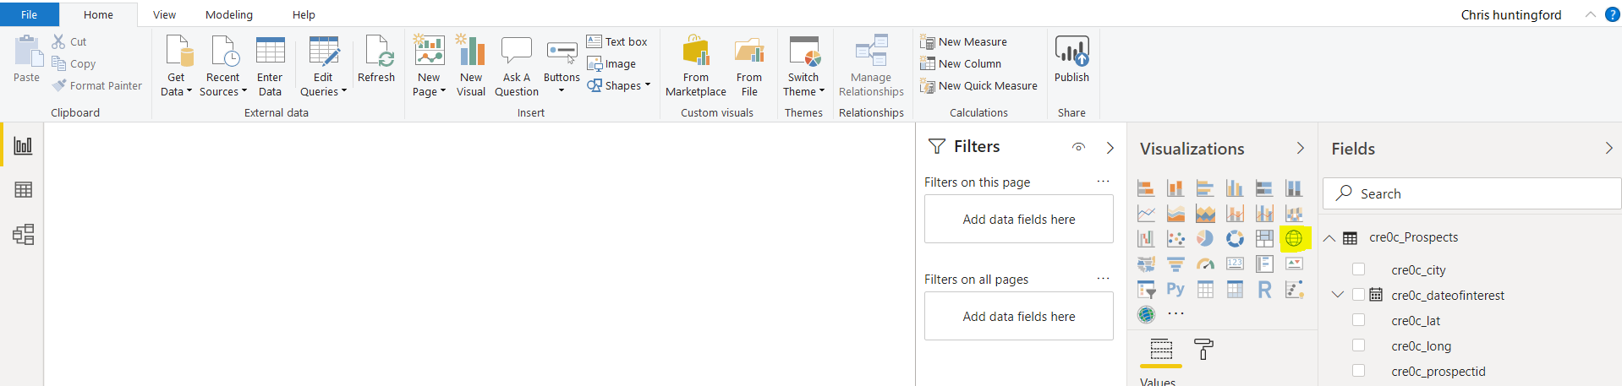

You will see the map visualisation in the main Power BI canvas. Drag and drop the following fields from the Field explorer into the visualisation properties:

1. Location: Prefix_city
2. Legend: Prefix_rating

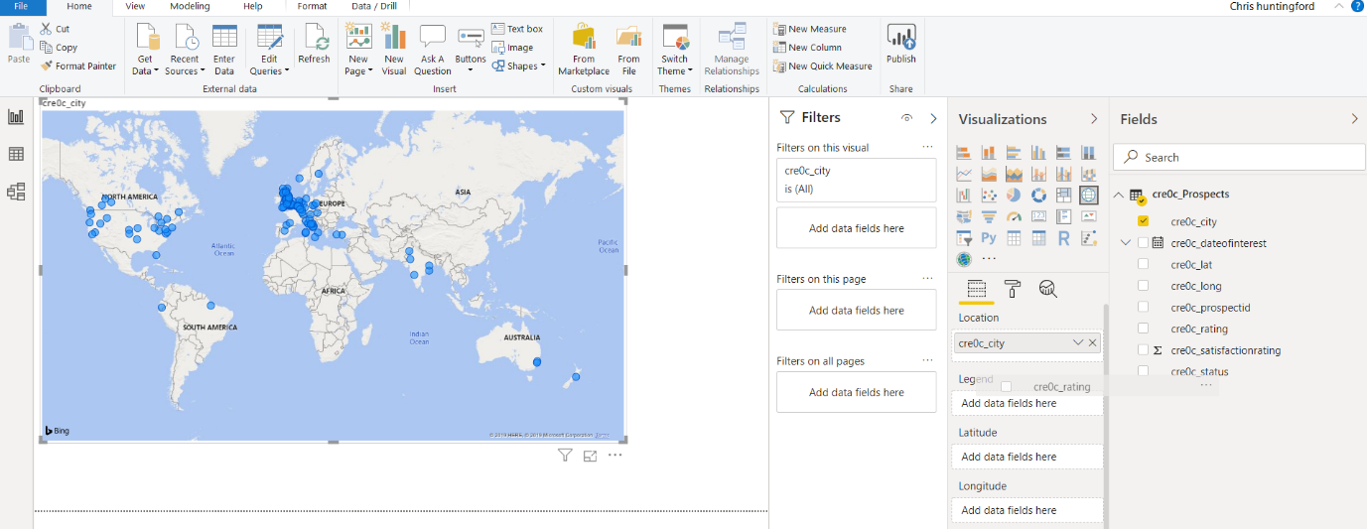

Resize your map accordingly until you have something that looks like the below image.

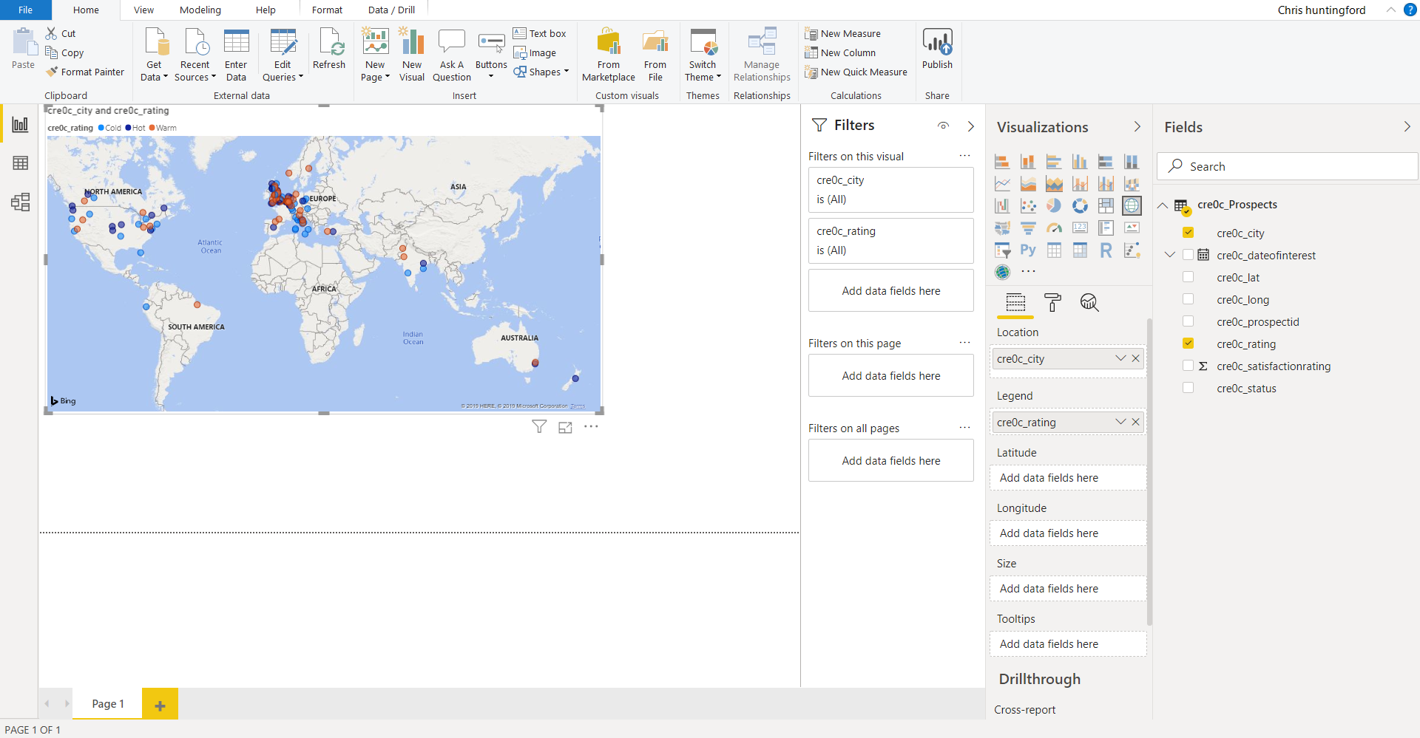

Click OUT of the map and into the blank canvas area. Add in a new Line Chart component from the visualisation menu.

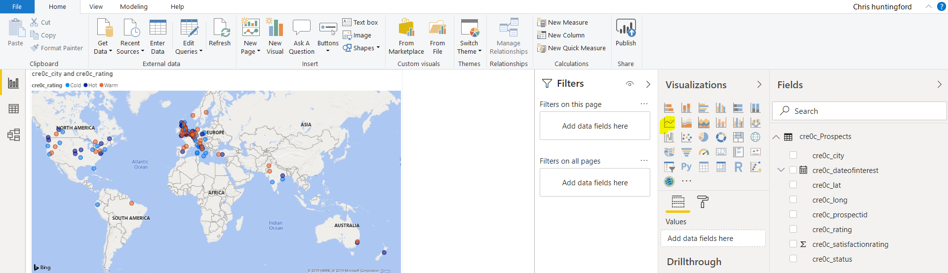

Drag and drop the following fields into the properties of the line chart visualisation:

1. Axis: prefix_Dateofinterest (Remove Quarter & month options.
2. Values: prefix_prospectid (This will automatically insert “Count of” in front)

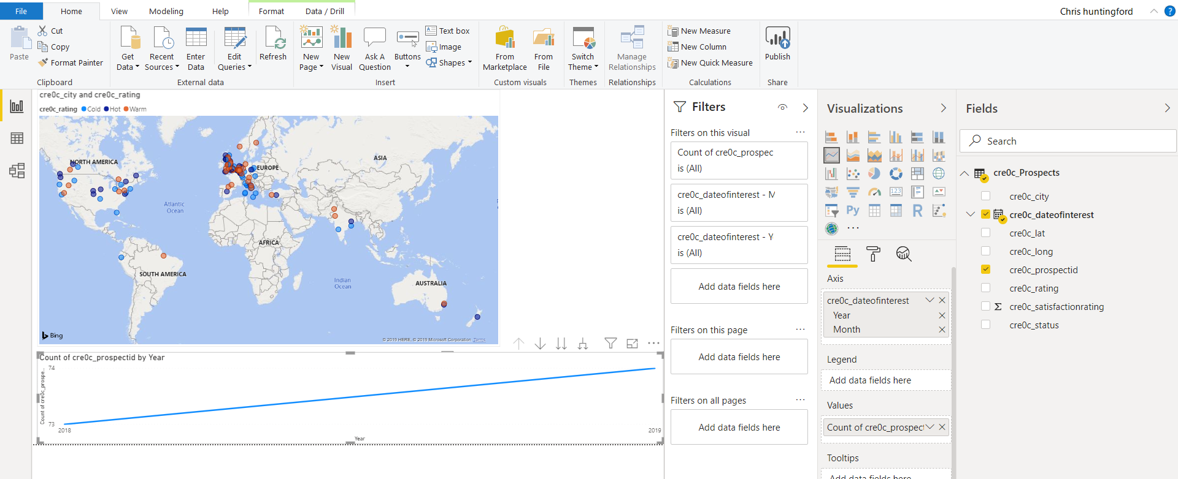

To further create more detail I the Line Chart, select the “Expand Down 1 Level in the Hierarchy” Button on the line chart visual.

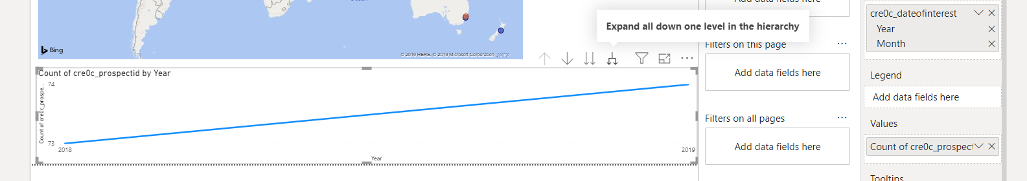

The result will look like this. Make sure you resize your visual accordingly.

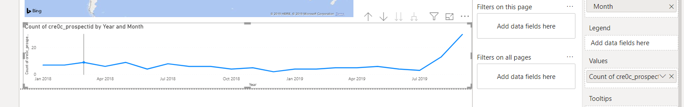

Click out of the visual and onto a clean area of the canvas. Add a doughnut visual to the report.

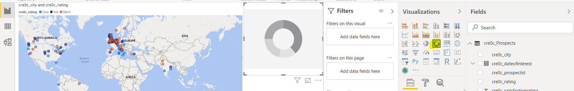

Drag the following fields into the properties of the doughnut chart:

1. Legend: prefix_Satisfactionrating
2. Values: prefix_prospectid (“Count of” will automatically be added in front of it)

Resize elements as required.

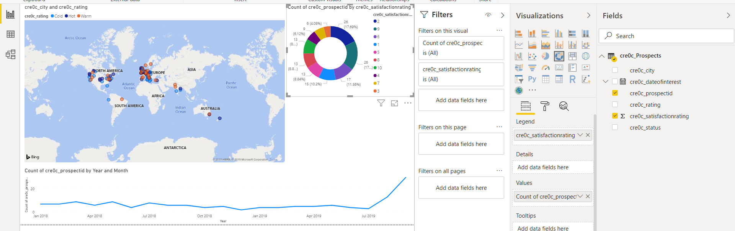

Finally, click out of the doughnut chart visual anywhere on the Blank Canvas and add a Tree map component from the visualisation pane.

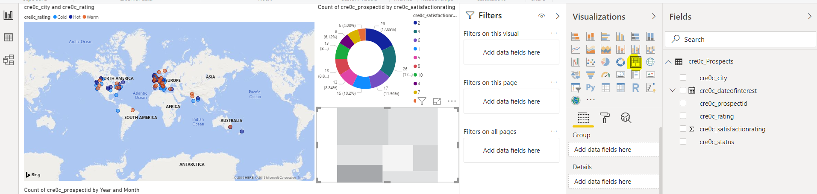

Drag the following fields into the properties of the doughnut chart:

1. Legend: prefix_status
2. Values: prefix_prospectid (“Count of” will automatically be added in front of it)

Resize elements as required.

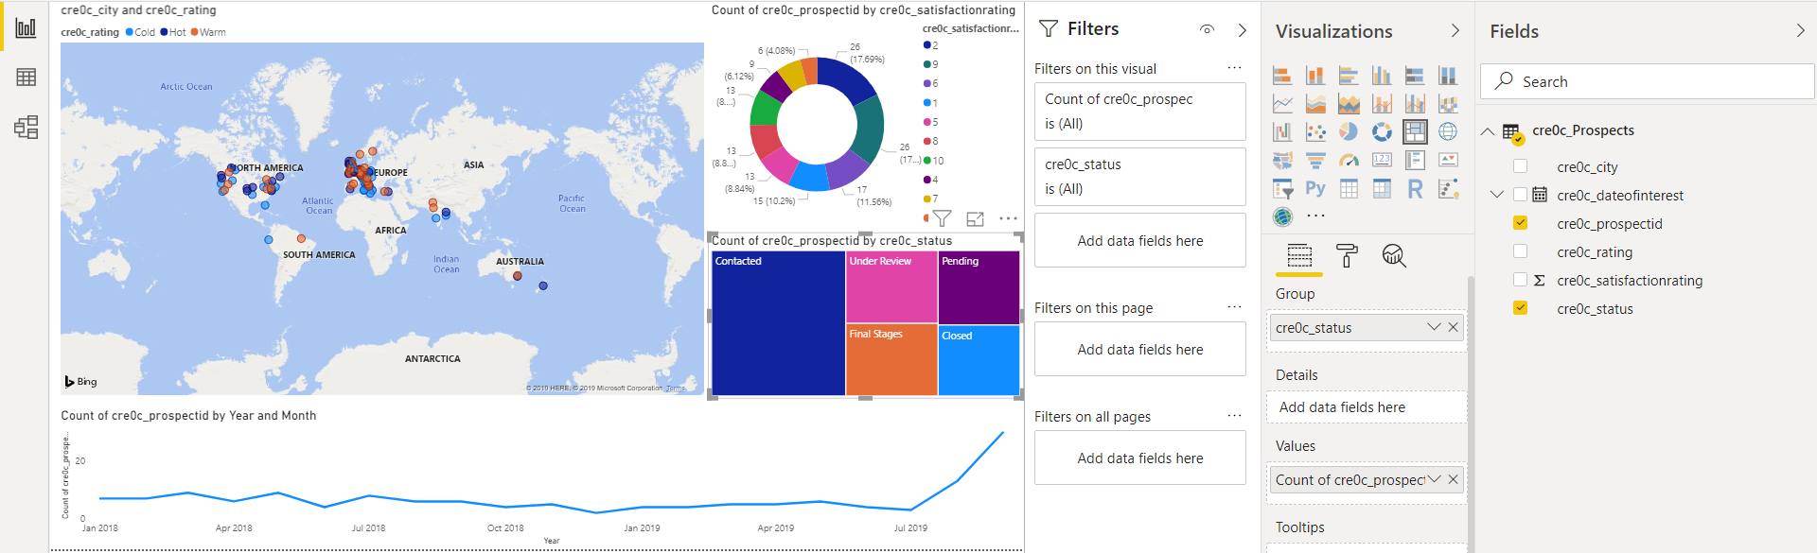

You are now ready to save an publish your amazing report to your power BI workspace. Elect “File | Save As” and save your *.Pbix file somewhere on your local machine.

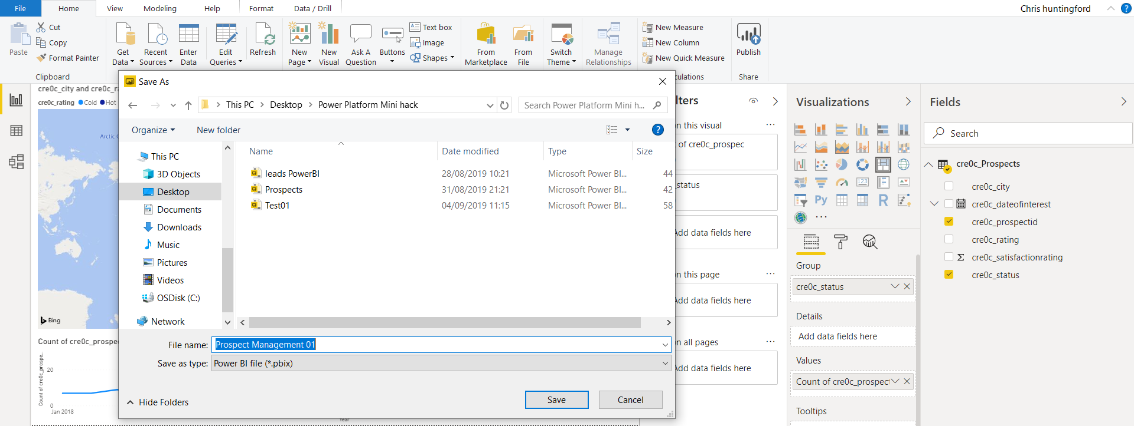

Publish to your workspace by clicking the “Publish” button in the ribbon.

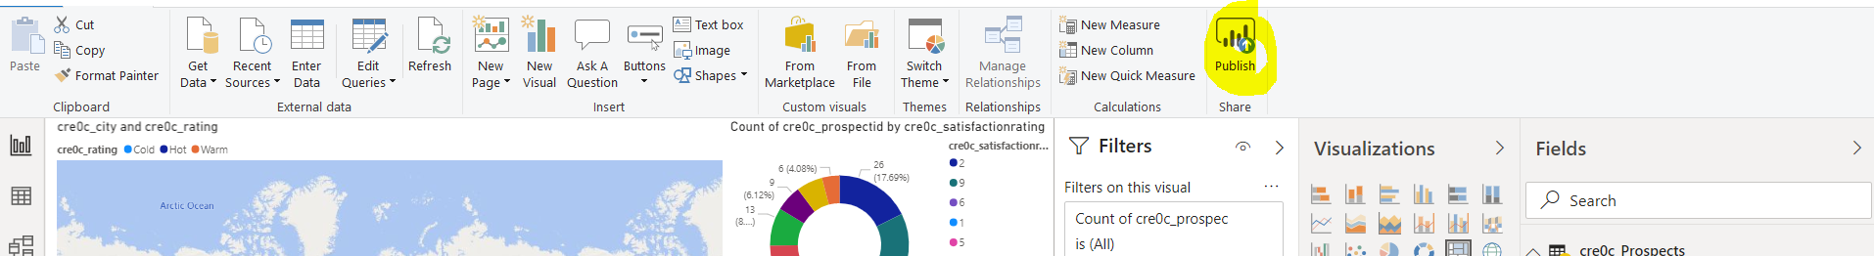

Select the workspace you would like to publish to.

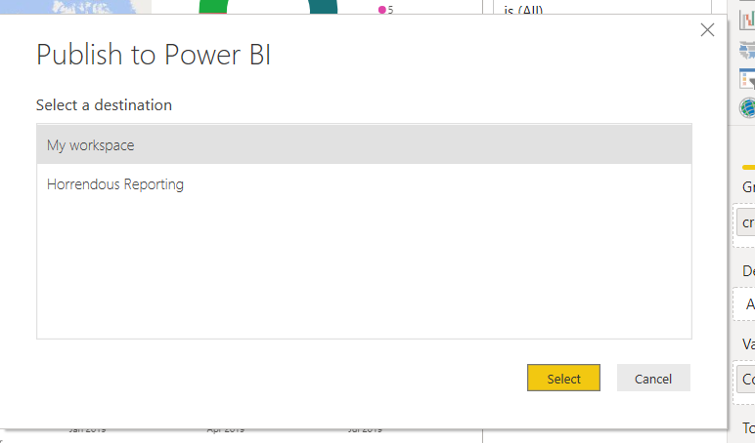

Your report will now be published to your workspace.

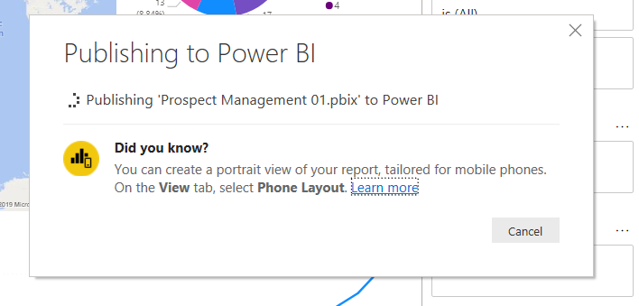

Once this is complete you will be notified.

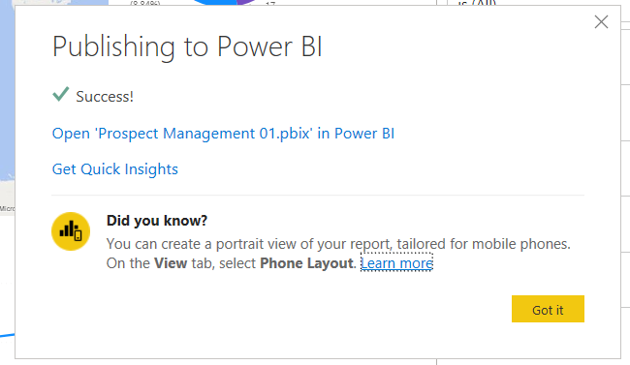

Open a browser window and make sure you are signed into Power BI. Navigate to the Power BI Home page (<https://app.powerbi.com/home>) and look for the report you just uploaded.

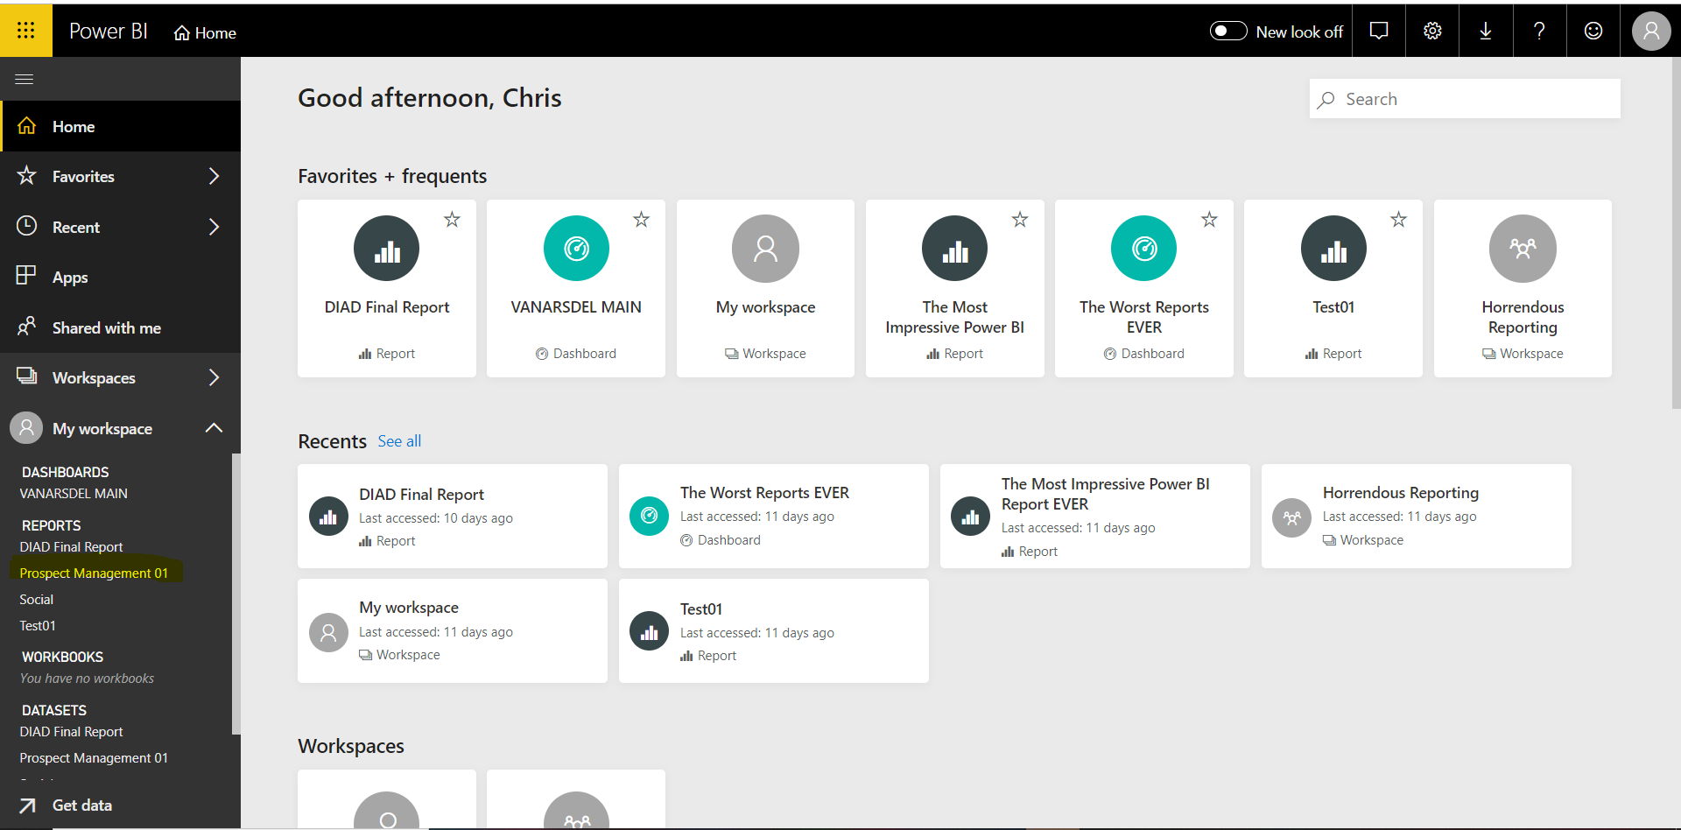

On clicking on it you will be able to interact with the visuals. Here is an example of all the hot prospects in my database over time.

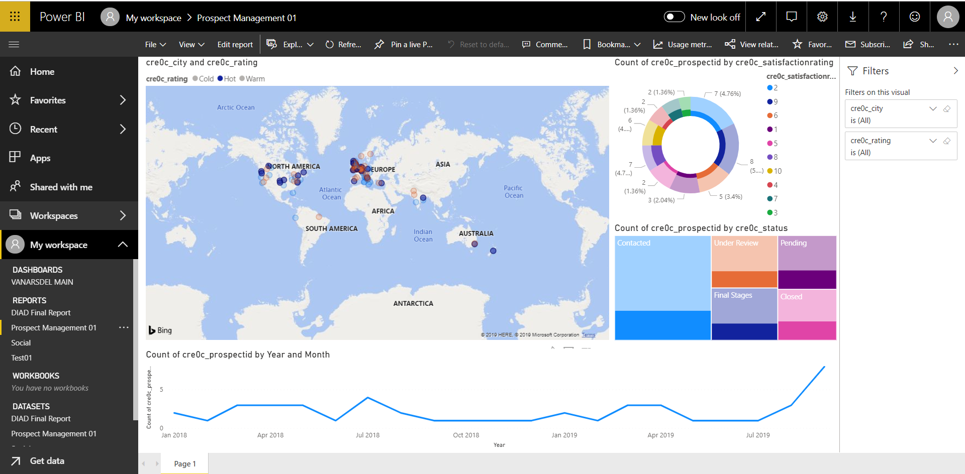

To add a visual to a dashboard, hover over it in the report and select the “Pin Visual” option.

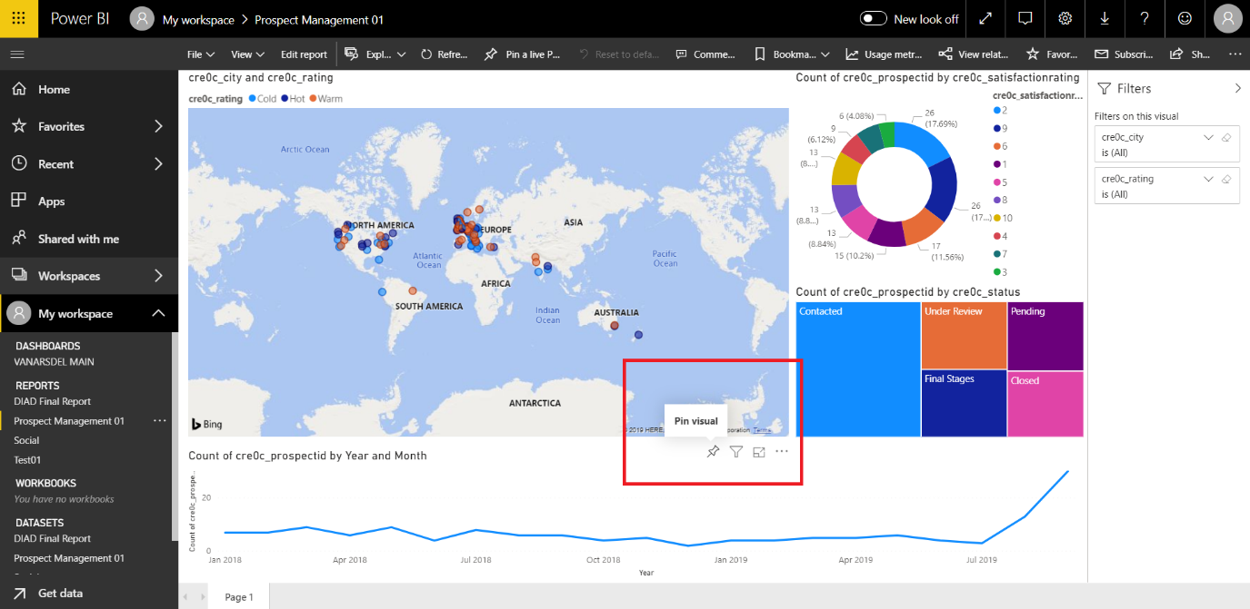

Create a new Dashboard called “Prospect Management”.

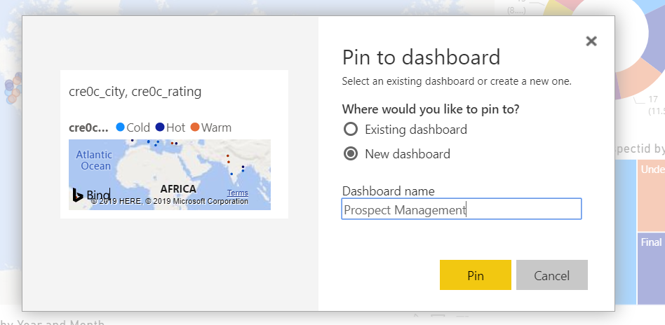

Go ahead and pin other visuals from the page onto this dashboard.

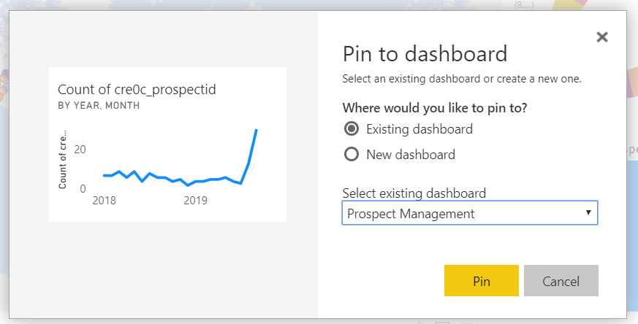

Look at the Dashboards on the left-hand side of the page and select the “Prospect Management” Dashboard. The fact that these visuals are now available in a dashboard makes them available to be used within Model-driven apps and Canvas apps.

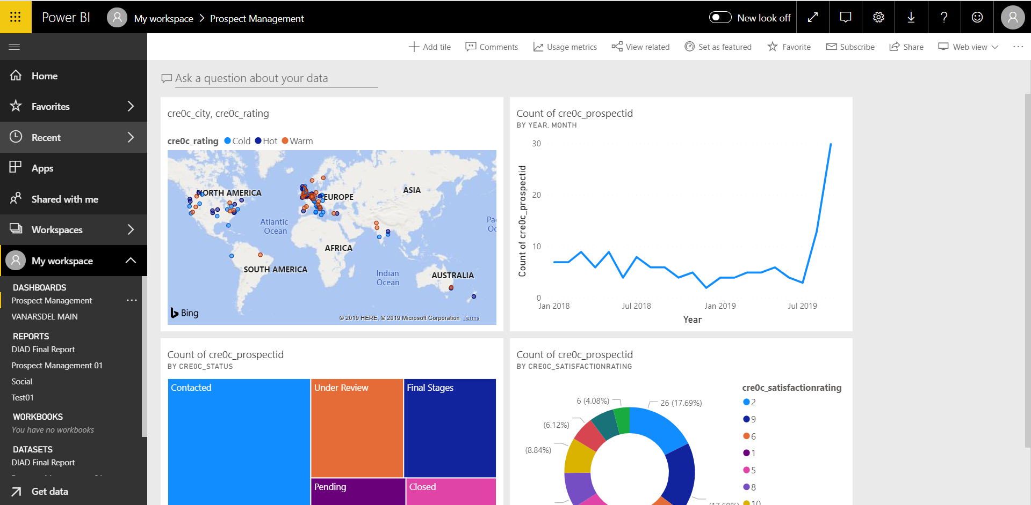

# Lab 6: Configuring the Sales Canvas App*

In this lab we will learn how to configure a basic PowerApps (Canvas App) that the Sales team can use on the road to capture information for the Mid office prospect management team to leverage. This app needs to be as simple and user friendly as possible.

***Please Note:***

***This lab can be completed independently, with only Lab 1 being and no support of the other labs. This does not include the embedded Power BI section of the Solution. If you would like to complete this without creating the actual Power BI report, you are able to import the “Prospect Management 01.Pbix report” into power BI and reference the relevant workspace.***

## Solution Components

PowerApps : Canvas Apps

Power BI (Optional)

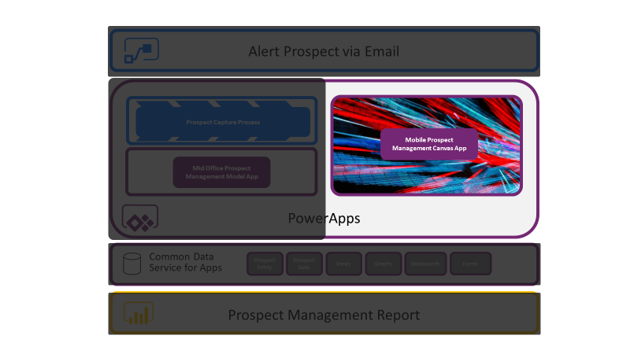

## Let’s Begin

### PowerApps Canvas App

Navigate to the maker Experience (Make.PowerApps.com) and then to the Apps section from the menu on the left-hand side of the page. You will be able to see your “Prospect Management” model driven application the list.

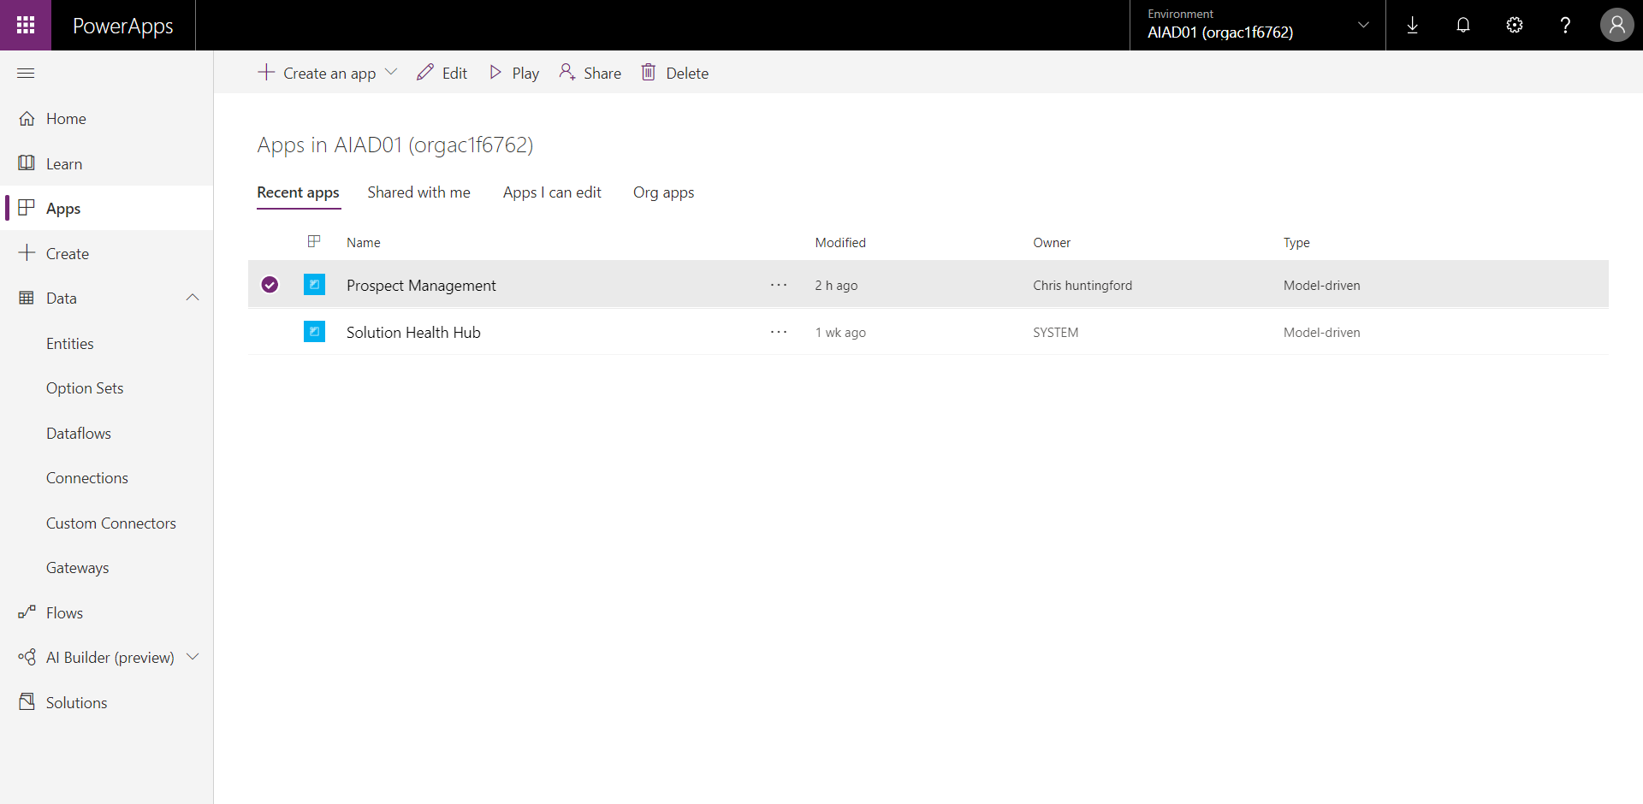

Select “Create an app” from the menu at the top and then select “Canvas App”.

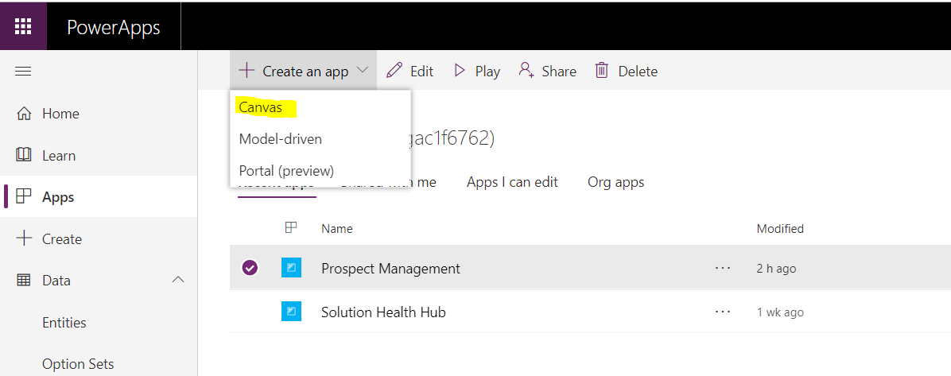

You will be taken to the “Create an App” page where you will be given the options to start with data or from blank. In this scenario we have some Prospect data in the CDS, so select “Common Data Service, Phone layout”.

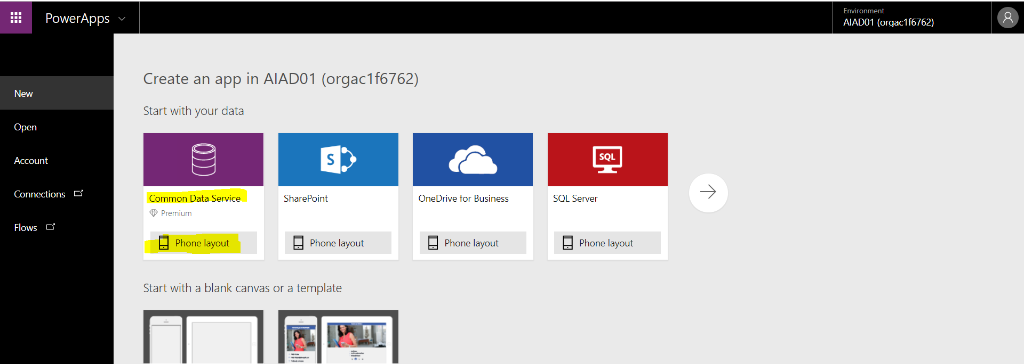

Search for and select “Prospects” from within your list of Common Data Service entities and then select the “Connect” button on the bottom right of the page.

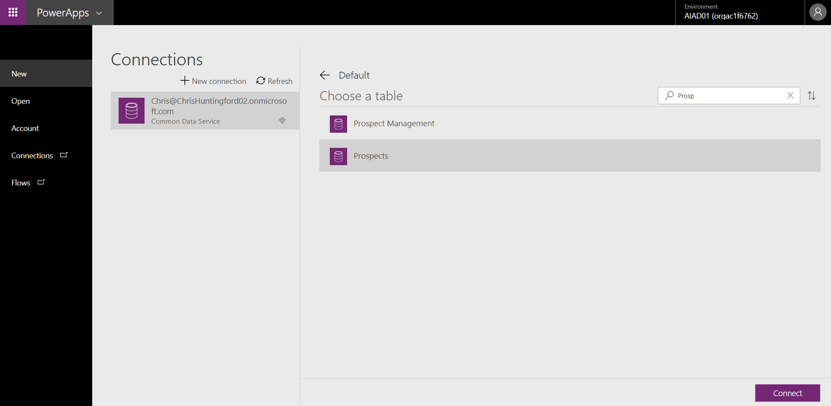

Once the connection is made the PowerApps will leverage the core application templates that it contains for the Common Data Service and generate a bae application for you to leverage. This should take around a minute.

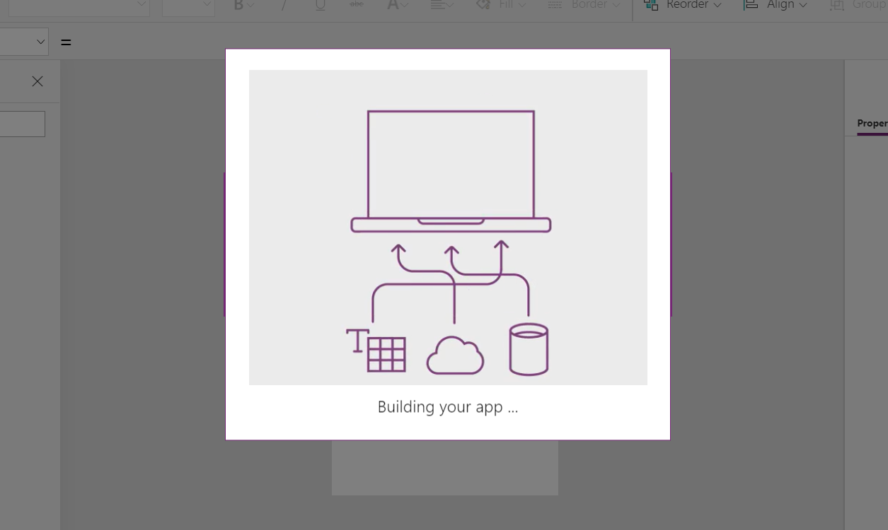

Once the app creation process is finished you will have the base structure that you can extend to create a Canvas app ready for the sales team to capture and manage prospects.

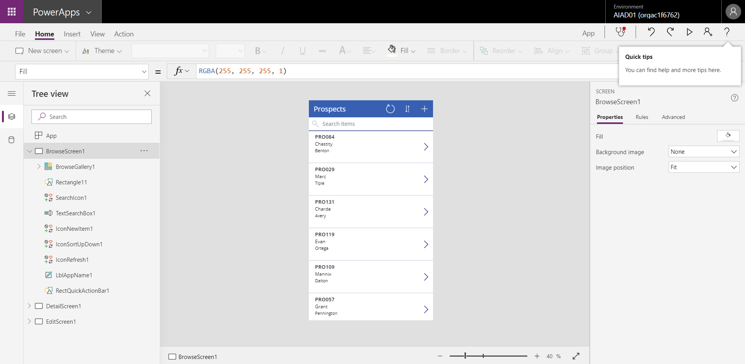

Before making any changes, navigate to the File menu and select “App Settings”. Give your app a title, and Icon and find a suitable colour.

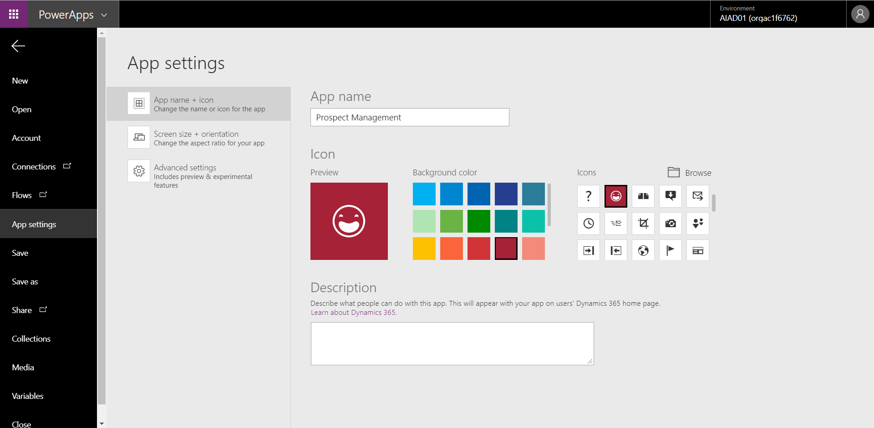

Once you have done this, Select SAVE from the menu on the left and then click the “Save” button on the bottom right hand corner of the page.

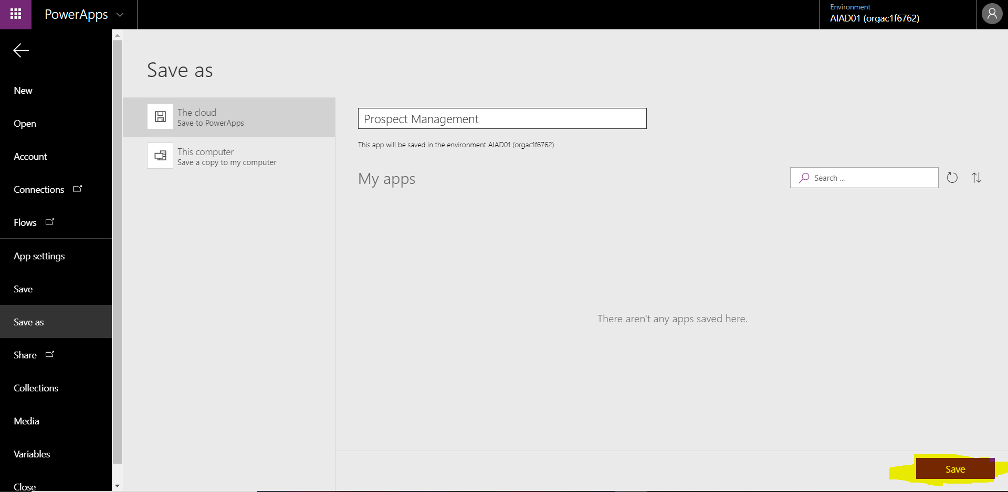

Your application will now be saved and will be made available for sharing.

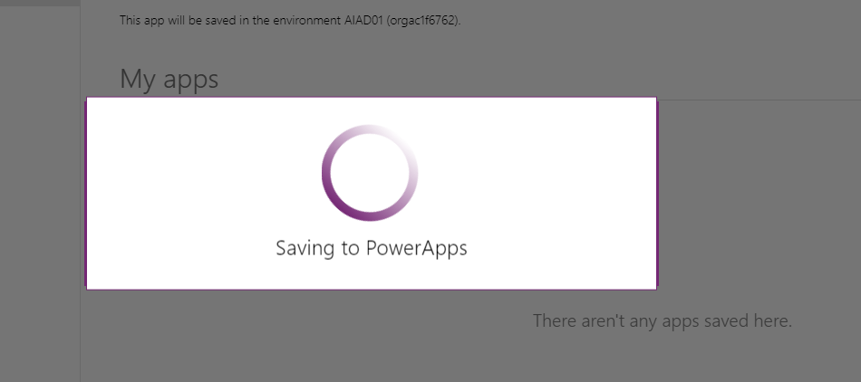

Select the back arrow to go back to editing your Canvas app.

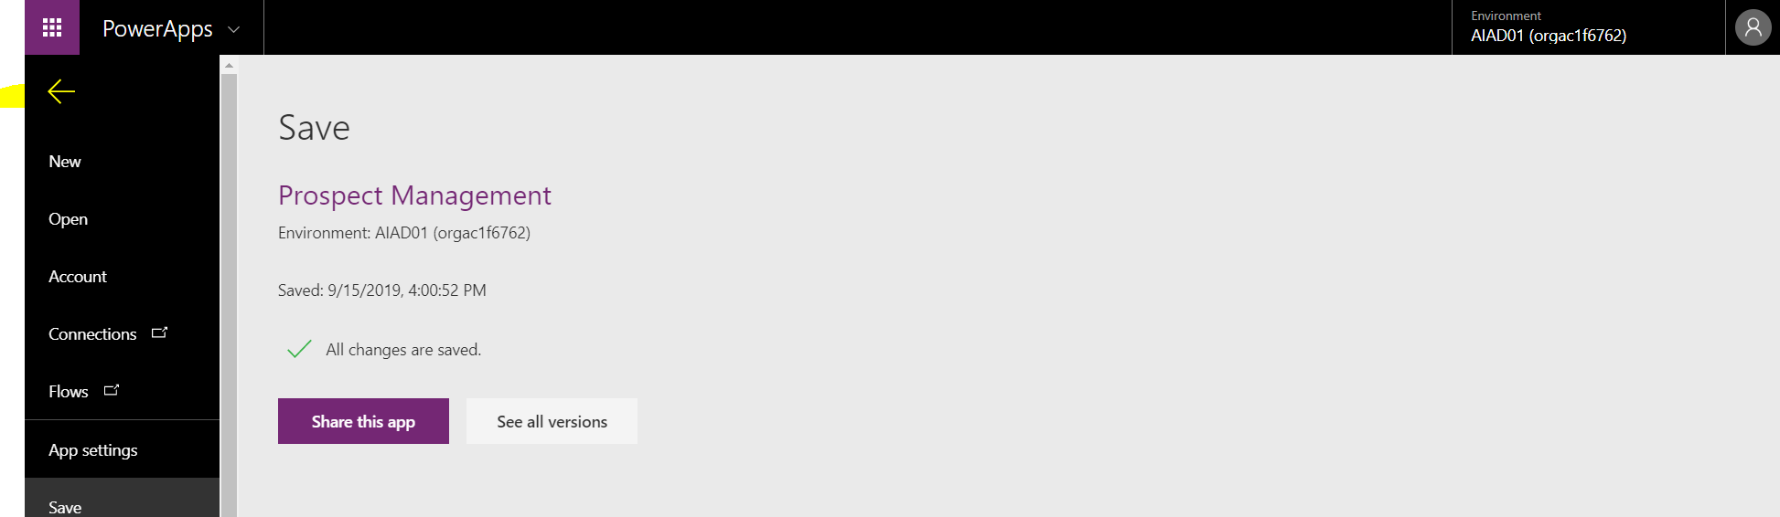

Before we change of the user Interface (UI) elements we need to make sure that all the relevant fields are available on the Capture form. Navigate to the EditScreen from the Treeview on the left.

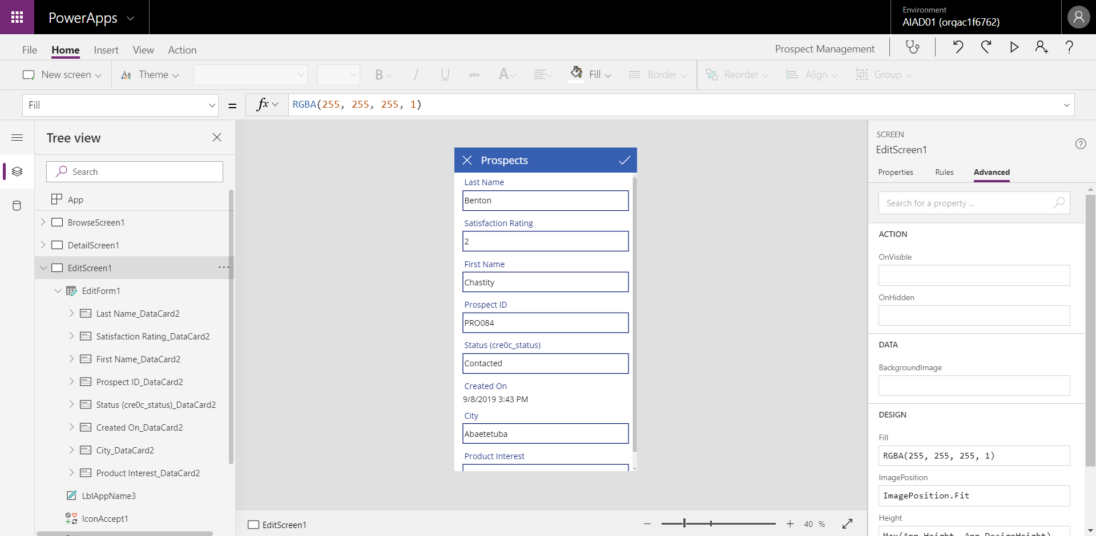

You will see that there are various fields that have automatically been added to the form. On the left select the “EditForm1” component from the Tree view. Click the “Edit Fields” option from the properties panel on the right.

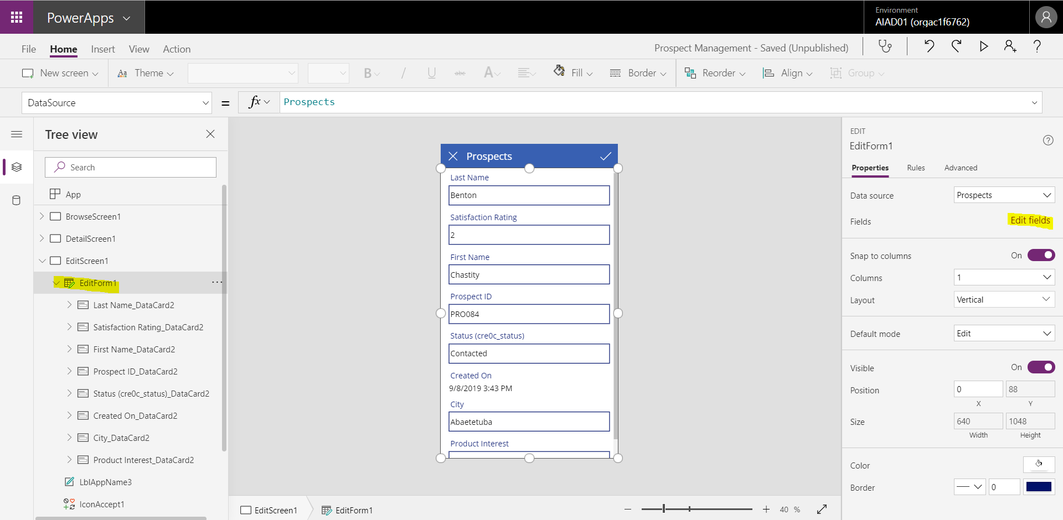

This will list the form fields that are available to the user for input. You can drag fields up and down in the form designer here. Move “First name” to the top of the list.

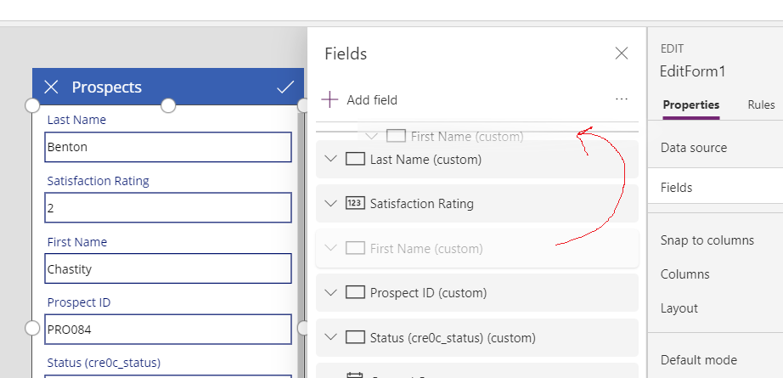

To add another field, select the “Add Field” option and then search for the field you would like to add. In this case, we will add the email field as it is used as the alert mechanism when running the Flow. Click the “Add” button to add this to the form.

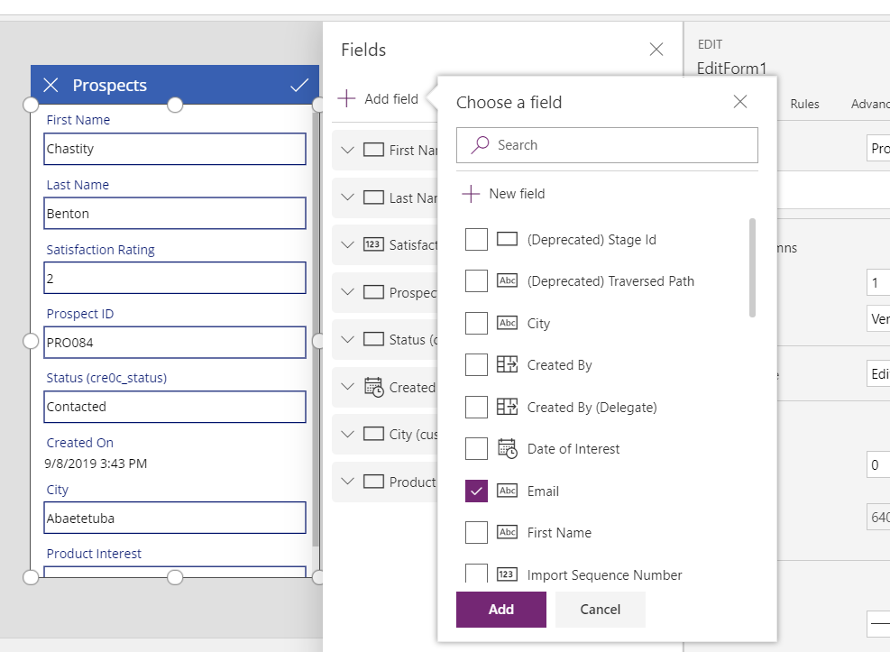

The Email field will be exposed in “Full Card” format. Select the field and drag it underneath “last Name on the form. (***NB: Sometimes the app will give you an error that has to do with the “Max Length” value of the field. Do not edit this for now, you will still be able to capture data***.)

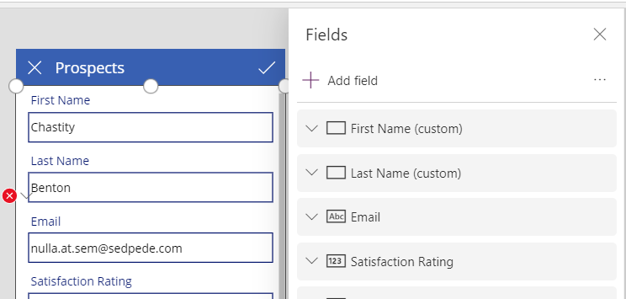

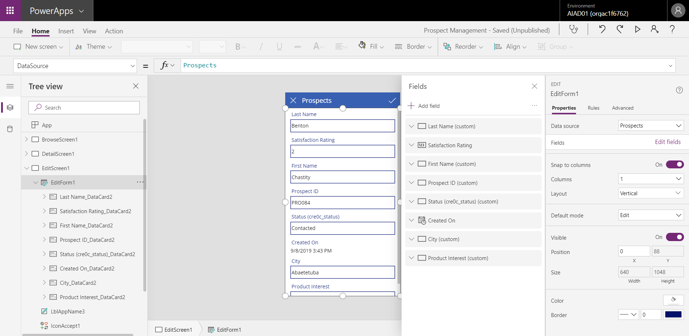

To make this application ready for the sales team we need to make sure that it is as user friendly as possible. In the home menu select the option to add a “New Screen” and then select “Blank”.

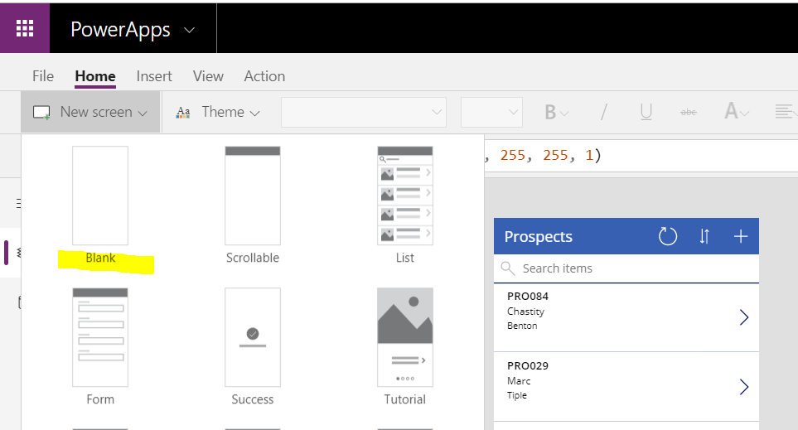

You will see a new blank screen appear in the Tree View.

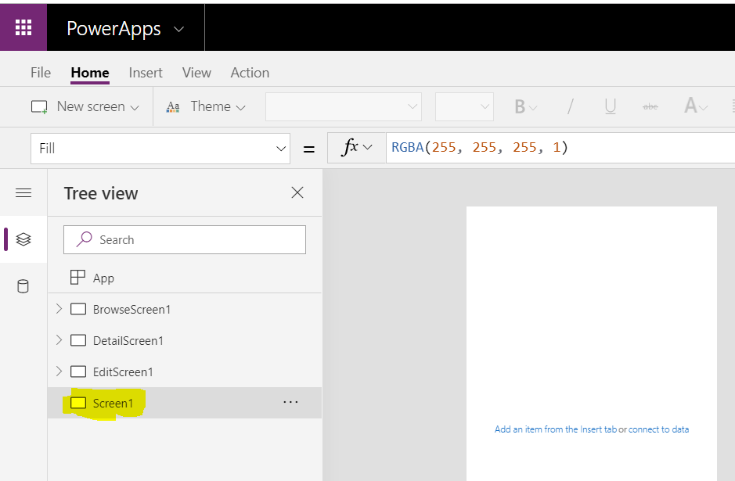

Double click on the screen name and rename it to “SplashScreen”.

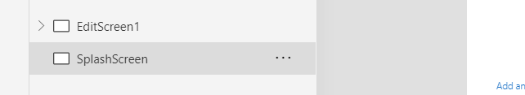

Update the Splash Screens image by either using one of our own images or using the example splash screen generated for this demo. In the Splash Screen select “background Image” from the screen properties panel.

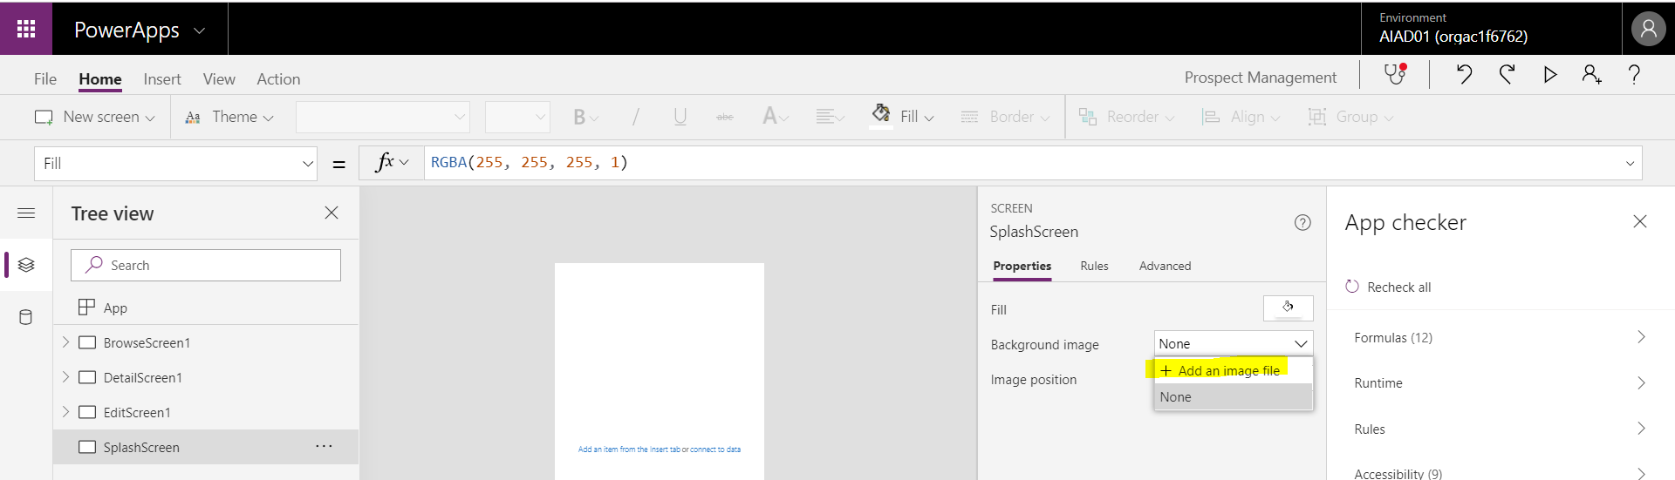

Go to the file location that you stored the relevant image and upload it.

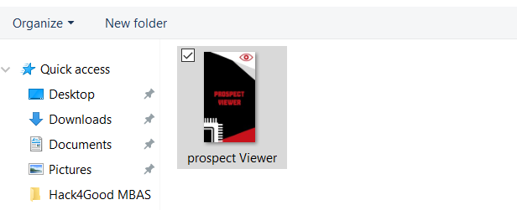

Your Splash Screen will look something like this.

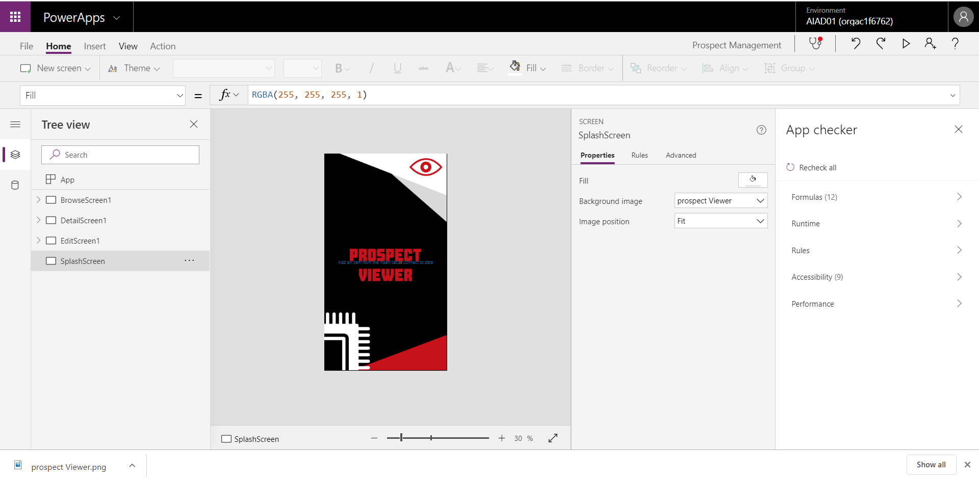

Let’s also add another new screen called “Reports”. Do this in the same way as you added and renamed the Splash Screen.

On the reports screen, navigate to “Insert” on the menu and then select “Controls”. Add in a new “Power BI Tile”.

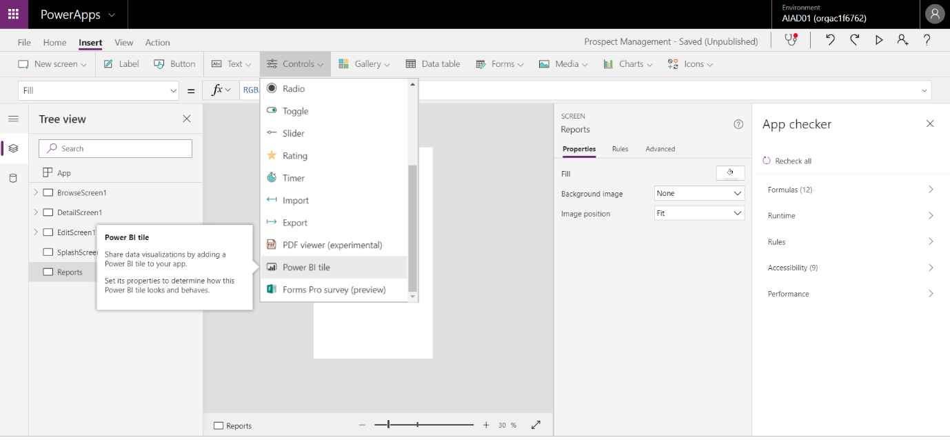

We are going to embed the MAP Power BI dashboard visualisation added in the previous lab, found here. Update the following information into the connection details on the Power BI widget:

1. Workspace: My Workspace
2. Dashboard: “Prospect Management”
3. Tile: Select the tile containing the “City” & “Rating” fields.

Close the connection details to get back to the Splash Screen.

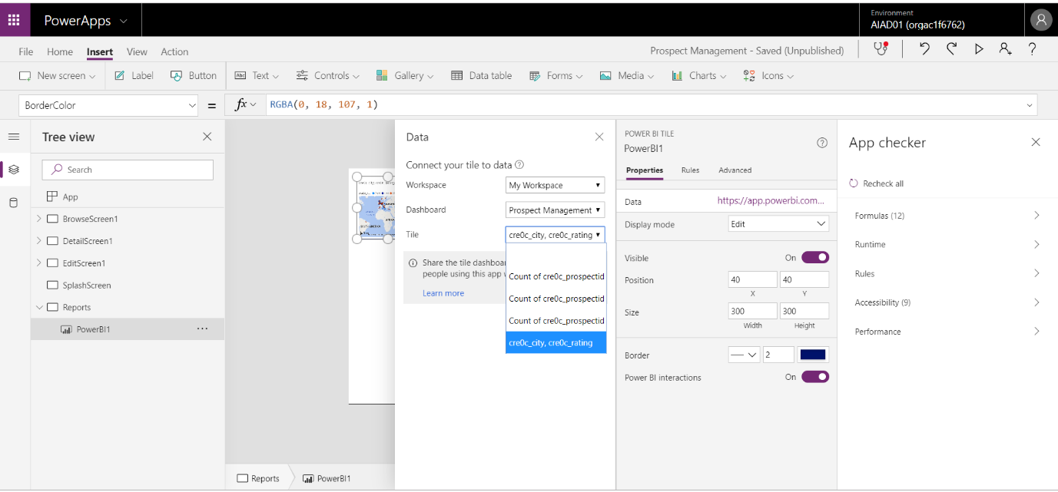

Resize the widget on the Splash screen to cover the entire screen, except for a piece on the very top.

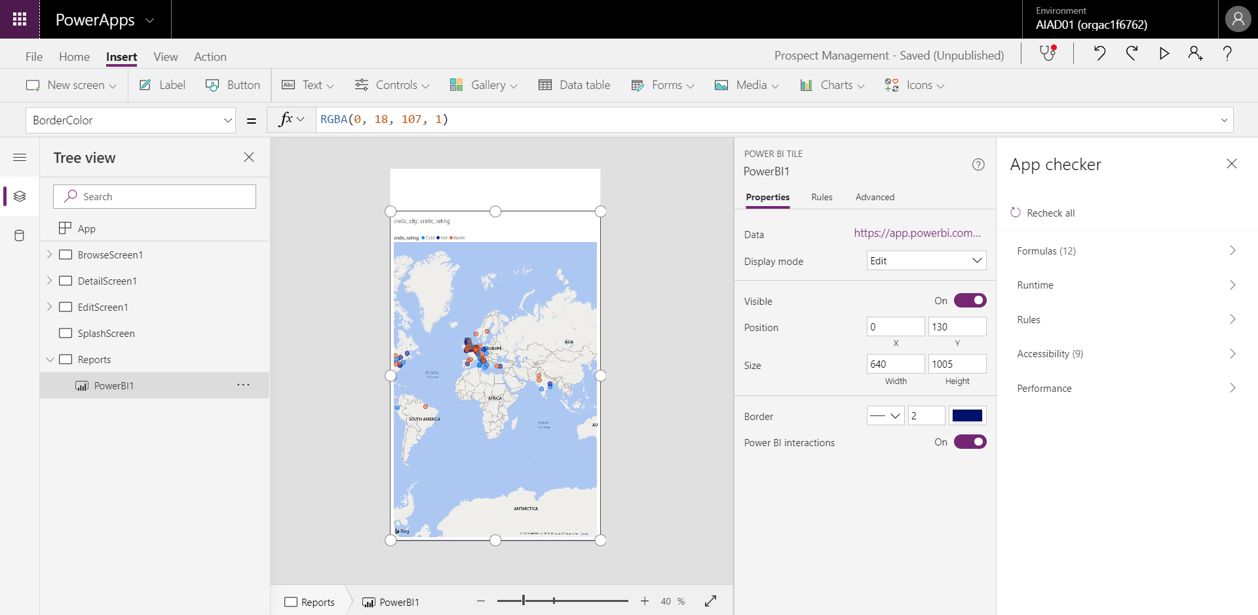

In the Splash Screen, navigate to the “Insert” menu and add in a new button by selecting the “Button” menu item.

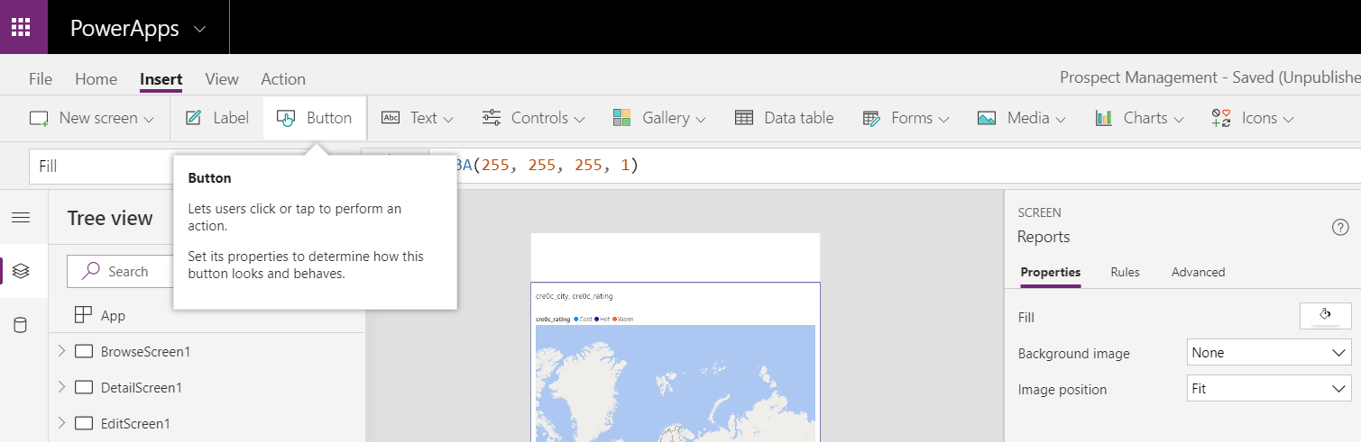

Move and resize the button to cover the full area of the open blank section of the page.

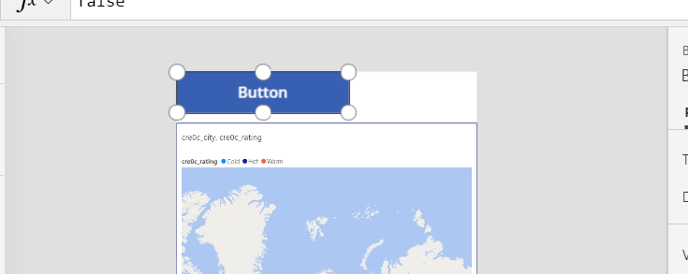

Double click on the button and enter in the word “Home”.

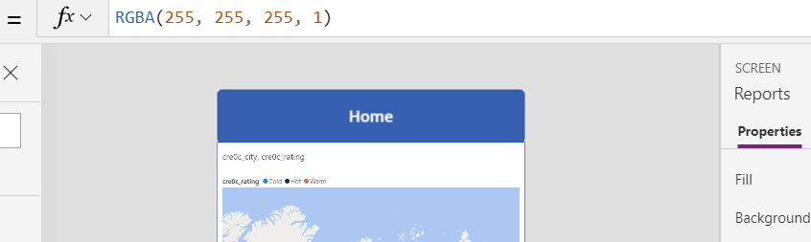

Select the “Browse Screen” from the Tree view on the left.

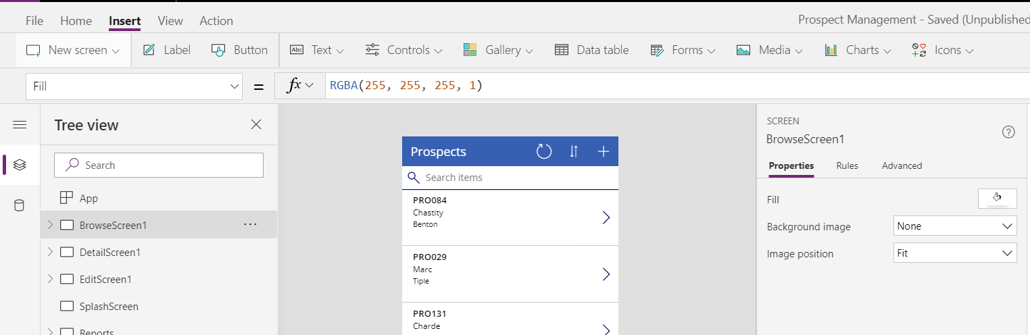

Navigate to the “Insert” menu and add in the icon in the shape of a house.

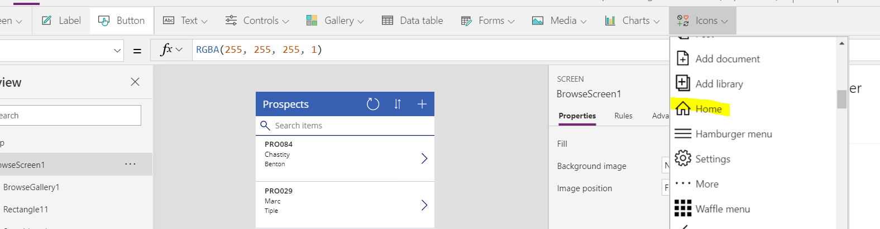

The Icon will land on a random location on the browse page.

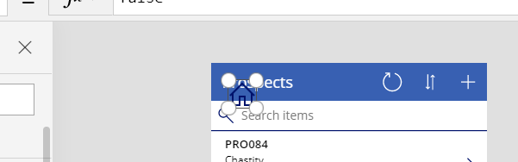

Select the icon and move it to the top menu of the browse screen. Navigate to the “Home” menu and change the colour of the icon to white.

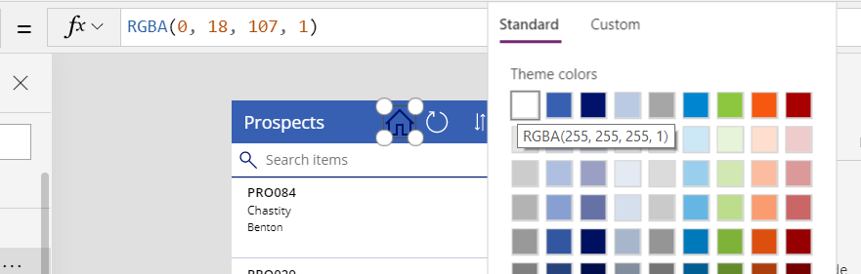

Make sure the Home icon is selected. Navigate to the “Action” area on the menu and select “navigate”. Select the “SplashScreen” from the list of screens.

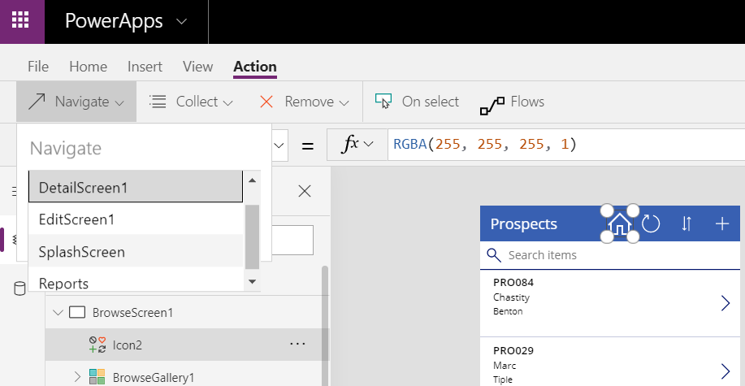

Navigate back to the SplashScreen in the tree view on the left.

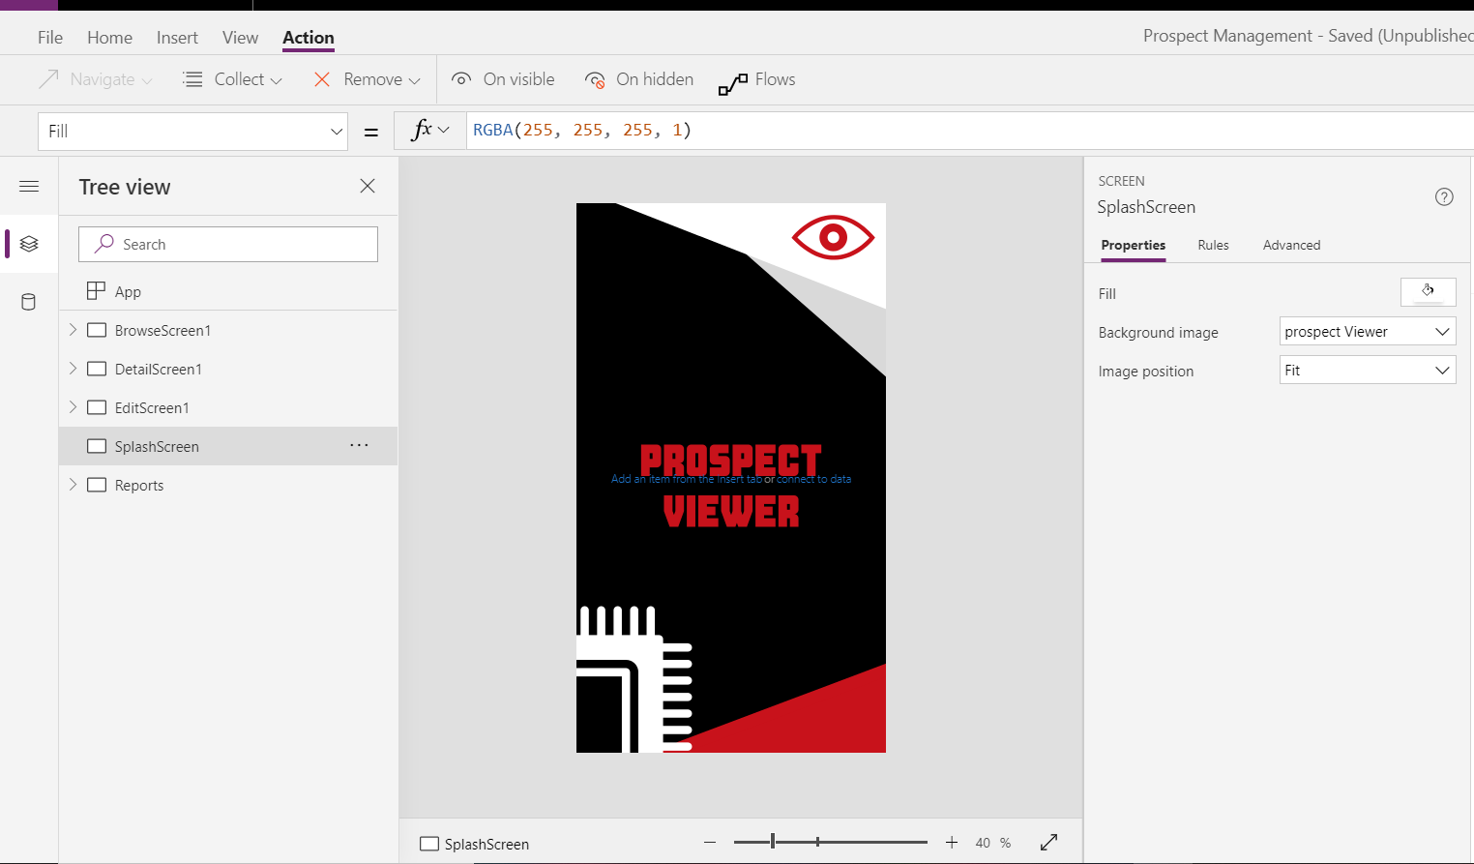

As done before, add in 2 new buttons and call them the following:

1. Browse prospects
2. Reporting

Resize the buttons as required.

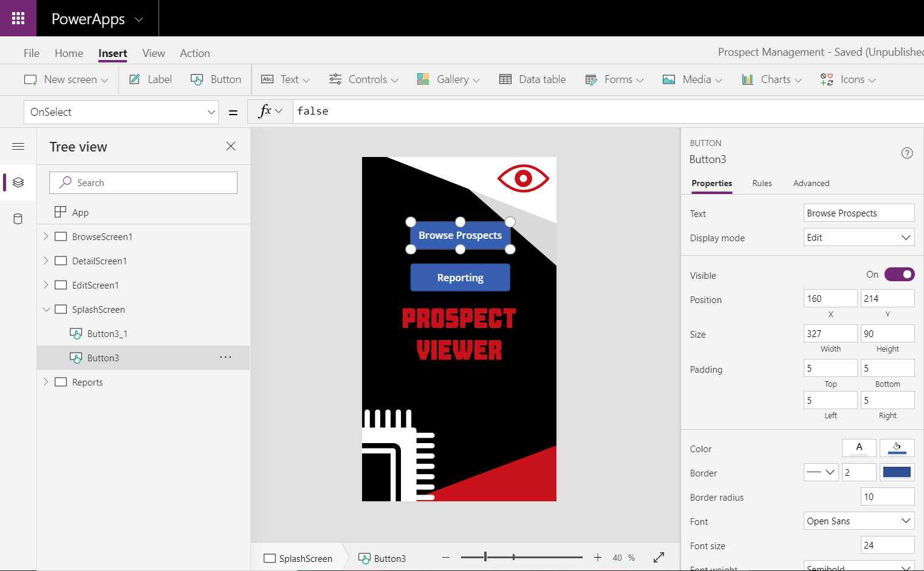

Select the first button and change the navigation to “Browse Screen”.

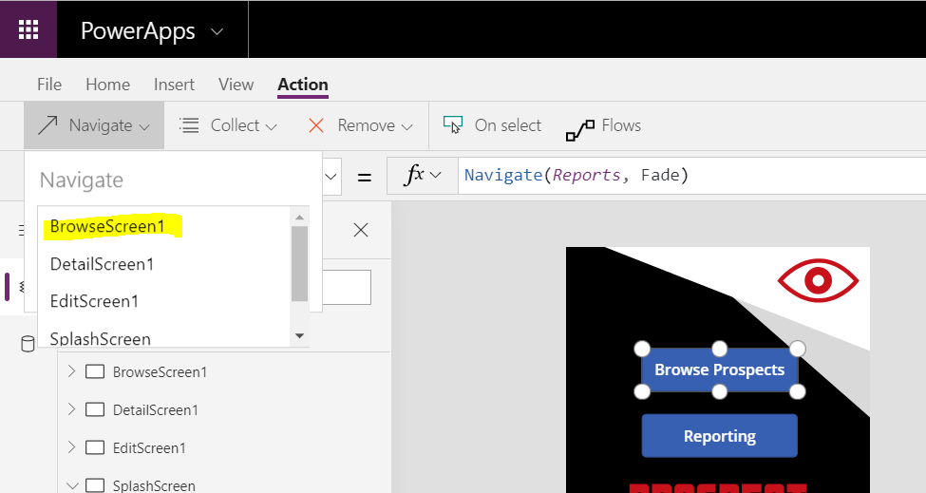

Select the Second button and change the navigation to “Reports”.

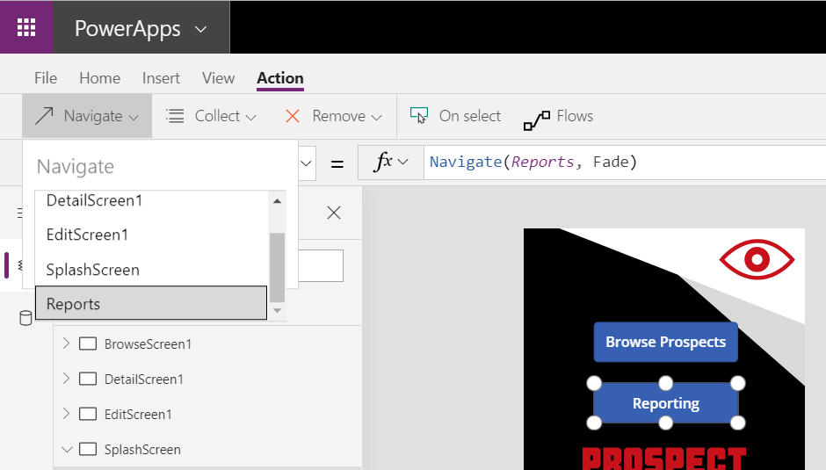

Finally, to make your app look just that little bit better, lets change the theme to a red theme. Navigate to “Home” from the menu and then select the “Red” theme from the theme options.

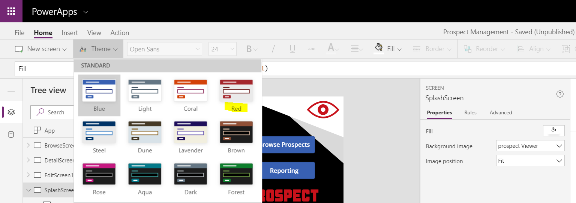

This will change the entire theme of all the core components of your app.

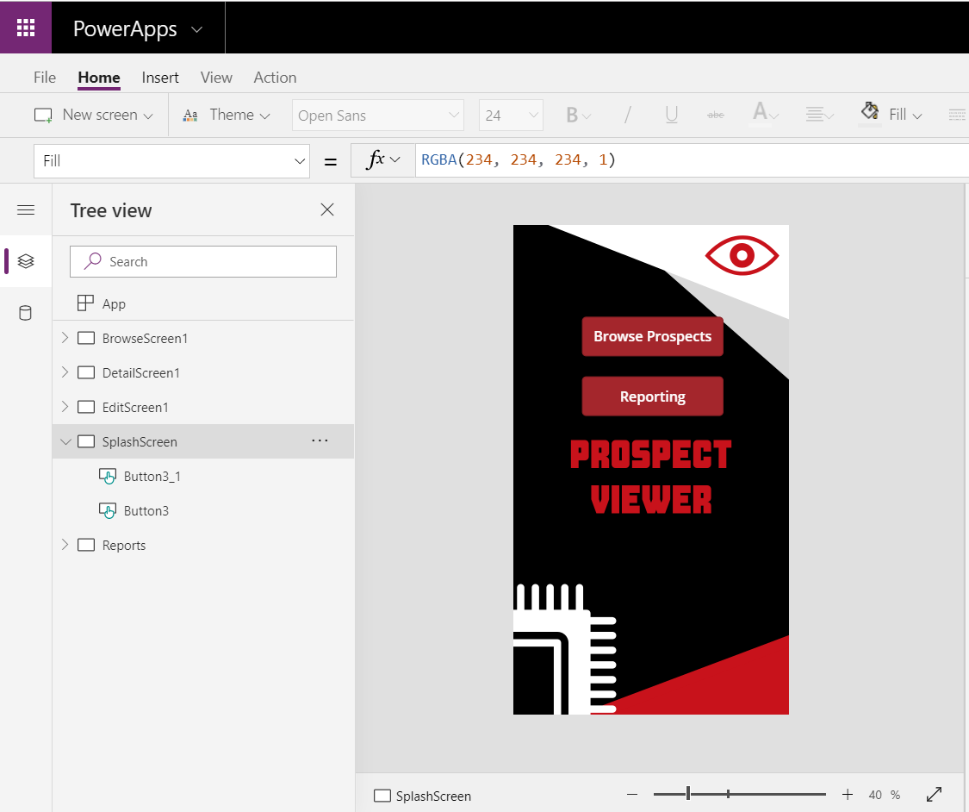

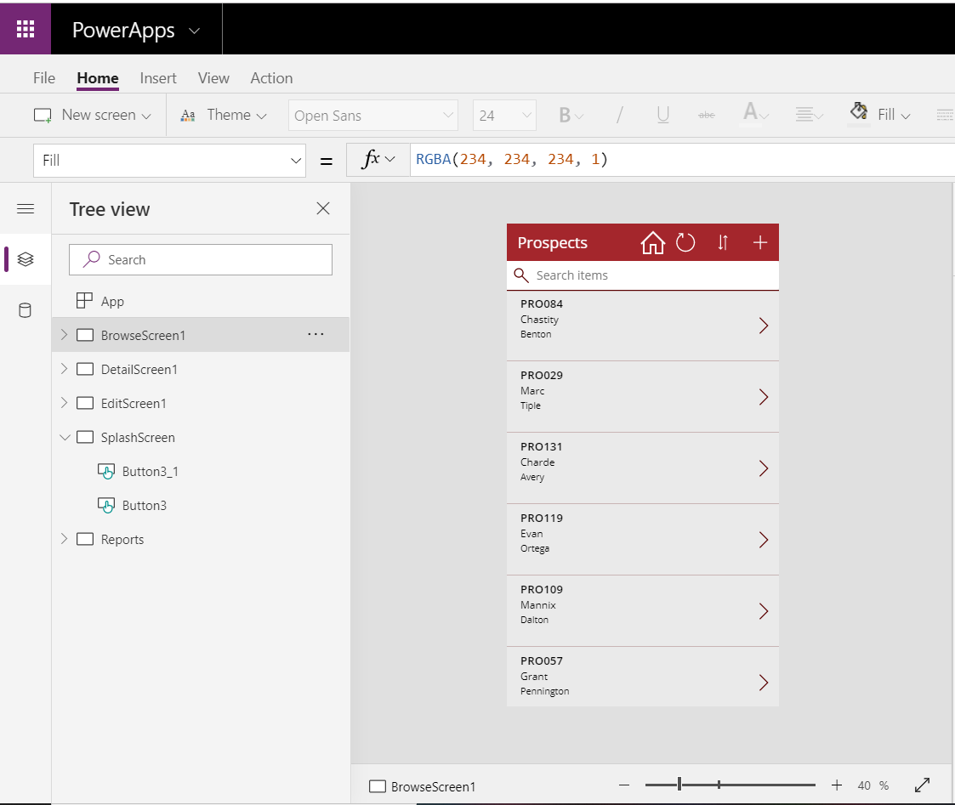

Make sure you save your application before testing it out. Select the file menu and then “Save”.

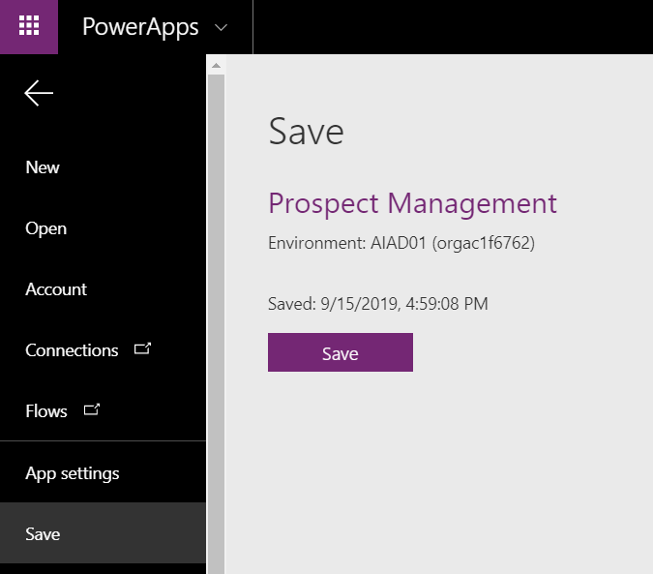

You can also now publish your app so that so that others may use it. Simply select “Publish” after you have saved.

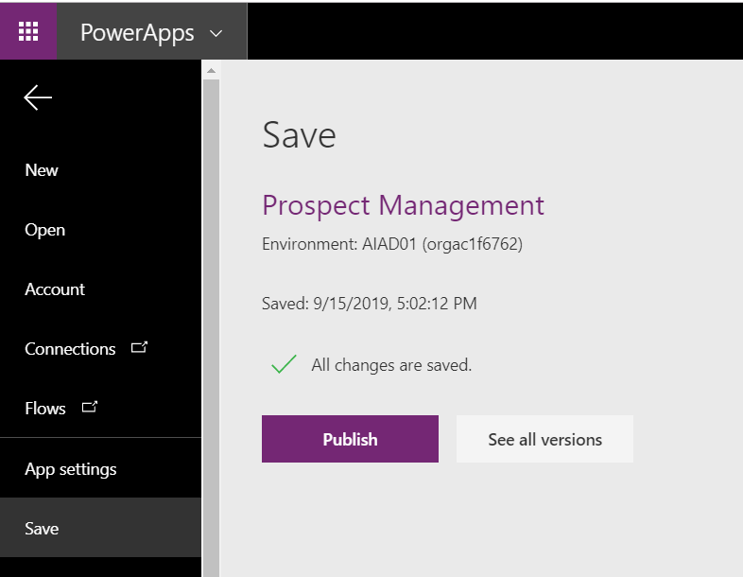

Once you have published your application you will be able to see it in the list of apps when navigating to the App screen from the Maker Experience in PowerApps.

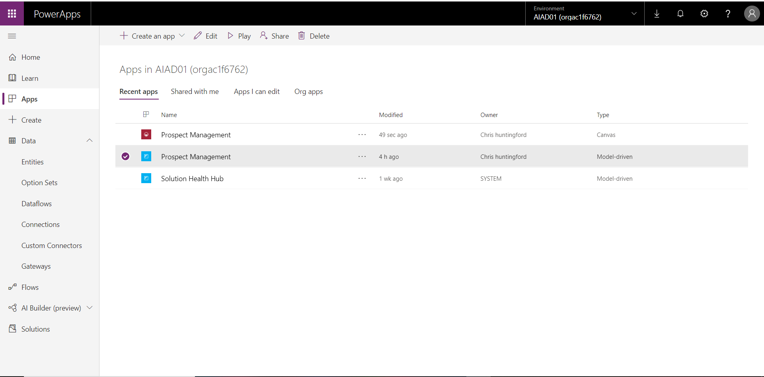

# Lab 7: Testing*

In this lab we will test the full prospect management process starting with the Canvas app and ending with power Bi. This will all be dependant on the labs you have completed in the time allocated.

## Solution Components

PowerApps: Canvas Apps

PowerApps: Model-driven Apps

Microsoft Flow

Power BI

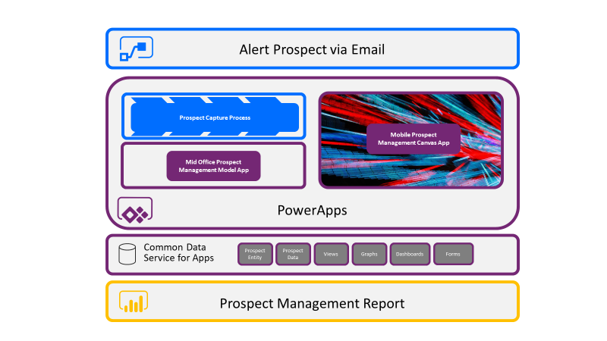

## Let’s Begin

### PowerApps Canvas App

1. Open your Canvas App from the Maker Experience (Make.PowerApps.com and navigate around.
2. From the Splash Screen navigate to the Browse Screen.
3. Capture a new prospect with your email address.
4. Navigate to the browse screen and search for your record by surname.
5. Close the Canvas app.

### PowerApps Model-driven App

1. Open the “Prospect management” model-driven App from the Maker Experience.
2. Lok for the record you just created in the prospects view. Preferably search by the prospect ID or created on Date.
3. Open the record and notice the Business process flow.
4. Take the record through the process flow by entering in data where necessary.

### Microsoft Flow

1. Open your email and make sure you received an email affirming that the process for qualification is underway.

### Power BI

1. Open the Power BI report and show how users can interact with data in a more inciteful manner.

# Final Learnings

The Microsoft Power Platform provides immediate value to businesses in an incredibly short amount of time by allowing users the ability to create solutions to solve problems and fill gaps in organisations typical SaaS type applications cannot normally solve. It’s Flexibility and ease of use provide makers with a performant, scalable and affordable platform that has the capacity to be adopted in all areas of the business.

